options(warn=-1)  
setwd('/Users/dsing001/LV/R')  
  
#load the csv file and provide the name as lv  
  
library(ggplot2)  
library(discretization)  
library(randomForest)

## randomForest 4.6-10  
## Type rfNews() to see new features/changes/bug fixes.

library(ROCR)

## Loading required package: gplots  
## KernSmooth 2.23 loaded  
## Copyright M. P. Wand 1997-2009  
##   
## Attaching package: 'gplots'  
##   
## The following object is masked from 'package:stats':  
##   
## lowess

library(LV)  
  
filename <- 'LendingClub.csv'  
header <- TRUE  
filename

## [1] "LendingClub.csv"

clscol='Class'  
  
# remove all the uncomplete data  
X <- read.csv(file=filename,header=header)  
clscolpos <- match(clscol,colnames(X))  
X <- X[complete.cases(X),]  
X <- moveclasscolintheend(X,clscolpos)  
X[,clscolpos] <- as.character(X[,clscolpos])  
  
# Change the levels to 0 and 1  
X[X[,clscolpos]=='Creditworthy',clscolpos] <- '0'  
X[X[,clscolpos]=='Uncreditworthy',clscolpos] <- '1'  
X[,clscolpos] <- as.factor(as.numeric(X[,clscol]))  
  
  
  
  
#After prelim processing I found that some of the data has vey few values in some of the levels and this could be an issue.  
#Also, based on graphs It looked like that some of the data in these factors is independent i.e. chi square test.  
#Thus running whether a process which will merge all the levels of a column which are independent base on chi square. I.e. these levels does not have discrimintaive power w.r.t. class.  
  
# However, first create 3 subsets to make sure that we run this process only on the train data and doesnt do it on test data otherwise there might be a bias in our model.  
  
# Generate the 3 sets. i.e test set 0.3 Valid set is 0.07 and train is 0.63  
dt_set <- generte_train_test_validset(X,test_ratio=0.3,valid_ratio=0.1)

## [1] "we have valid test"  
## [1] "valid set is generated"

train_data <- dt_set$train_data  
test_data <- dt_set$test_data  
valid_data <- dt_set$valid_data  
  
#Run the merge level proces. Not that independence will be tested only on the train data but to be consstent we have to merge the same lable in test data and valid data as well.  
td <- merge_lvls(train_data,test_data,valid_data)

## [1] 0 0 0 0 0 0  
## Levels: 0 1  
## [1] 2 4 6 7 9 15 20 21  
## 'data.frame': 15578 obs. of 21 variables:  
## $ Loan.Amount : int 1200 10800 7500 3000 4000 3200 2525 10625 2800 7500 ...  
## $ Loan.Term : Factor w/ 2 levels "36 Months","60 Months": 1 1 1 1 1 1 1 1 2 1 ...  
## $ Employment.Length : num 10 6 3 3 0.5 5 3 10 0.5 3 ...  
## $ Home.Ownership : Factor w/ 5 levels "MORTGAGE","NOne",..: 4 5 5 1 1 5 5 1 5 1 ...  
## $ Annual.Income : num 54000 32000 85000 80800 148000 54000 27000 34000 24000 138000 ...  
## $ Loan.Purpose : Factor w/ 15 levels "0","Car","Credit Card",..: 4 4 4 3 3 4 4 4 4 4 ...  
## $ Address.State : Factor w/ 51 levels "","AK","AL","AR",..: 44 8 6 44 44 21 19 27 6 18 ...  
## $ Debt.To.Income.Ratio : num 5.47 11.63 8.1 14.97 16.98 ...  
## $ No..Delinquencies.In.Last.2.Years: Factor w/ 10 levels "Eight","Five",..: 5 5 5 6 5 5 5 5 5 6 ...  
## $ Earliest.Credit.Line.Opened : num 31068 35411 36846 36004 34095 ...  
## $ FICO.Credit.Score : int 675 680 710 665 725 740 705 675 705 660 ...  
## $ No..Inquiries.In.Last.6.Months : int 0 1 1 0 0 0 1 2 0 2 ...  
## $ Months.Since.Last.Delinquency : int 64 58 0 13 0 0 0 57 0 10 ...  
## $ No..Of.Credit.Lines : int 5 14 3 13 11 7 5 5 7 11 ...  
## $ No..Adverse.Public.Records : Factor w/ 5 levels "Four","None",..: 2 2 2 2 2 2 2 3 3 2 ...  
## $ Total.Credit.Balance : int 2584 3511 33667 4740 50000 3198 5630 13846 2183 5122 ...  
## $ Use.Of.Credit.Line : num 40.4 25.6 73.2 39.5 51 51.1 23 71 19.5 18.2 ...  
## $ Total.Number.Of.Credit.Lines : int 31 40 11 23 19 11 8 16 23 37 ...  
## $ Loan.Application.Description : int 748 403 293 487 363 141 171 62 302 981 ...  
## $ No..Of.Public.Record.Bankruptcies: Factor w/ 3 levels "None","One","Two": 1 1 1 1 1 1 1 2 2 1 ...  
## $ Class : Factor w/ 2 levels "0","1": 1 1 1 1 1 1 1 1 1 1 ...  
## NULL  
## [1] "Home.Ownership"  
## [1] "MORTGAGE" "NOne" "OTHER" "OWN" "RENT"   
## [1] 4  
## [1] FALSE  
## [1] "usual"  
## [1] 4  
## [1] "print the p values for factor levels which are independent.These are order by p values. It is for column Home.Ownership"  
## col lvl1 lvl2 pvalue  
## 6 Home.Ownership NOne OTHER 1  
## [1] "here"  
## [1] "OTHER"  
## [1] "Home.Ownership"  
## [1] "MORTGAGE" "NOne" "OWN" "RENT"   
## [1] 4  
## [1] FALSE  
## [1] "usual"  
## [1] 3  
## [1] "print the p values for factor levels which are independent.These are order by p values. It is for column Home.Ownership"  
## col lvl1 lvl2 pvalue  
## 2 Home.Ownership MORTGAGE NOne 1  
## [1] "here"  
## [1] "NOne"  
## [1] "Home.Ownership"  
## [1] "MORTGAGE" "OWN" "RENT"   
## [1] 4  
## [1] FALSE  
## [1] "usual"  
## [1] 2  
## [1] "print the p values for factor levels which are independent.These are order by p values. It is for column Home.Ownership"  
## col lvl1 lvl2 pvalue  
## 4 Home.Ownership OWN RENT 0.3360218  
## [1] "here"  
## [1] "RENT"  
## 'data.frame': 15578 obs. of 21 variables:  
## $ Loan.Amount : int 1200 10800 7500 3000 4000 3200 2525 10625 2800 7500 ...  
## $ Loan.Term : Factor w/ 2 levels "36 Months","60 Months": 1 1 1 1 1 1 1 1 2 1 ...  
## $ Employment.Length : num 10 6 3 3 0.5 5 3 10 0.5 3 ...  
## $ Home.Ownership : Factor w/ 2 levels "MORTGAGE","OWN": 2 2 2 1 1 2 2 1 2 1 ...  
## $ Annual.Income : num 54000 32000 85000 80800 148000 54000 27000 34000 24000 138000 ...  
## $ Loan.Purpose : Factor w/ 15 levels "0","Car","Credit Card",..: 4 4 4 3 3 4 4 4 4 4 ...  
## $ Address.State : Factor w/ 51 levels "","AK","AL","AR",..: 44 8 6 44 44 21 19 27 6 18 ...  
## $ Debt.To.Income.Ratio : num 5.47 11.63 8.1 14.97 16.98 ...  
## $ No..Delinquencies.In.Last.2.Years: Factor w/ 10 levels "Eight","Five",..: 5 5 5 6 5 5 5 5 5 6 ...  
## $ Earliest.Credit.Line.Opened : num 31068 35411 36846 36004 34095 ...  
## $ FICO.Credit.Score : int 675 680 710 665 725 740 705 675 705 660 ...  
## $ No..Inquiries.In.Last.6.Months : int 0 1 1 0 0 0 1 2 0 2 ...  
## $ Months.Since.Last.Delinquency : int 64 58 0 13 0 0 0 57 0 10 ...  
## $ No..Of.Credit.Lines : int 5 14 3 13 11 7 5 5 7 11 ...  
## $ No..Adverse.Public.Records : Factor w/ 5 levels "Four","None",..: 2 2 2 2 2 2 2 3 3 2 ...  
## $ Total.Credit.Balance : int 2584 3511 33667 4740 50000 3198 5630 13846 2183 5122 ...  
## $ Use.Of.Credit.Line : num 40.4 25.6 73.2 39.5 51 51.1 23 71 19.5 18.2 ...  
## $ Total.Number.Of.Credit.Lines : int 31 40 11 23 19 11 8 16 23 37 ...  
## $ Loan.Application.Description : int 748 403 293 487 363 141 171 62 302 981 ...  
## $ No..Of.Public.Record.Bankruptcies: Factor w/ 3 levels "None","One","Two": 1 1 1 1 1 1 1 2 2 1 ...  
## $ Class : Factor w/ 2 levels "0","1": 1 1 1 1 1 1 1 1 1 1 ...  
## NULL  
## [1] "Loan.Purpose"  
## [1] "0" "Car" "Credit Card"   
## [4] "Debt Consolidation" "Educationalal" "Home Improvement"   
## [7] "House" "Major Purchase" "Medical"   
## [10] "Moving" "Other" "Renewable Energy"   
## [13] "Small Business" "Vacation" "Wedding"   
## [1] 6  
## [1] FALSE  
## [1] "usual"  
## [1] 14  
## [1] "print the p values for factor levels which are independent.These are order by p values. It is for column Loan.Purpose"  
## col lvl1 lvl2 pvalue  
## 2 Loan.Purpose 0 Car 1  
## [1] "here"  
## [1] "Car"  
## [1] "Loan.Purpose"  
## [1] "0" "Credit Card" "Debt Consolidation"  
## [4] "Educationalal" "Home Improvement" "House"   
## [7] "Major Purchase" "Medical" "Moving"   
## [10] "Other" "Renewable Energy" "Small Business"   
## [13] "Vacation" "Wedding"   
## [1] 6  
## [1] FALSE  
## [1] "usual"  
## [1] 13  
## [1] "print the p values for factor levels which are independent.These are order by p values. It is for column Loan.Purpose"  
## col lvl1 lvl2 pvalue  
## 63 Loan.Purpose House Vacation 1  
## [1] "here"  
## [1] "Vacation"  
## [1] "Loan.Purpose"  
## [1] "0" "Credit Card" "Debt Consolidation"  
## [4] "Educationalal" "Home Improvement" "House"   
## [7] "Major Purchase" "Medical" "Moving"   
## [10] "Other" "Renewable Energy" "Small Business"   
## [13] "Wedding"   
## [1] 6  
## [1] FALSE  
## [1] "usual"  
## [1] 12  
## [1] "print the p values for factor levels which are independent.These are order by p values. It is for column Loan.Purpose"  
## col lvl1 lvl2 pvalue  
## 51 Loan.Purpose Home Improvement Wedding 1  
## [1] "here"  
## [1] "Wedding"  
## [1] "Loan.Purpose"  
## [1] "0" "Credit Card" "Debt Consolidation"  
## [4] "Educationalal" "Home Improvement" "House"   
## [7] "Major Purchase" "Medical" "Moving"   
## [10] "Other" "Renewable Energy" "Small Business"   
## [1] 6  
## [1] FALSE  
## [1] "usual"  
## [1] 11  
## [1] "print the p values for factor levels which are independent.These are order by p values. It is for column Loan.Purpose"  
## col lvl1 lvl2 pvalue  
## 27 Loan.Purpose Debt Consolidation Medical 1  
## [1] "here"  
## [1] "Medical"  
## [1] "Loan.Purpose"  
## [1] "0" "Credit Card" "Debt Consolidation"  
## [4] "Educationalal" "Home Improvement" "House"   
## [7] "Major Purchase" "Moving" "Other"   
## [10] "Renewable Energy" "Small Business"   
## [1] 6  
## [1] FALSE  
## [1] "usual"  
## [1] 10  
## [1] "print the p values for factor levels which are independent.These are order by p values. It is for column Loan.Purpose"  
## col lvl1 lvl2 pvalue  
## 51 Loan.Purpose Moving Other 0.9616755  
## [1] "here"  
## [1] "Other"  
## [1] "Loan.Purpose"  
## [1] "0" "Credit Card" "Debt Consolidation"  
## [4] "Educationalal" "Home Improvement" "House"   
## [7] "Major Purchase" "Moving" "Renewable Energy"   
## [10] "Small Business"   
## [1] 6  
## [1] FALSE  
## [1] "usual"  
## [1] 9  
## [1] "print the p values for factor levels which are independent.These are order by p values. It is for column Loan.Purpose"  
## col lvl1 lvl2 pvalue  
## 27 Loan.Purpose Educationalal House 0.9345415  
## [1] "here"  
## [1] "House"  
## [1] "Loan.Purpose"  
## [1] "0" "Credit Card" "Debt Consolidation"  
## [4] "Educationalal" "Home Improvement" "Major Purchase"   
## [7] "Moving" "Renewable Energy" "Small Business"   
## [1] 6  
## [1] FALSE  
## [1] "usual"  
## [1] 8  
## [1] "print the p values for factor levels which are independent.These are order by p values. It is for column Loan.Purpose"  
## col lvl1 lvl2 pvalue  
## 35 Loan.Purpose Moving Renewable Energy 0.8204806  
## [1] "here"  
## [1] "Renewable Energy"  
## [1] "Loan.Purpose"  
## [1] "0" "Credit Card" "Debt Consolidation"  
## [4] "Educationalal" "Home Improvement" "Major Purchase"   
## [7] "Moving" "Small Business"   
## [1] 6  
## [1] FALSE  
## [1] "usual"  
## [1] 7  
## [1] "print the p values for factor levels which are independent.These are order by p values. It is for column Loan.Purpose"  
## col lvl1 lvl2 pvalue  
## 12 Loan.Purpose Credit Card Major Purchase 0.6545652  
## [1] "here"  
## [1] "Major Purchase"  
## [1] "Loan.Purpose"  
## [1] "0" "Credit Card" "Debt Consolidation"  
## [4] "Educationalal" "Home Improvement" "Moving"   
## [7] "Small Business"   
## [1] 6  
## [1] FALSE  
## [1] "usual"  
## [1] 6  
## [1] "print the p values for factor levels which are independent.These are order by p values. It is for column Loan.Purpose"  
## col lvl1 lvl2 pvalue  
## 17 Loan.Purpose Educationalal Home Improvement 0.4840299  
## [1] "here"  
## [1] "Home Improvement"  
## [1] "Loan.Purpose"  
## [1] "0" "Credit Card" "Debt Consolidation"  
## [4] "Educationalal" "Moving" "Small Business"   
## [1] 6  
## [1] FALSE  
## [1] "usual"  
## [1] 5  
## [1] "print the p values for factor levels which are independent.These are order by p values. It is for column Loan.Purpose"  
## col lvl1 lvl2 pvalue  
## 2 Loan.Purpose 0 Credit Card 0.257589  
## [1] "here"  
## [1] "Credit Card"  
## [1] "Loan.Purpose"  
## [1] "0" "Debt Consolidation" "Educationalal"   
## [4] "Moving" "Small Business"   
## [1] 6  
## [1] FALSE  
## [1] "usual"  
## [1] 4  
## [1] "print the p values for factor levels which are independent.These are order by p values. It is for column Loan.Purpose"  
## col lvl1 lvl2 pvalue  
## 7 Loan.Purpose Debt Consolidation Moving 0.04422498  
## [1] "here"  
## [1] "Moving"  
## [1] "Loan.Purpose"  
## [1] "0" "Debt Consolidation" "Educationalal"   
## [4] "Small Business"   
## [1] 6  
## [1] FALSE  
## [1] "usual"  
## [1] 3  
## [1] "print the p values for factor levels which are independent.These are order by p values. It is for column Loan.Purpose"  
## col lvl1 lvl2 pvalue  
## 5 Loan.Purpose Debt Consolidation Educationalal 0.002622288  
## [1] "thr"  
## 'data.frame': 15578 obs. of 21 variables:  
## $ Loan.Amount : int 1200 10800 7500 3000 4000 3200 2525 10625 2800 7500 ...  
## $ Loan.Term : Factor w/ 2 levels "36 Months","60 Months": 1 1 1 1 1 1 1 1 2 1 ...  
## $ Employment.Length : num 10 6 3 3 0.5 5 3 10 0.5 3 ...  
## $ Home.Ownership : Factor w/ 2 levels "MORTGAGE","OWN": 2 2 2 1 1 2 2 1 2 1 ...  
## $ Annual.Income : num 54000 32000 85000 80800 148000 54000 27000 34000 24000 138000 ...  
## $ Loan.Purpose : Factor w/ 4 levels "0","Debt Consolidation",..: 2 2 2 1 1 2 2 2 2 2 ...  
## $ Address.State : Factor w/ 51 levels "","AK","AL","AR",..: 44 8 6 44 44 21 19 27 6 18 ...  
## $ Debt.To.Income.Ratio : num 5.47 11.63 8.1 14.97 16.98 ...  
## $ No..Delinquencies.In.Last.2.Years: Factor w/ 10 levels "Eight","Five",..: 5 5 5 6 5 5 5 5 5 6 ...  
## $ Earliest.Credit.Line.Opened : num 31068 35411 36846 36004 34095 ...  
## $ FICO.Credit.Score : int 675 680 710 665 725 740 705 675 705 660 ...  
## $ No..Inquiries.In.Last.6.Months : int 0 1 1 0 0 0 1 2 0 2 ...  
## $ Months.Since.Last.Delinquency : int 64 58 0 13 0 0 0 57 0 10 ...  
## $ No..Of.Credit.Lines : int 5 14 3 13 11 7 5 5 7 11 ...  
## $ No..Adverse.Public.Records : Factor w/ 5 levels "Four","None",..: 2 2 2 2 2 2 2 3 3 2 ...  
## $ Total.Credit.Balance : int 2584 3511 33667 4740 50000 3198 5630 13846 2183 5122 ...  
## $ Use.Of.Credit.Line : num 40.4 25.6 73.2 39.5 51 51.1 23 71 19.5 18.2 ...  
## $ Total.Number.Of.Credit.Lines : int 31 40 11 23 19 11 8 16 23 37 ...  
## $ Loan.Application.Description : int 748 403 293 487 363 141 171 62 302 981 ...  
## $ No..Of.Public.Record.Bankruptcies: Factor w/ 3 levels "None","One","Two": 1 1 1 1 1 1 1 2 2 1 ...  
## $ Class : Factor w/ 2 levels "0","1": 1 1 1 1 1 1 1 1 1 1 ...  
## NULL  
## [1] "Address.State"  
## [1] "" "AK" "AL" "AR" "AZ" "CA" "CO" "CT" "DC" "DE" "FL" "GA" "HI" "IA"  
## [15] "ID" "IL" "IN" "KS" "KY" "LA" "MA" "MD" "ME" "MI" "MN" "MO" "MS" "MT"  
## [29] "NC" "NE" "NH" "NJ" "NM" "NV" "NY" "OH" "OK" "OR" "PA" "RI" "SC" "SD"  
## [43] "TN" "TX" "UT" "VA" "VT" "WA" "WI" "WV" "WY"  
## [1] 7  
## [1] FALSE  
## [1] "usual"  
## [1] 50  
## [1] "print the p values for factor levels which are independent.These are order by p values. It is for column Address.State"  
## col lvl1 lvl2 pvalue  
## 2 Address.State AK 1  
## [1] "here"  
## [1] "AK"  
## [1] "Address.State"  
## [1] "" "AL" "AR" "AZ" "CA" "CO" "CT" "DC" "DE" "FL" "GA" "HI" "IA" "ID"  
## [15] "IL" "IN" "KS" "KY" "LA" "MA" "MD" "ME" "MI" "MN" "MO" "MS" "MT" "NC"  
## [29] "NE" "NH" "NJ" "NM" "NV" "NY" "OH" "OK" "OR" "PA" "RI" "SC" "SD" "TN"  
## [43] "TX" "UT" "VA" "VT" "WA" "WI" "WV" "WY"  
## [1] 7  
## [1] FALSE  
## [1] "usual"  
## [1] 49  
## [1] "print the p values for factor levels which are independent.These are order by p values. It is for column Address.State"  
## col lvl1 lvl2 pvalue  
## 12 Address.State HI 1  
## [1] "here"  
## [1] "HI"  
## [1] "Address.State"  
## [1] "" "AL" "AR" "AZ" "CA" "CO" "CT" "DC" "DE" "FL" "GA" "IA" "ID" "IL"  
## [15] "IN" "KS" "KY" "LA" "MA" "MD" "ME" "MI" "MN" "MO" "MS" "MT" "NC" "NE"  
## [29] "NH" "NJ" "NM" "NV" "NY" "OH" "OK" "OR" "PA" "RI" "SC" "SD" "TN" "TX"  
## [43] "UT" "VA" "VT" "WA" "WI" "WV" "WY"  
## [1] 7  
## [1] FALSE  
## [1] "usual"  
## [1] 48  
## [1] "print the p values for factor levels which are independent.These are order by p values. It is for column Address.State"  
## col lvl1 lvl2 pvalue  
## 18 Address.State LA 1  
## [1] "here"  
## [1] "LA"  
## [1] "Address.State"  
## [1] "" "AL" "AR" "AZ" "CA" "CO" "CT" "DC" "DE" "FL" "GA" "IA" "ID" "IL"  
## [15] "IN" "KS" "KY" "MA" "MD" "ME" "MI" "MN" "MO" "MS" "MT" "NC" "NE" "NH"  
## [29] "NJ" "NM" "NV" "NY" "OH" "OK" "OR" "PA" "RI" "SC" "SD" "TN" "TX" "UT"  
## [43] "VA" "VT" "WA" "WI" "WV" "WY"  
## [1] 7  
## [1] FALSE  
## [1] "usual"  
## [1] 47  
## [1] "print the p values for factor levels which are independent.These are order by p values. It is for column Address.State"  
## col lvl1 lvl2 pvalue  
## 7 Address.State CT 1  
## [1] "here"  
## [1] "CT"  
## [1] "Address.State"  
## [1] "" "AL" "AR" "AZ" "CA" "CO" "DC" "DE" "FL" "GA" "IA" "ID" "IL" "IN"  
## [15] "KS" "KY" "MA" "MD" "ME" "MI" "MN" "MO" "MS" "MT" "NC" "NE" "NH" "NJ"  
## [29] "NM" "NV" "NY" "OH" "OK" "OR" "PA" "RI" "SC" "SD" "TN" "TX" "UT" "VA"  
## [43] "VT" "WA" "WI" "WV" "WY"  
## [1] 7  
## [1] FALSE  
## [1] "usual"  
## [1] 46  
## [1] "print the p values for factor levels which are independent.These are order by p values. It is for column Address.State"  
## col lvl1 lvl2 pvalue  
## 72 Address.State AL NH 1  
## [1] "here"  
## [1] "NH"  
## [1] "Address.State"  
## [1] "" "AL" "AR" "AZ" "CA" "CO" "DC" "DE" "FL" "GA" "IA" "ID" "IL" "IN"  
## [15] "KS" "KY" "MA" "MD" "ME" "MI" "MN" "MO" "MS" "MT" "NC" "NE" "NJ" "NM"  
## [29] "NV" "NY" "OH" "OK" "OR" "PA" "RI" "SC" "SD" "TN" "TX" "UT" "VA" "VT"  
## [43] "WA" "WI" "WV" "WY"  
## [1] 7  
## [1] FALSE  
## [1] "usual"  
## [1] 45  
## [1] "print the p values for factor levels which are independent.These are order by p values. It is for column Address.State"  
## col lvl1 lvl2 pvalue  
## 298 Address.State DE IA 1  
## [1] "here"  
## [1] "IA"  
## [1] "Address.State"  
## [1] "" "AL" "AR" "AZ" "CA" "CO" "DC" "DE" "FL" "GA" "ID" "IL" "IN" "KS"  
## [15] "KY" "MA" "MD" "ME" "MI" "MN" "MO" "MS" "MT" "NC" "NE" "NJ" "NM" "NV"  
## [29] "NY" "OH" "OK" "OR" "PA" "RI" "SC" "SD" "TN" "TX" "UT" "VA" "VT" "WA"  
## [43] "WI" "WV" "WY"  
## [1] 7  
## [1] FALSE  
## [1] "usual"  
## [1] 44  
## [1] "print the p values for factor levels which are independent.These are order by p values. It is for column Address.State"  
## col lvl1 lvl2 pvalue  
## 298 Address.State DE ME 1  
## [1] "here"  
## [1] "ME"  
## [1] "Address.State"  
## [1] "" "AL" "AR" "AZ" "CA" "CO" "DC" "DE" "FL" "GA" "ID" "IL" "IN" "KS"  
## [15] "KY" "MA" "MD" "MI" "MN" "MO" "MS" "MT" "NC" "NE" "NJ" "NM" "NV" "NY"  
## [29] "OH" "OK" "OR" "PA" "RI" "SC" "SD" "TN" "TX" "UT" "VA" "VT" "WA" "WI"  
## [43] "WV" "WY"  
## [1] 7  
## [1] FALSE  
## [1] "usual"  
## [1] 43  
## [1] "print the p values for factor levels which are independent.These are order by p values. It is for column Address.State"  
## col lvl1 lvl2 pvalue  
## 286 Address.State DE IN 1  
## [1] "here"  
## [1] "IN"  
## [1] "Address.State"  
## [1] "" "AL" "AR" "AZ" "CA" "CO" "DC" "DE" "FL" "GA" "ID" "IL" "KS" "KY"  
## [15] "MA" "MD" "MI" "MN" "MO" "MS" "MT" "NC" "NE" "NJ" "NM" "NV" "NY" "OH"  
## [29] "OK" "OR" "PA" "RI" "SC" "SD" "TN" "TX" "UT" "VA" "VT" "WA" "WI" "WV"  
## [43] "WY"  
## [1] 7  
## [1] FALSE  
## [1] "usual"  
## [1] 42  
## [1] "print the p values for factor levels which are independent.These are order by p values. It is for column Address.State"  
## col lvl1 lvl2 pvalue  
## 388 Address.State ID NE 1  
## [1] "here"  
## [1] "NE"  
## [1] "Address.State"  
## [1] "" "AL" "AR" "AZ" "CA" "CO" "DC" "DE" "FL" "GA" "ID" "IL" "KS" "KY"  
## [15] "MA" "MD" "MI" "MN" "MO" "MS" "MT" "NC" "NJ" "NM" "NV" "NY" "OH" "OK"  
## [29] "OR" "PA" "RI" "SC" "SD" "TN" "TX" "UT" "VA" "VT" "WA" "WI" "WV" "WY"  
## [1] 7  
## [1] FALSE  
## [1] "usual"  
## [1] 41  
## [1] "print the p values for factor levels which are independent.These are order by p values. It is for column Address.State"  
## col lvl1 lvl2 pvalue  
## 434 Address.State KS MS 1  
## [1] "here"  
## [1] "MS"  
## [1] "Address.State"  
## [1] "" "AL" "AR" "AZ" "CA" "CO" "DC" "DE" "FL" "GA" "ID" "IL" "KS" "KY"  
## [15] "MA" "MD" "MI" "MN" "MO" "MT" "NC" "NJ" "NM" "NV" "NY" "OH" "OK" "OR"  
## [29] "PA" "RI" "SC" "SD" "TN" "TX" "UT" "VA" "VT" "WA" "WI" "WV" "WY"  
## [1] 7  
## [1] FALSE  
## [1] "usual"  
## [1] 40  
## [1] "print the p values for factor levels which are independent.These are order by p values. It is for column Address.State"  
## col lvl1 lvl2 pvalue  
## 452 Address.State KY NM 1  
## [1] "here"  
## [1] "NM"  
## [1] "Address.State"  
## [1] "" "AL" "AR" "AZ" "CA" "CO" "DC" "DE" "FL" "GA" "ID" "IL" "KS" "KY"  
## [15] "MA" "MD" "MI" "MN" "MO" "MT" "NC" "NJ" "NV" "NY" "OH" "OK" "OR" "PA"  
## [29] "RI" "SC" "SD" "TN" "TX" "UT" "VA" "VT" "WA" "WI" "WV" "WY"  
## [1] 7  
## [1] FALSE  
## [1] "usual"  
## [1] 39  
## [1] "print the p values for factor levels which are independent.These are order by p values. It is for column Address.State"  
## col lvl1 lvl2 pvalue  
## 436 Address.State KY MT 1  
## [1] "here"  
## [1] "MT"  
## [1] "Address.State"  
## [1] "" "AL" "AR" "AZ" "CA" "CO" "DC" "DE" "FL" "GA" "ID" "IL" "KS" "KY"  
## [15] "MA" "MD" "MI" "MN" "MO" "NC" "NJ" "NV" "NY" "OH" "OK" "OR" "PA" "RI"  
## [29] "SC" "SD" "TN" "TX" "UT" "VA" "VT" "WA" "WI" "WV" "WY"  
## [1] 7  
## [1] FALSE  
## [1] "usual"  
## [1] 38  
## [1] "print the p values for factor levels which are independent.These are order by p values. It is for column Address.State"  
## col lvl1 lvl2 pvalue  
## 122 Address.State AZ KY 1  
## [1] "here"  
## [1] "KY"  
## [1] "Address.State"  
## [1] "" "AL" "AR" "AZ" "CA" "CO" "DC" "DE" "FL" "GA" "ID" "IL" "KS" "MA"  
## [15] "MD" "MI" "MN" "MO" "NC" "NJ" "NV" "NY" "OH" "OK" "OR" "PA" "RI" "SC"  
## [29] "SD" "TN" "TX" "UT" "VA" "VT" "WA" "WI" "WV" "WY"  
## [1] 7  
## [1] FALSE  
## [1] "usual"  
## [1] 37  
## [1] "print the p values for factor levels which are independent.These are order by p values. It is for column Address.State"  
## col lvl1 lvl2 pvalue  
## 595 Address.State OH VT 1  
## [1] "here"  
## [1] "VT"  
## [1] "Address.State"  
## [1] "" "AL" "AR" "AZ" "CA" "CO" "DC" "DE" "FL" "GA" "ID" "IL" "KS" "MA"  
## [15] "MD" "MI" "MN" "MO" "NC" "NJ" "NV" "NY" "OH" "OK" "OR" "PA" "RI" "SC"  
## [29] "SD" "TN" "TX" "UT" "VA" "WA" "WI" "WV" "WY"  
## [1] 7  
## [1] FALSE  
## [1] "usual"  
## [1] 36  
## [1] "print the p values for factor levels which are independent.These are order by p values. It is for column Address.State"  
## col lvl1 lvl2 pvalue  
## 602 Address.State PA RI 1  
## [1] "here"  
## [1] "RI"  
## [1] "Address.State"  
## [1] "" "AL" "AR" "AZ" "CA" "CO" "DC" "DE" "FL" "GA" "ID" "IL" "KS" "MA"  
## [15] "MD" "MI" "MN" "MO" "NC" "NJ" "NV" "NY" "OH" "OK" "OR" "PA" "SC" "SD"  
## [29] "TN" "TX" "UT" "VA" "WA" "WI" "WV" "WY"  
## [1] 7  
## [1] FALSE  
## [1] "usual"  
## [1] 35  
## [1] "print the p values for factor levels which are independent.These are order by p values. It is for column Address.State"  
## col lvl1 lvl2 pvalue  
## 598 Address.State SD UT 1  
## [1] "here"  
## [1] "UT"  
## [1] "Address.State"  
## [1] "" "AL" "AR" "AZ" "CA" "CO" "DC" "DE" "FL" "GA" "ID" "IL" "KS" "MA"  
## [15] "MD" "MI" "MN" "MO" "NC" "NJ" "NV" "NY" "OH" "OK" "OR" "PA" "SC" "SD"  
## [29] "TN" "TX" "VA" "WA" "WI" "WV" "WY"  
## [1] 7  
## [1] FALSE  
## [1] "usual"  
## [1] 34  
## [1] "print the p values for factor levels which are independent.These are order by p values. It is for column Address.State"  
## col lvl1 lvl2 pvalue  
## 3 Address.State AR 1  
## [1] "here"  
## [1] "AR"  
## [1] "Address.State"  
## [1] "" "AL" "AZ" "CA" "CO" "DC" "DE" "FL" "GA" "ID" "IL" "KS" "MA" "MD"  
## [15] "MI" "MN" "MO" "NC" "NJ" "NV" "NY" "OH" "OK" "OR" "PA" "SC" "SD" "TN"  
## [29] "TX" "VA" "WA" "WI" "WV" "WY"  
## [1] 7  
## [1] FALSE  
## [1] "usual"  
## [1] 33  
## [1] "print the p values for factor levels which are independent.These are order by p values. It is for column Address.State"  
## col lvl1 lvl2 pvalue  
## 44 Address.State AL KS 1  
## [1] "here"  
## [1] "KS"  
## [1] "Address.State"  
## [1] "" "AL" "AZ" "CA" "CO" "DC" "DE" "FL" "GA" "ID" "IL" "MA" "MD" "MI"  
## [15] "MN" "MO" "NC" "NJ" "NV" "NY" "OH" "OK" "OR" "PA" "SC" "SD" "TN" "TX"  
## [29] "VA" "WA" "WI" "WV" "WY"  
## [1] 7  
## [1] FALSE  
## [1] "usual"  
## [1] 32  
## [1] "print the p values for factor levels which are independent.These are order by p values. It is for column Address.State"  
## col lvl1 lvl2 pvalue  
## 58 Address.State AL TN 1  
## [1] "here"  
## [1] "TN"  
## [1] "Address.State"  
## [1] "" "AL" "AZ" "CA" "CO" "DC" "DE" "FL" "GA" "ID" "IL" "MA" "MD" "MI"  
## [15] "MN" "MO" "NC" "NJ" "NV" "NY" "OH" "OK" "OR" "PA" "SC" "SD" "TX" "VA"  
## [29] "WA" "WI" "WV" "WY"  
## [1] 7  
## [1] FALSE  
## [1] "usual"  
## [1] 31  
## [1] "print the p values for factor levels which are independent.These are order by p values. It is for column Address.State"  
## col lvl1 lvl2 pvalue  
## 43 Address.State AL MD 1  
## [1] "here"  
## [1] "MD"  
## [1] "Address.State"  
## [1] "" "AL" "AZ" "CA" "CO" "DC" "DE" "FL" "GA" "ID" "IL" "MA" "MI" "MN"  
## [15] "MO" "NC" "NJ" "NV" "NY" "OH" "OK" "OR" "PA" "SC" "SD" "TX" "VA" "WA"  
## [29] "WI" "WV" "WY"  
## [1] 7  
## [1] FALSE  
## [1] "usual"  
## [1] 30  
## [1] "print the p values for factor levels which are independent.These are order by p values. It is for column Address.State"  
## col lvl1 lvl2 pvalue  
## 70 Address.State AZ MI 1  
## [1] "here"  
## [1] "MI"  
## [1] "Address.State"  
## [1] "" "AL" "AZ" "CA" "CO" "DC" "DE" "FL" "GA" "ID" "IL" "MA" "MN" "MO"  
## [15] "NC" "NJ" "NV" "NY" "OH" "OK" "OR" "PA" "SC" "SD" "TX" "VA" "WA" "WI"  
## [29] "WV" "WY"  
## [1] 7  
## [1] FALSE  
## [1] "usual"  
## [1] 29  
## [1] "print the p values for factor levels which are independent.These are order by p values. It is for column Address.State"  
## col lvl1 lvl2 pvalue  
## 129 Address.State CO SC 1  
## [1] "here"  
## [1] "SC"  
## [1] "Address.State"  
## [1] "" "AL" "AZ" "CA" "CO" "DC" "DE" "FL" "GA" "ID" "IL" "MA" "MN" "MO"  
## [15] "NC" "NJ" "NV" "NY" "OH" "OK" "OR" "PA" "SD" "TX" "VA" "WA" "WI" "WV"  
## [29] "WY"  
## [1] 7  
## [1] FALSE  
## [1] "usual"  
## [1] 28  
## [1] "print the p values for factor levels which are independent.These are order by p values. It is for column Address.State"  
## col lvl1 lvl2 pvalue  
## 129 Address.State CO WI 1  
## [1] "here"  
## [1] "WI"  
## [1] "Address.State"  
## [1] "" "AL" "AZ" "CA" "CO" "DC" "DE" "FL" "GA" "ID" "IL" "MA" "MN" "MO"  
## [15] "NC" "NJ" "NV" "NY" "OH" "OK" "OR" "PA" "SD" "TX" "VA" "WA" "WV" "WY"  
## [1] 7  
## [1] FALSE  
## [1] "usual"  
## [1] 27  
## [1] "print the p values for factor levels which are independent.These are order by p values. It is for column Address.State"  
## col lvl1 lvl2 pvalue  
## 131 Address.State DC IL 1  
## [1] "here"  
## [1] "IL"  
## [1] "Address.State"  
## [1] "" "AL" "AZ" "CA" "CO" "DC" "DE" "FL" "GA" "ID" "MA" "MN" "MO" "NC"  
## [15] "NJ" "NV" "NY" "OH" "OK" "OR" "PA" "SD" "TX" "VA" "WA" "WV" "WY"  
## [1] 7  
## [1] FALSE  
## [1] "usual"  
## [1] 26  
## [1] "print the p values for factor levels which are independent.These are order by p values. It is for column Address.State"  
## col lvl1 lvl2 pvalue  
## 185 Address.State GA MO 1  
## [1] "here"  
## [1] "MO"  
## [1] "Address.State"  
## [1] "" "AL" "AZ" "CA" "CO" "DC" "DE" "FL" "GA" "ID" "MA" "MN" "NC" "NJ"  
## [15] "NV" "NY" "OH" "OK" "OR" "PA" "SD" "TX" "VA" "WA" "WV" "WY"  
## [1] 7  
## [1] FALSE  
## [1] "usual"  
## [1] 25  
## [1] "print the p values for factor levels which are independent.These are order by p values. It is for column Address.State"  
## col lvl1 lvl2 pvalue  
## 286 Address.State OH TX 1  
## [1] "here"  
## [1] "TX"  
## [1] "Address.State"  
## [1] "" "AL" "AZ" "CA" "CO" "DC" "DE" "FL" "GA" "ID" "MA" "MN" "NC" "NJ"  
## [15] "NV" "NY" "OH" "OK" "OR" "PA" "SD" "VA" "WA" "WV" "WY"  
## [1] 7  
## [1] FALSE  
## [1] "usual"  
## [1] 24  
## [1] "print the p values for factor levels which are independent.These are order by p values. It is for column Address.State"  
## col lvl1 lvl2 pvalue  
## 282 Address.State OR SD 1  
## [1] "here"  
## [1] "SD"  
## [1] "Address.State"  
## [1] "" "AL" "AZ" "CA" "CO" "DC" "DE" "FL" "GA" "ID" "MA" "MN" "NC" "NJ"  
## [15] "NV" "NY" "OH" "OK" "OR" "PA" "VA" "WA" "WV" "WY"  
## [1] 7  
## [1] FALSE  
## [1] "usual"  
## [1] 23  
## [1] "print the p values for factor levels which are independent.These are order by p values. It is for column Address.State"  
## col lvl1 lvl2 pvalue  
## 167 Address.State GA OR 1  
## [1] "here"  
## [1] "OR"  
## [1] "Address.State"  
## [1] "" "AL" "AZ" "CA" "CO" "DC" "DE" "FL" "GA" "ID" "MA" "MN" "NC" "NJ"  
## [15] "NV" "NY" "OH" "OK" "PA" "VA" "WA" "WV" "WY"  
## [1] 7  
## [1] FALSE  
## [1] "usual"  
## [1] 22  
## [1] "print the p values for factor levels which are independent.These are order by p values. It is for column Address.State"  
## col lvl1 lvl2 pvalue  
## 73 Address.State CA NC 1  
## [1] "here"  
## [1] "NC"  
## [1] "Address.State"  
## [1] "" "AL" "AZ" "CA" "CO" "DC" "DE" "FL" "GA" "ID" "MA" "MN" "NJ" "NV"  
## [15] "NY" "OH" "OK" "PA" "VA" "WA" "WV" "WY"  
## [1] 7  
## [1] FALSE  
## [1] "usual"  
## [1] 21  
## [1] "print the p values for factor levels which are independent.These are order by p values. It is for column Address.State"  
## col lvl1 lvl2 pvalue  
## 219 Address.State OK VA 1  
## [1] "here"  
## [1] "VA"  
## [1] "Address.State"  
## [1] "" "AL" "AZ" "CA" "CO" "DC" "DE" "FL" "GA" "ID" "MA" "MN" "NJ" "NV"  
## [15] "NY" "OH" "OK" "PA" "WA" "WV" "WY"  
## [1] 7  
## [1] FALSE  
## [1] "usual"  
## [1] 20  
## [1] "print the p values for factor levels which are independent.These are order by p values. It is for column Address.State"  
## col lvl1 lvl2 pvalue  
## 160 Address.State MA NY 1  
## [1] "here"  
## [1] "NY"  
## [1] "Address.State"  
## [1] "" "AL" "AZ" "CA" "CO" "DC" "DE" "FL" "GA" "ID" "MA" "MN" "NJ" "NV"  
## [15] "OH" "OK" "PA" "WA" "WV" "WY"  
## [1] 7  
## [1] FALSE  
## [1] "usual"  
## [1] 19  
## [1] "print the p values for factor levels which are independent.These are order by p values. It is for column Address.State"  
## col lvl1 lvl2 pvalue  
## 53 Address.State AZ WA 0.9767569  
## [1] "here"  
## [1] "WA"  
## [1] "Address.State"  
## [1] "" "AL" "AZ" "CA" "CO" "DC" "DE" "FL" "GA" "ID" "MA" "MN" "NJ" "NV"  
## [15] "OH" "OK" "PA" "WV" "WY"  
## [1] 7  
## [1] FALSE  
## [1] "usual"  
## [1] 18  
## [1] "print the p values for factor levels which are independent.These are order by p values. It is for column Address.State"  
## col lvl1 lvl2 pvalue  
## 147 Address.State MN OH 0.9206823  
## [1] "here"  
## [1] "OH"  
## [1] "Address.State"  
## [1] "" "AL" "AZ" "CA" "CO" "DC" "DE" "FL" "GA" "ID" "MA" "MN" "NJ" "NV"  
## [15] "OK" "PA" "WV" "WY"  
## [1] 7  
## [1] FALSE  
## [1] "usual"  
## [1] 17  
## [1] "print the p values for factor levels which are independent.These are order by p values. It is for column Address.State"  
## col lvl1 lvl2 pvalue  
## 29 Address.State AL NJ 0.9041917  
## [1] "here"  
## [1] "NJ"  
## [1] "Address.State"  
## [1] "" "AL" "AZ" "CA" "CO" "DC" "DE" "FL" "GA" "ID" "MA" "MN" "NV" "OK"  
## [15] "PA" "WV" "WY"  
## [1] 7  
## [1] FALSE  
## [1] "usual"  
## [1] 16  
## [1] "print the p values for factor levels which are independent.These are order by p values. It is for column Address.State"  
## col lvl1 lvl2 pvalue  
## 14 Address.State OK 0.8884515  
## [1] "here"  
## [1] "OK"  
## [1] "Address.State"  
## [1] "" "AL" "AZ" "CA" "CO" "DC" "DE" "FL" "GA" "ID" "MA" "MN" "NV" "PA"  
## [15] "WV" "WY"  
## [1] 7  
## [1] FALSE  
## [1] "usual"  
## [1] 15  
## [1] "print the p values for factor levels which are independent.These are order by p values. It is for column Address.State"  
## col lvl1 lvl2 pvalue  
## 107 Address.State MA MN 0.8674209  
## [1] "here"  
## [1] "MN"  
## [1] "Address.State"  
## [1] "" "AL" "AZ" "CA" "CO" "DC" "DE" "FL" "GA" "ID" "MA" "NV" "PA" "WV"  
## [15] "WY"  
## [1] 7  
## [1] FALSE  
## [1] "usual"  
## [1] 14  
## [1] "print the p values for factor levels which are independent.These are order by p values. It is for column Address.State"  
## col lvl1 lvl2 pvalue  
## 88 Address.State GA NV 0.7949807  
## [1] "here"  
## [1] "NV"  
## [1] "Address.State"  
## [1] "" "AL" "AZ" "CA" "CO" "DC" "DE" "FL" "GA" "ID" "MA" "PA" "WV" "WY"  
## [1] 7  
## [1] FALSE  
## [1] "usual"  
## [1] 13  
## [1] "print the p values for factor levels which are independent.These are order by p values. It is for column Address.State"  
## col lvl1 lvl2 pvalue  
## 63 Address.State DC WV 0.7932052  
## [1] "here"  
## [1] "WV"  
## [1] "Address.State"  
## [1] "" "AL" "AZ" "CA" "CO" "DC" "DE" "FL" "GA" "ID" "MA" "PA" "WY"  
## [1] 7  
## [1] FALSE  
## [1] "usual"  
## [1] 12  
## [1] "print the p values for factor levels which are independent.These are order by p values. It is for column Address.State"  
## col lvl1 lvl2 pvalue  
## 49 Address.State CO MA 0.7074929  
## [1] "here"  
## [1] "MA"  
## [1] "Address.State"  
## [1] "" "AL" "AZ" "CA" "CO" "DC" "DE" "FL" "GA" "ID" "PA" "WY"  
## [1] 7  
## [1] FALSE  
## [1] "usual"  
## [1] 11  
## [1] "print the p values for factor levels which are independent.These are order by p values. It is for column Address.State"  
## col lvl1 lvl2 pvalue  
## 51 Address.State DC PA 0.6890048  
## [1] "here"  
## [1] "PA"  
## [1] "Address.State"  
## [1] "" "AL" "AZ" "CA" "CO" "DC" "DE" "FL" "GA" "ID" "WY"  
## [1] 7  
## [1] FALSE  
## [1] "usual"  
## [1] 10  
## [1] "print the p values for factor levels which are independent.These are order by p values. It is for column Address.State"  
## col lvl1 lvl2 pvalue  
## 33 Address.State CA GA 0.5439335  
## [1] "here"  
## [1] "GA"  
## [1] "Address.State"  
## [1] "" "AL" "AZ" "CA" "CO" "DC" "DE" "FL" "ID" "WY"  
## [1] 7  
## [1] FALSE  
## [1] "usual"  
## [1] 9  
## [1] "print the p values for factor levels which are independent.These are order by p values. It is for column Address.State"  
## col lvl1 lvl2 pvalue  
## 43 Address.State DE WY 0.4886569  
## [1] "here"  
## [1] "WY"  
## [1] "Address.State"  
## [1] "" "AL" "AZ" "CA" "CO" "DC" "DE" "FL" "ID"  
## [1] 7  
## [1] FALSE  
## [1] "usual"  
## [1] 8  
## [1] "print the p values for factor levels which are independent.These are order by p values. It is for column Address.State"  
## col lvl1 lvl2 pvalue  
## 6 Address.State DC 0.3704858  
## [1] "here"  
## [1] "DC"  
## [1] "Address.State"  
## [1] "" "AL" "AZ" "CA" "CO" "DE" "FL" "ID"  
## [1] 7  
## [1] FALSE  
## [1] "usual"  
## [1] 7  
## [1] "print the p values for factor levels which are independent.These are order by p values. It is for column Address.State"  
## col lvl1 lvl2 pvalue  
## 29 Address.State FL ID 0.3290215  
## [1] "here"  
## [1] "ID"  
## [1] "Address.State"  
## [1] "" "AL" "AZ" "CA" "CO" "DE" "FL"  
## [1] 7  
## [1] FALSE  
## [1] "usual"  
## [1] 6  
## [1] "print the p values for factor levels which are independent.These are order by p values. It is for column Address.State"  
## col lvl1 lvl2 pvalue  
## 14 Address.State AZ CO 0.2650827  
## [1] "here"  
## [1] "CO"  
## [1] "Address.State"  
## [1] "" "AL" "AZ" "CA" "DE" "FL"  
## [1] 7  
## [1] FALSE  
## [1] "usual"  
## [1] 5  
## [1] "print the p values for factor levels which are independent.These are order by p values. It is for column Address.State"  
## col lvl1 lvl2 pvalue  
## 8 Address.State AL CA 0.08269232  
## [1] "here"  
## [1] "CA"  
## [1] "Address.State"  
## [1] "" "AL" "AZ" "DE" "FL"  
## [1] 7  
## [1] FALSE  
## [1] "usual"  
## [1] 4  
## [1] "print the p values for factor levels which are independent.These are order by p values. It is for column Address.State"  
## col lvl1 lvl2 pvalue  
## 8 Address.State AL FL 0.007906615  
## [1] "thr"  
## 'data.frame': 15578 obs. of 21 variables:  
## $ Loan.Amount : int 1200 10800 7500 3000 4000 3200 2525 10625 2800 7500 ...  
## $ Loan.Term : Factor w/ 2 levels "36 Months","60 Months": 1 1 1 1 1 1 1 1 2 1 ...  
## $ Employment.Length : num 10 6 3 3 0.5 5 3 10 0.5 3 ...  
## $ Home.Ownership : Factor w/ 2 levels "MORTGAGE","OWN": 2 2 2 1 1 2 2 1 2 1 ...  
## $ Annual.Income : num 54000 32000 85000 80800 148000 54000 27000 34000 24000 138000 ...  
## $ Loan.Purpose : Factor w/ 4 levels "0","Debt Consolidation",..: 2 2 2 1 1 2 2 2 2 2 ...  
## $ Address.State : Factor w/ 5 levels "","AL","AZ","DE",..: 3 1 2 3 3 3 3 2 2 2 ...  
## $ Debt.To.Income.Ratio : num 5.47 11.63 8.1 14.97 16.98 ...  
## $ No..Delinquencies.In.Last.2.Years: Factor w/ 10 levels "Eight","Five",..: 5 5 5 6 5 5 5 5 5 6 ...  
## $ Earliest.Credit.Line.Opened : num 31068 35411 36846 36004 34095 ...  
## $ FICO.Credit.Score : int 675 680 710 665 725 740 705 675 705 660 ...  
## $ No..Inquiries.In.Last.6.Months : int 0 1 1 0 0 0 1 2 0 2 ...  
## $ Months.Since.Last.Delinquency : int 64 58 0 13 0 0 0 57 0 10 ...  
## $ No..Of.Credit.Lines : int 5 14 3 13 11 7 5 5 7 11 ...  
## $ No..Adverse.Public.Records : Factor w/ 5 levels "Four","None",..: 2 2 2 2 2 2 2 3 3 2 ...  
## $ Total.Credit.Balance : int 2584 3511 33667 4740 50000 3198 5630 13846 2183 5122 ...  
## $ Use.Of.Credit.Line : num 40.4 25.6 73.2 39.5 51 51.1 23 71 19.5 18.2 ...  
## $ Total.Number.Of.Credit.Lines : int 31 40 11 23 19 11 8 16 23 37 ...  
## $ Loan.Application.Description : int 748 403 293 487 363 141 171 62 302 981 ...  
## $ No..Of.Public.Record.Bankruptcies: Factor w/ 3 levels "None","One","Two": 1 1 1 1 1 1 1 2 2 1 ...  
## $ Class : Factor w/ 2 levels "0","1": 1 1 1 1 1 1 1 1 1 1 ...  
## NULL  
## [1] "No..Delinquencies.In.Last.2.Years"  
## [1] "Eight" "Five" "Four" "Nine" "None" "One" "Seven" "Six"   
## [9] "Three" "Two"   
## [1] 9  
## [1] FALSE  
## [1] "usual"  
## [1] 9  
## [1] "print the p values for factor levels which are independent.These are order by p values. It is for column No..Delinquencies.In.Last.2.Years"  
## col lvl1 lvl2 pvalue  
## 4 No..Delinquencies.In.Last.2.Years Eight Nine 1  
## [1] "here"  
## [1] "Nine"  
## [1] "No..Delinquencies.In.Last.2.Years"  
## [1] "Eight" "Five" "Four" "None" "One" "Seven" "Six" "Three" "Two"   
## [1] 9  
## [1] FALSE  
## [1] "usual"  
## [1] 8  
## [1] "print the p values for factor levels which are independent.These are order by p values. It is for column No..Delinquencies.In.Last.2.Years"  
## col lvl1 lvl2 pvalue  
## 3 No..Delinquencies.In.Last.2.Years Eight Four 1  
## [1] "here"  
## [1] "Four"  
## [1] "No..Delinquencies.In.Last.2.Years"  
## [1] "Eight" "Five" "None" "One" "Seven" "Six" "Three" "Two"   
## [1] 9  
## [1] FALSE  
## [1] "usual"  
## [1] 7  
## [1] "print the p values for factor levels which are independent.These are order by p values. It is for column No..Delinquencies.In.Last.2.Years"  
## col lvl1 lvl2 pvalue  
## 5 No..Delinquencies.In.Last.2.Years Eight Seven 1  
## [1] "here"  
## [1] "Seven"  
## [1] "No..Delinquencies.In.Last.2.Years"  
## [1] "Eight" "Five" "None" "One" "Six" "Three" "Two"   
## [1] 9  
## [1] FALSE  
## [1] "usual"  
## [1] 6  
## [1] "print the p values for factor levels which are independent.These are order by p values. It is for column No..Delinquencies.In.Last.2.Years"  
## col lvl1 lvl2 pvalue  
## 10 No..Delinquencies.In.Last.2.Years Five Six 1  
## [1] "here"  
## [1] "Six"  
## [1] "No..Delinquencies.In.Last.2.Years"  
## [1] "Eight" "Five" "None" "One" "Three" "Two"   
## [1] 9  
## [1] FALSE  
## [1] "usual"  
## [1] 5  
## [1] "print the p values for factor levels which are independent.These are order by p values. It is for column No..Delinquencies.In.Last.2.Years"  
## col lvl1 lvl2 pvalue  
## 16 No..Delinquencies.In.Last.2.Years Three Two 1  
## [1] "here"  
## [1] "Two"  
## [1] "No..Delinquencies.In.Last.2.Years"  
## [1] "Eight" "Five" "None" "One" "Three"  
## [1] 9  
## [1] FALSE  
## [1] "usual"  
## [1] 4  
## [1] "print the p values for factor levels which are independent.These are order by p values. It is for column No..Delinquencies.In.Last.2.Years"  
## col lvl1 lvl2 pvalue  
## 6 No..Delinquencies.In.Last.2.Years Five None 0.7376226  
## [1] "here"  
## [1] "None"  
## [1] "No..Delinquencies.In.Last.2.Years"  
## [1] "Eight" "Five" "One" "Three"  
## [1] 9  
## [1] FALSE  
## [1] "usual"  
## [1] 3  
## [1] "print the p values for factor levels which are independent.These are order by p values. It is for column No..Delinquencies.In.Last.2.Years"  
## col lvl1 lvl2 pvalue  
## 4 No..Delinquencies.In.Last.2.Years Eight Three 0.7023295  
## [1] "here"  
## [1] "Three"  
## [1] "No..Delinquencies.In.Last.2.Years"  
## [1] "Eight" "Five" "One"   
## [1] 9  
## [1] FALSE  
## [1] "usual"  
## [1] 2  
## [1] "print the p values for factor levels which are independent.These are order by p values. It is for column No..Delinquencies.In.Last.2.Years"  
## col lvl1 lvl2 pvalue  
## 3 No..Delinquencies.In.Last.2.Years Eight One 0.2431993  
## [1] "here"  
## [1] "One"  
## 'data.frame': 15578 obs. of 21 variables:  
## $ Loan.Amount : int 1200 10800 7500 3000 4000 3200 2525 10625 2800 7500 ...  
## $ Loan.Term : Factor w/ 2 levels "36 Months","60 Months": 1 1 1 1 1 1 1 1 2 1 ...  
## $ Employment.Length : num 10 6 3 3 0.5 5 3 10 0.5 3 ...  
## $ Home.Ownership : Factor w/ 2 levels "MORTGAGE","OWN": 2 2 2 1 1 2 2 1 2 1 ...  
## $ Annual.Income : num 54000 32000 85000 80800 148000 54000 27000 34000 24000 138000 ...  
## $ Loan.Purpose : Factor w/ 4 levels "0","Debt Consolidation",..: 2 2 2 1 1 2 2 2 2 2 ...  
## $ Address.State : Factor w/ 5 levels "","AL","AZ","DE",..: 3 1 2 3 3 3 3 2 2 2 ...  
## $ Debt.To.Income.Ratio : num 5.47 11.63 8.1 14.97 16.98 ...  
## $ No..Delinquencies.In.Last.2.Years: Factor w/ 2 levels "Eight","Five": 2 2 2 1 2 2 2 2 2 1 ...  
## $ Earliest.Credit.Line.Opened : num 31068 35411 36846 36004 34095 ...  
## $ FICO.Credit.Score : int 675 680 710 665 725 740 705 675 705 660 ...  
## $ No..Inquiries.In.Last.6.Months : int 0 1 1 0 0 0 1 2 0 2 ...  
## $ Months.Since.Last.Delinquency : int 64 58 0 13 0 0 0 57 0 10 ...  
## $ No..Of.Credit.Lines : int 5 14 3 13 11 7 5 5 7 11 ...  
## $ No..Adverse.Public.Records : Factor w/ 5 levels "Four","None",..: 2 2 2 2 2 2 2 3 3 2 ...  
## $ Total.Credit.Balance : int 2584 3511 33667 4740 50000 3198 5630 13846 2183 5122 ...  
## $ Use.Of.Credit.Line : num 40.4 25.6 73.2 39.5 51 51.1 23 71 19.5 18.2 ...  
## $ Total.Number.Of.Credit.Lines : int 31 40 11 23 19 11 8 16 23 37 ...  
## $ Loan.Application.Description : int 748 403 293 487 363 141 171 62 302 981 ...  
## $ No..Of.Public.Record.Bankruptcies: Factor w/ 3 levels "None","One","Two": 1 1 1 1 1 1 1 2 2 1 ...  
## $ Class : Factor w/ 2 levels "0","1": 1 1 1 1 1 1 1 1 1 1 ...  
## NULL  
## [1] "No..Adverse.Public.Records"  
## [1] "Four" "None" "One" "Three" "Two"   
## [1] 15  
## [1] FALSE  
## [1] "usual"  
## [1] 4  
## [1] "print the p values for factor levels which are independent.These are order by p values. It is for column No..Adverse.Public.Records"  
## col lvl1 lvl2 pvalue  
## 11 No..Adverse.Public.Records Three Two 1  
## [1] "here"  
## [1] "Two"  
## [1] "No..Adverse.Public.Records"  
## [1] "Four" "None" "One" "Three"  
## [1] 15  
## [1] FALSE  
## [1] "usual"  
## [1] 3  
## [1] "print the p values for factor levels which are independent.These are order by p values. It is for column No..Adverse.Public.Records"  
## col lvl1 lvl2 pvalue  
## 2 No..Adverse.Public.Records Four None 1  
## [1] "here"  
## [1] "None"  
## [1] "No..Adverse.Public.Records"  
## [1] "Four" "One" "Three"  
## [1] 15  
## [1] FALSE  
## [1] "usual"  
## [1] 2  
## [1] "print the p values for factor levels which are independent.These are order by p values. It is for column No..Adverse.Public.Records"  
## col lvl1 lvl2 pvalue  
## 4 No..Adverse.Public.Records One Three 0.8669502  
## [1] "here"  
## [1] "Three"  
## 'data.frame': 15578 obs. of 21 variables:  
## $ Loan.Amount : int 1200 10800 7500 3000 4000 3200 2525 10625 2800 7500 ...  
## $ Loan.Term : Factor w/ 2 levels "36 Months","60 Months": 1 1 1 1 1 1 1 1 2 1 ...  
## $ Employment.Length : num 10 6 3 3 0.5 5 3 10 0.5 3 ...  
## $ Home.Ownership : Factor w/ 2 levels "MORTGAGE","OWN": 2 2 2 1 1 2 2 1 2 1 ...  
## $ Annual.Income : num 54000 32000 85000 80800 148000 54000 27000 34000 24000 138000 ...  
## $ Loan.Purpose : Factor w/ 4 levels "0","Debt Consolidation",..: 2 2 2 1 1 2 2 2 2 2 ...  
## $ Address.State : Factor w/ 5 levels "","AL","AZ","DE",..: 3 1 2 3 3 3 3 2 2 2 ...  
## $ Debt.To.Income.Ratio : num 5.47 11.63 8.1 14.97 16.98 ...  
## $ No..Delinquencies.In.Last.2.Years: Factor w/ 2 levels "Eight","Five": 2 2 2 1 2 2 2 2 2 1 ...  
## $ Earliest.Credit.Line.Opened : num 31068 35411 36846 36004 34095 ...  
## $ FICO.Credit.Score : int 675 680 710 665 725 740 705 675 705 660 ...  
## $ No..Inquiries.In.Last.6.Months : int 0 1 1 0 0 0 1 2 0 2 ...  
## $ Months.Since.Last.Delinquency : int 64 58 0 13 0 0 0 57 0 10 ...  
## $ No..Of.Credit.Lines : int 5 14 3 13 11 7 5 5 7 11 ...  
## $ No..Adverse.Public.Records : Factor w/ 2 levels "Four","One": 1 1 1 1 1 1 1 2 2 1 ...  
## $ Total.Credit.Balance : int 2584 3511 33667 4740 50000 3198 5630 13846 2183 5122 ...  
## $ Use.Of.Credit.Line : num 40.4 25.6 73.2 39.5 51 51.1 23 71 19.5 18.2 ...  
## $ Total.Number.Of.Credit.Lines : int 31 40 11 23 19 11 8 16 23 37 ...  
## $ Loan.Application.Description : int 748 403 293 487 363 141 171 62 302 981 ...  
## $ No..Of.Public.Record.Bankruptcies: Factor w/ 3 levels "None","One","Two": 1 1 1 1 1 1 1 2 2 1 ...  
## $ Class : Factor w/ 2 levels "0","1": 1 1 1 1 1 1 1 1 1 1 ...  
## NULL  
## [1] "No..Of.Public.Record.Bankruptcies"  
## [1] "None" "One" "Two"   
## [1] 20  
## [1] FALSE  
## [1] "usual"  
## [1] 2  
## [1] "print the p values for factor levels which are independent.These are order by p values. It is for column No..Of.Public.Record.Bankruptcies"  
## col lvl1 lvl2 pvalue  
## 4 No..Of.Public.Record.Bankruptcies One Two 1  
## [1] "here"  
## [1] "Two"  
## 'data.frame': 15578 obs. of 21 variables:  
## $ Loan.Amount : int 1200 10800 7500 3000 4000 3200 2525 10625 2800 7500 ...  
## $ Loan.Term : Factor w/ 2 levels "36 Months","60 Months": 1 1 1 1 1 1 1 1 2 1 ...  
## $ Employment.Length : num 10 6 3 3 0.5 5 3 10 0.5 3 ...  
## $ Home.Ownership : Factor w/ 2 levels "MORTGAGE","OWN": 2 2 2 1 1 2 2 1 2 1 ...  
## $ Annual.Income : num 54000 32000 85000 80800 148000 54000 27000 34000 24000 138000 ...  
## $ Loan.Purpose : Factor w/ 4 levels "0","Debt Consolidation",..: 2 2 2 1 1 2 2 2 2 2 ...  
## $ Address.State : Factor w/ 5 levels "","AL","AZ","DE",..: 3 1 2 3 3 3 3 2 2 2 ...  
## $ Debt.To.Income.Ratio : num 5.47 11.63 8.1 14.97 16.98 ...  
## $ No..Delinquencies.In.Last.2.Years: Factor w/ 2 levels "Eight","Five": 2 2 2 1 2 2 2 2 2 1 ...  
## $ Earliest.Credit.Line.Opened : num 31068 35411 36846 36004 34095 ...  
## $ FICO.Credit.Score : int 675 680 710 665 725 740 705 675 705 660 ...  
## $ No..Inquiries.In.Last.6.Months : int 0 1 1 0 0 0 1 2 0 2 ...  
## $ Months.Since.Last.Delinquency : int 64 58 0 13 0 0 0 57 0 10 ...  
## $ No..Of.Credit.Lines : int 5 14 3 13 11 7 5 5 7 11 ...  
## $ No..Adverse.Public.Records : Factor w/ 2 levels "Four","One": 1 1 1 1 1 1 1 2 2 1 ...  
## $ Total.Credit.Balance : int 2584 3511 33667 4740 50000 3198 5630 13846 2183 5122 ...  
## $ Use.Of.Credit.Line : num 40.4 25.6 73.2 39.5 51 51.1 23 71 19.5 18.2 ...  
## $ Total.Number.Of.Credit.Lines : int 31 40 11 23 19 11 8 16 23 37 ...  
## $ Loan.Application.Description : int 748 403 293 487 363 141 171 62 302 981 ...  
## $ No..Of.Public.Record.Bankruptcies: Factor w/ 2 levels "None","One": 1 1 1 1 1 1 1 2 2 1 ...  
## $ Class : Factor w/ 2 levels "0","1": 1 1 1 1 1 1 1 1 1 1 ...  
## NULL

train_data <- td[[1]]  
test_data <- td[[2]]  
valid_data <- td[[3]]  
  
  
#Now write all the data to the files so taht we use this data for modelling and other purposes.  
write.csv(train_data,'fs_train_data.csv',row.names=FALSE,quote=TRUE)  
write.csv(test_data,'fs_test_data.csv',row.names=FALSE,quote=TRUE)  
write.csv(valid_data,'fs_validdata.csv',row.names=FALSE,quote=TRUE)  
  
#Generate graph. It might take long time but these graphs might be useful as we have merged some of the level. You can skip these steps if you want.  
plotvariousgraphs(train_data,individualplots=TRUE,crossplot=TRUE,byfactcols=FALSE,plotall=FALSE,clscol=clscol,timetovieweachinput=0)

## [1] "now generating the first set of plots i.e. individual plots for each column"  
## [1] "generating graph for the column Loan.Amount"

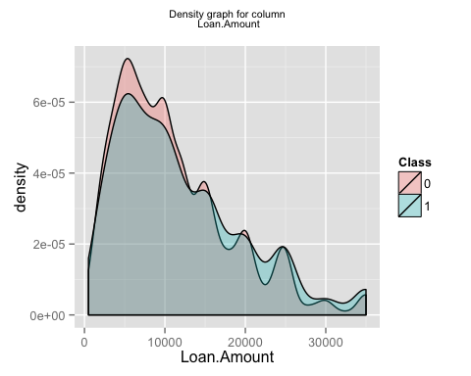

## [1] "generating graph for the column Loan.Term"

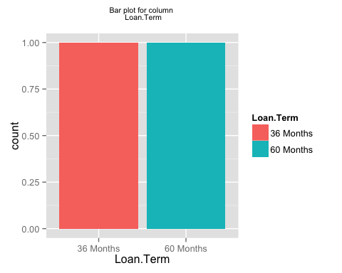

## [1] "generating graph for the column Employment.Length"

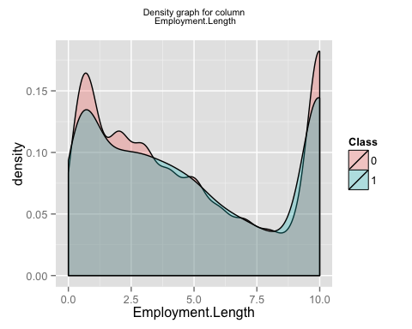

## [1] "generating graph for the column Home.Ownership"

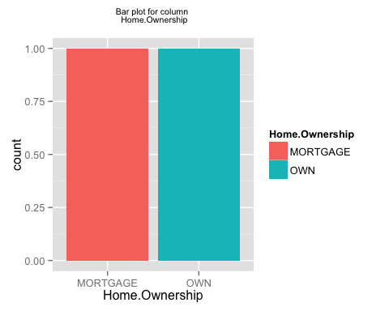

## [1] "generating graph for the column Annual.Income"

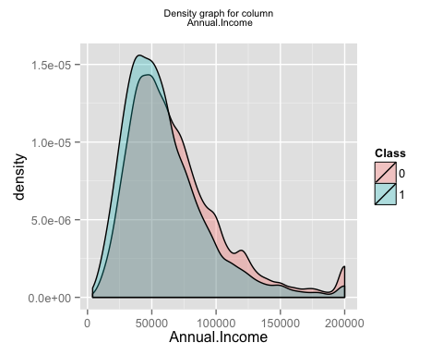

## [1] "generating graph for the column Loan.Purpose"

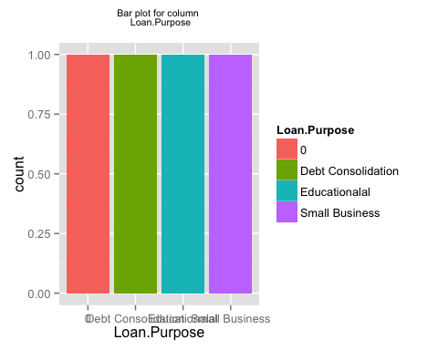

## [1] "generating graph for the column Address.State"

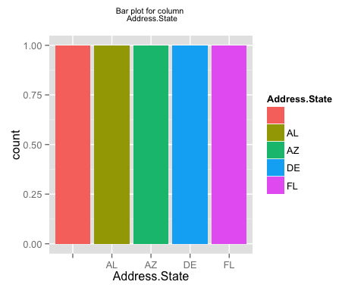

## [1] "generating graph for the column Debt.To.Income.Ratio"

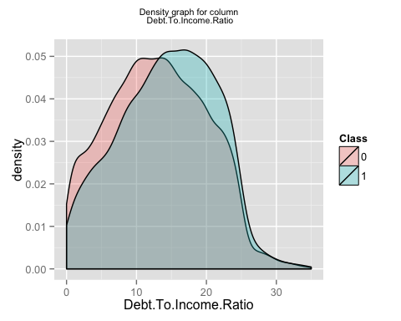

## [1] "generating graph for the column No..Delinquencies.In.Last.2.Years"

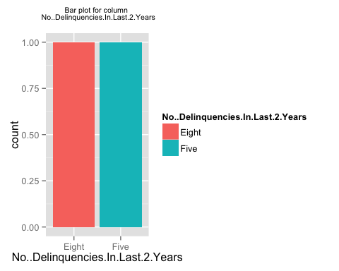

## [1] "generating graph for the column Earliest.Credit.Line.Opened"

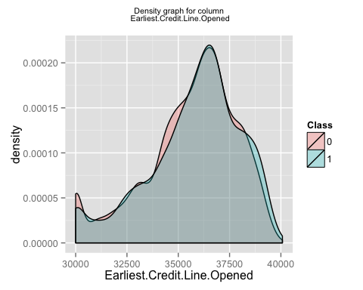

## [1] "generating graph for the column FICO.Credit.Score"

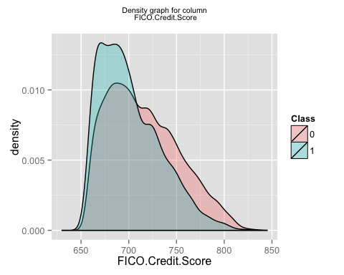

## [1] "generating graph for the column No..Inquiries.In.Last.6.Months"

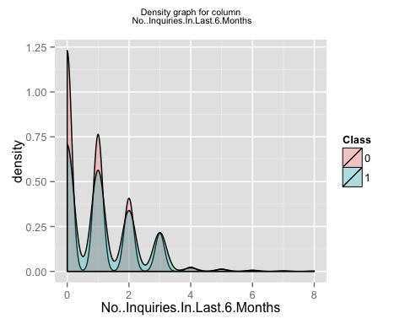

## [1] "generating graph for the column Months.Since.Last.Delinquency"

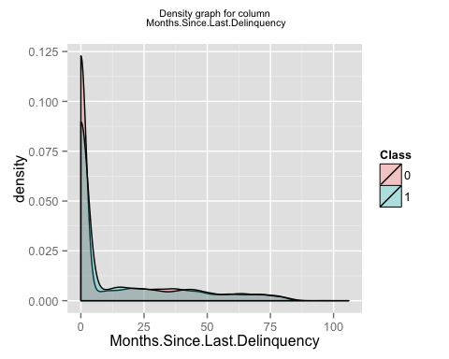

## [1] "generating graph for the column No..Of.Credit.Lines"

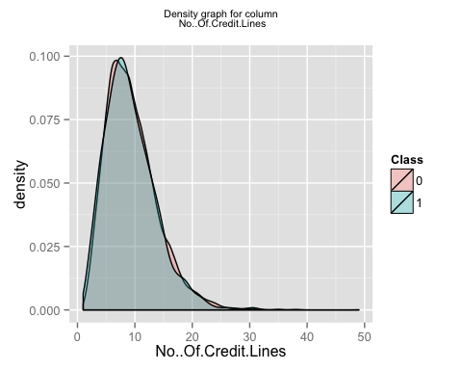

## [1] "generating graph for the column No..Adverse.Public.Records"

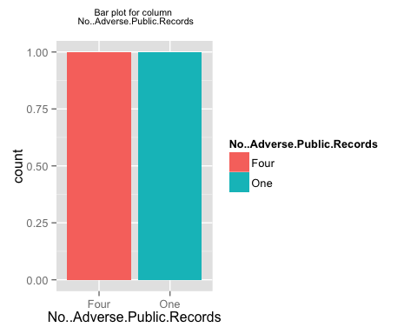

## [1] "generating graph for the column Total.Credit.Balance"

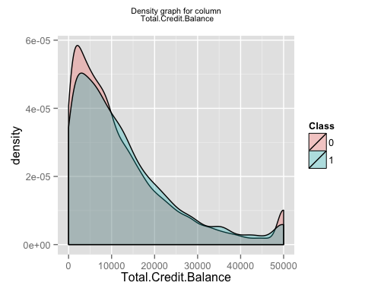

## [1] "generating graph for the column Use.Of.Credit.Line"

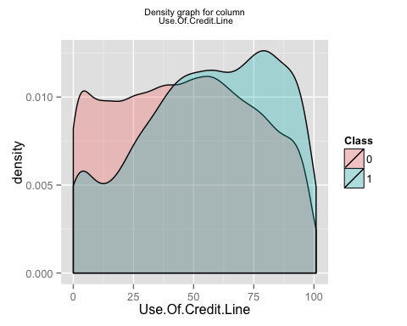

## [1] "generating graph for the column Total.Number.Of.Credit.Lines"

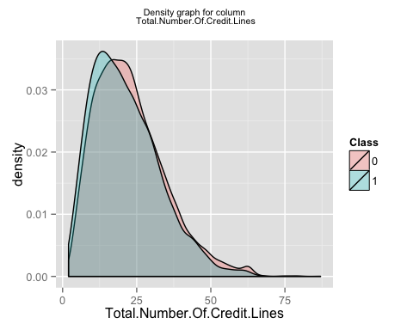

## [1] "generating graph for the column Loan.Application.Description"

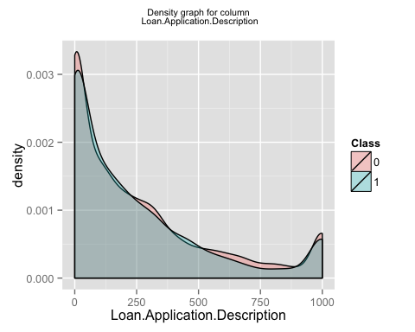

## [1] "generating graph for the column No..Of.Public.Record.Bankruptcies"

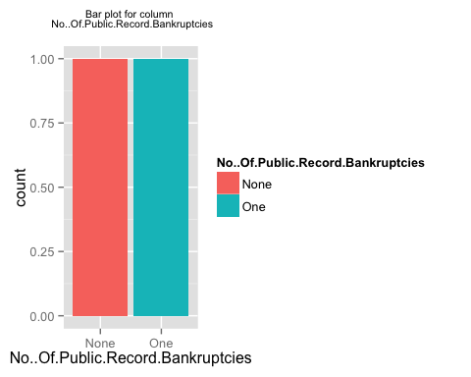

## [1] "generating graph for the column Class"

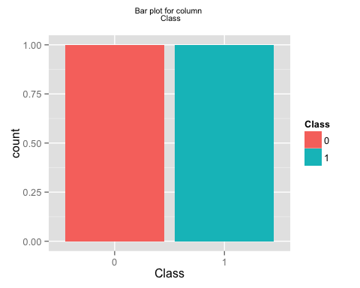

## [1] "finished generating the first set of plots i.e. individual plots for each column"  
## [1] "now generating the second set of plots i.e. plots for a pair of columns"

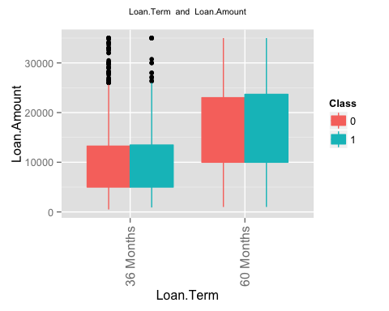 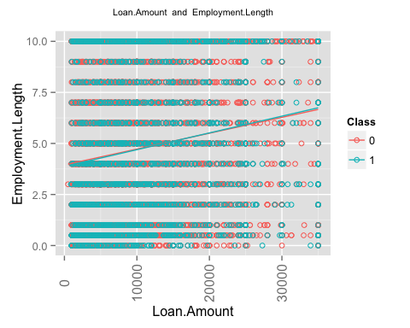 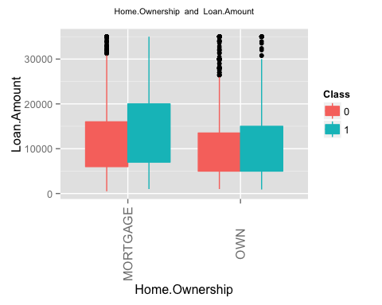 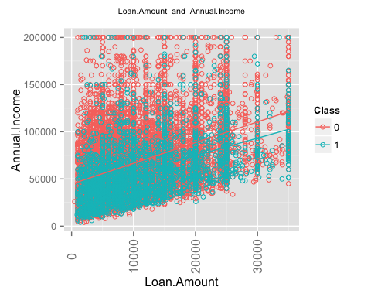 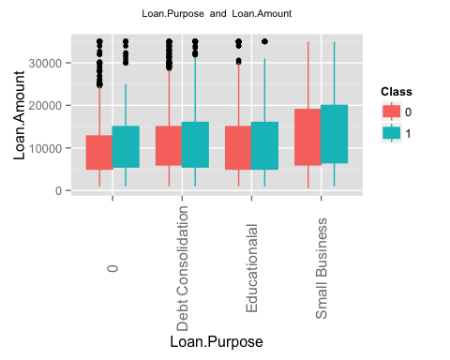 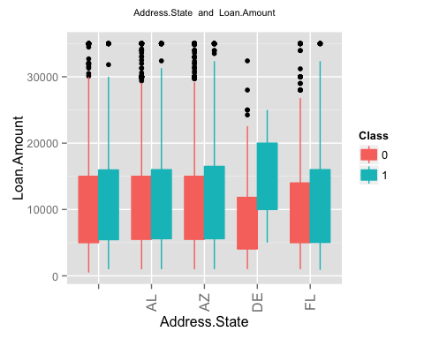 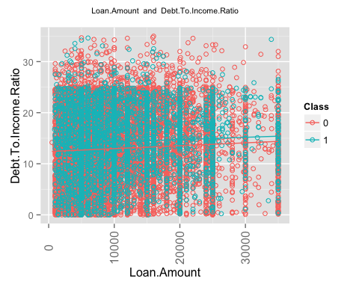 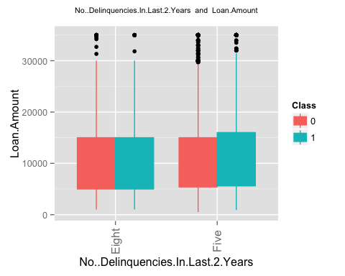 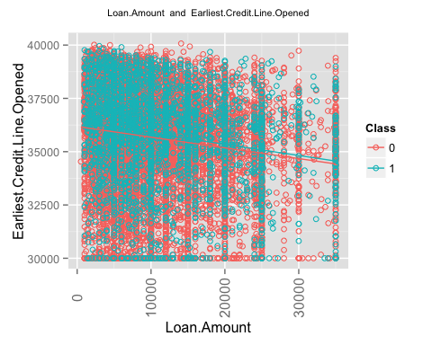 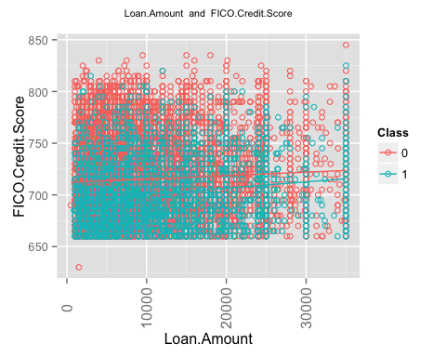 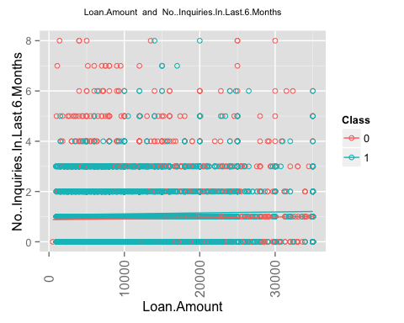 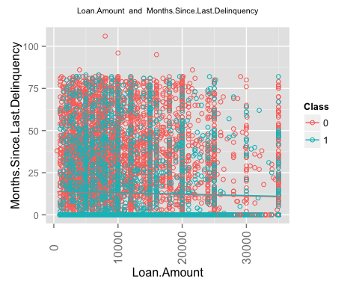 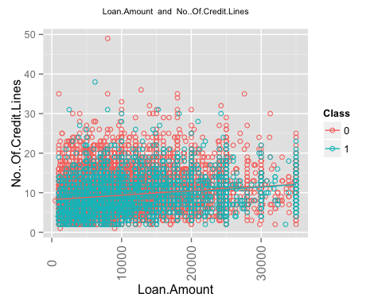 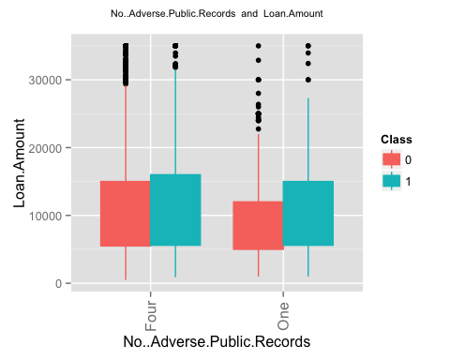 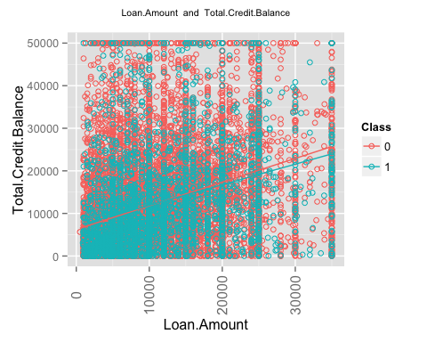 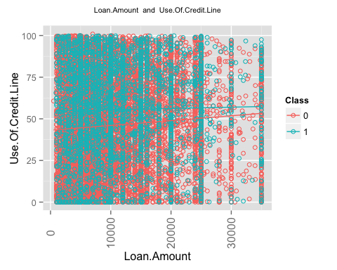 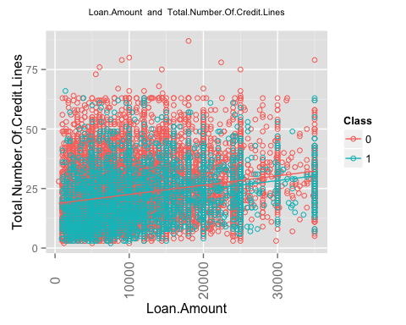 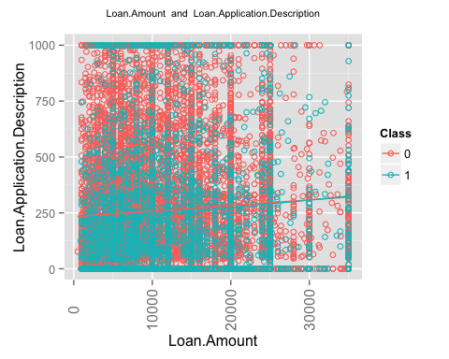 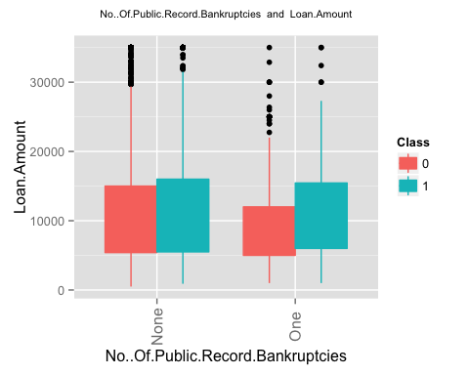 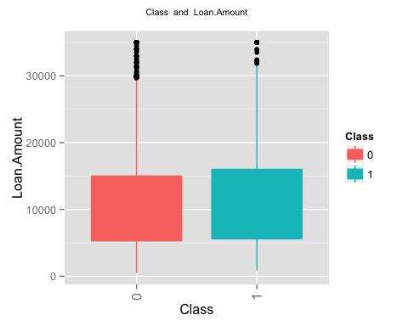 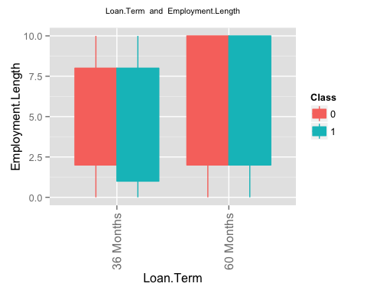 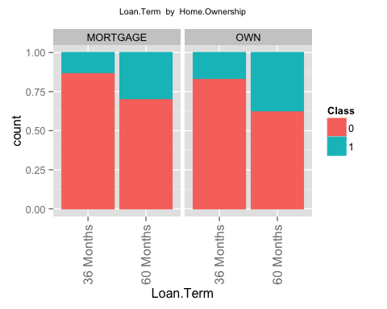 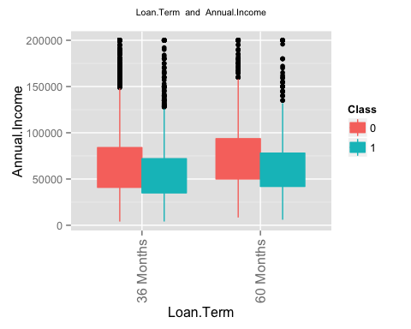 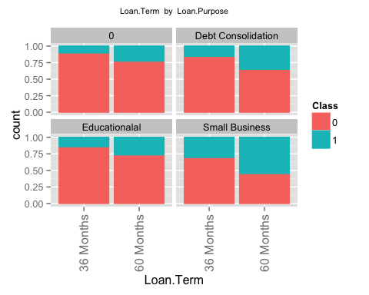 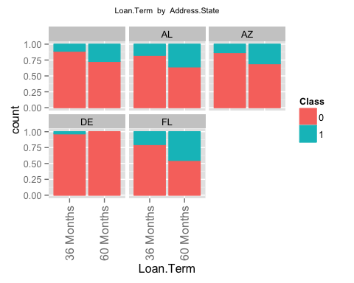 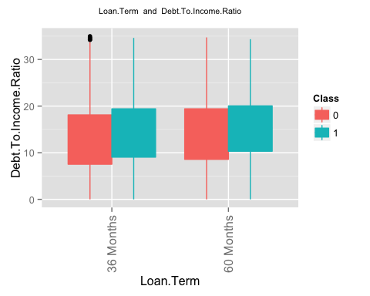 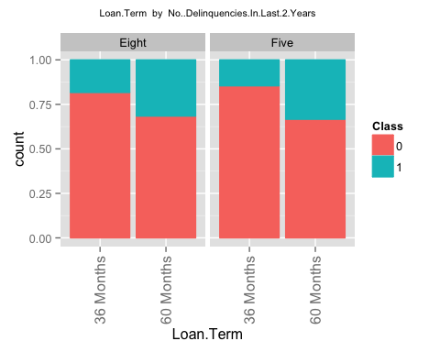 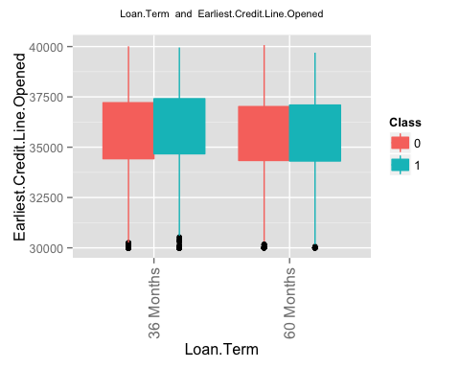 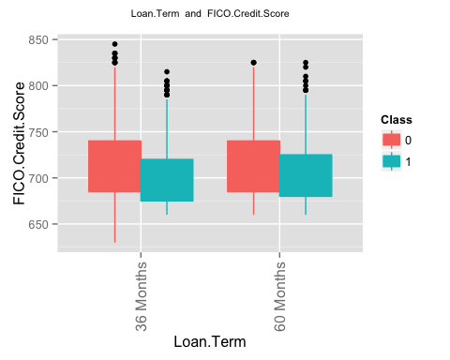 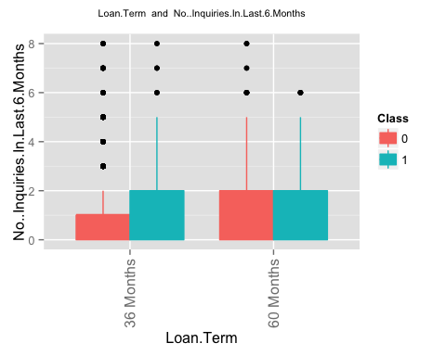 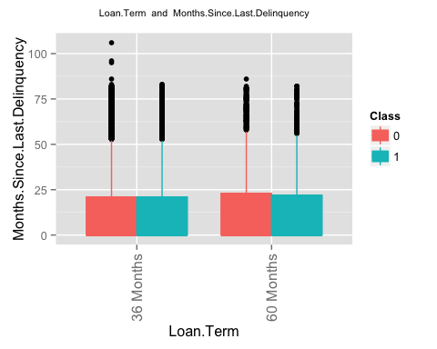 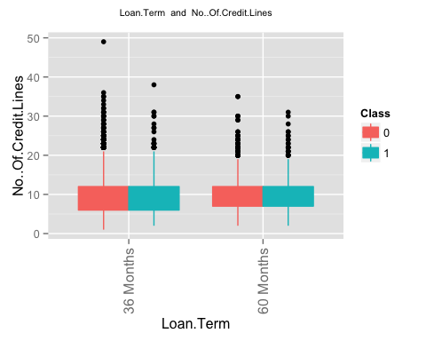 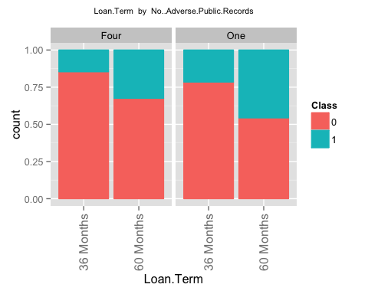 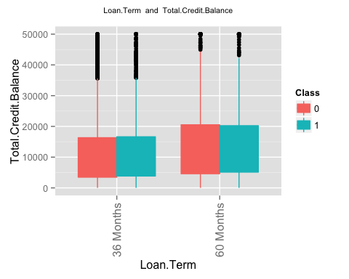 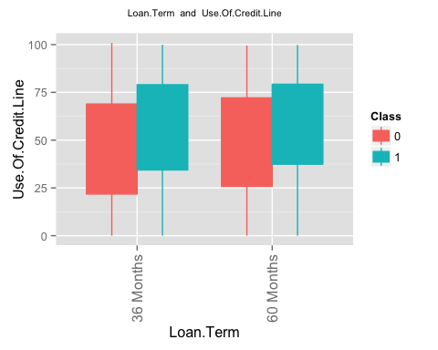 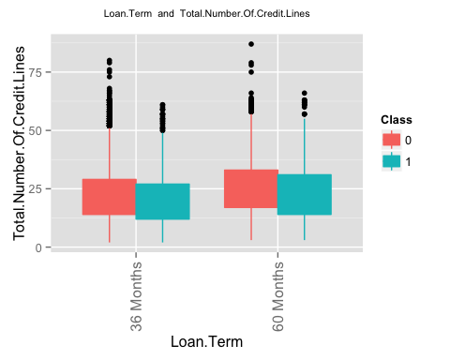 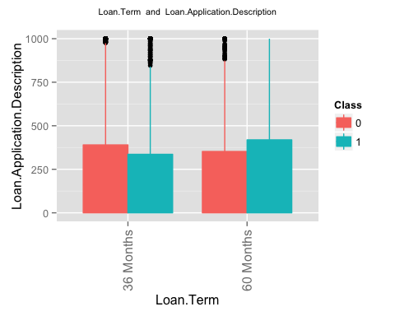 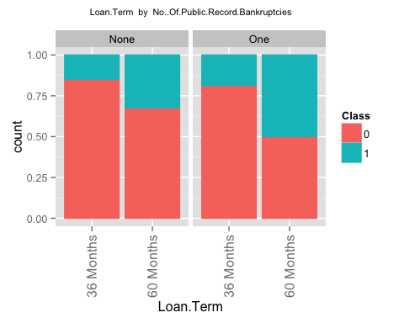 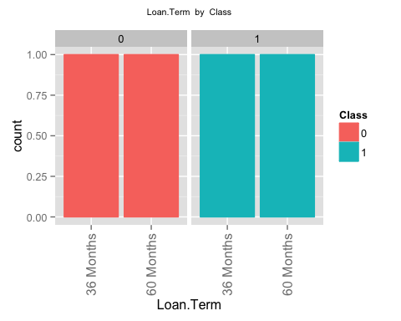 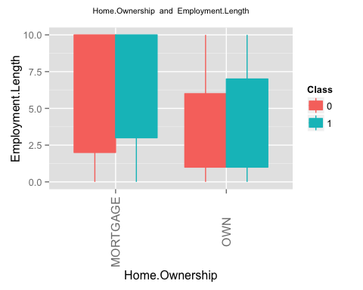 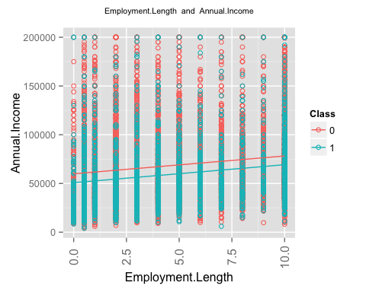 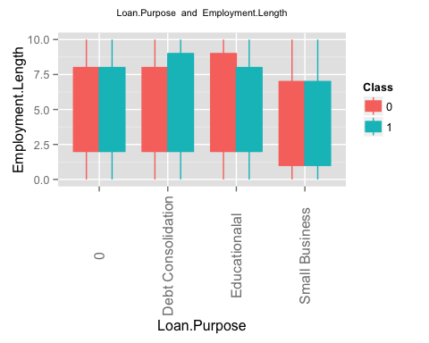 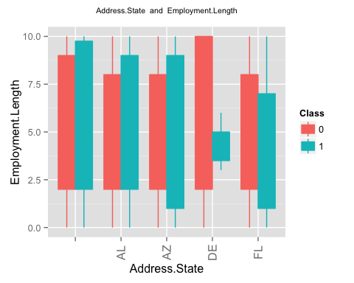 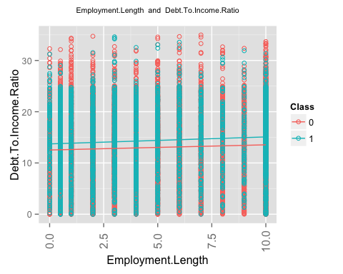 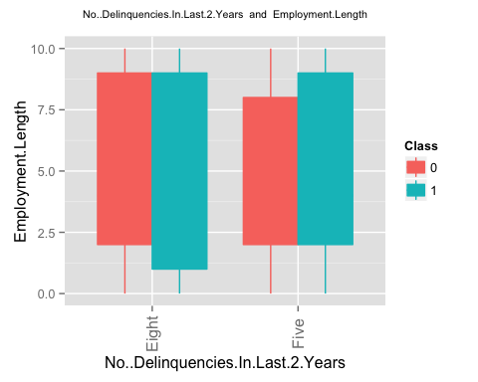 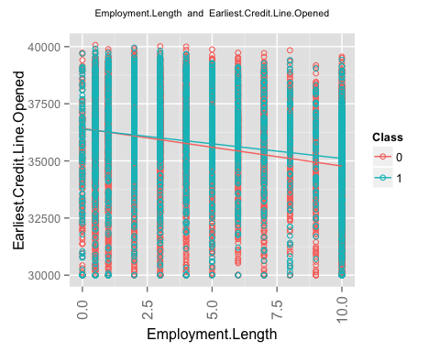 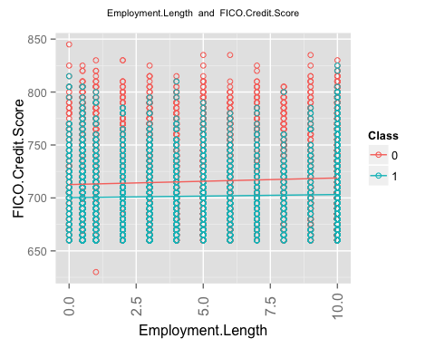 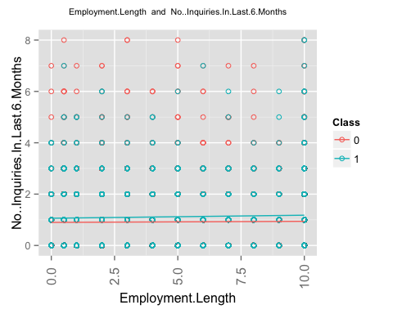 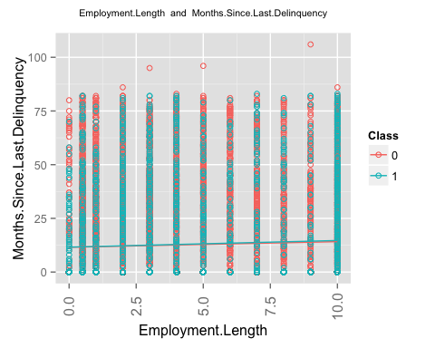 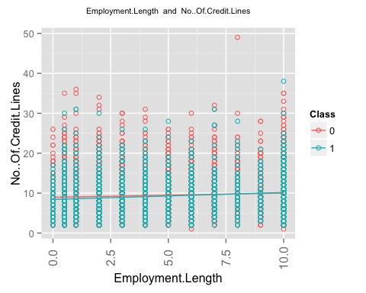 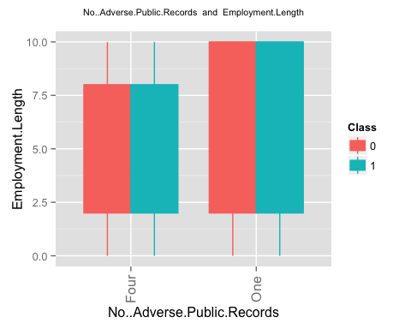 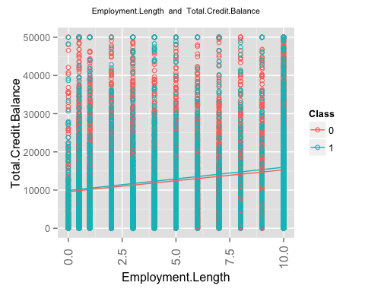 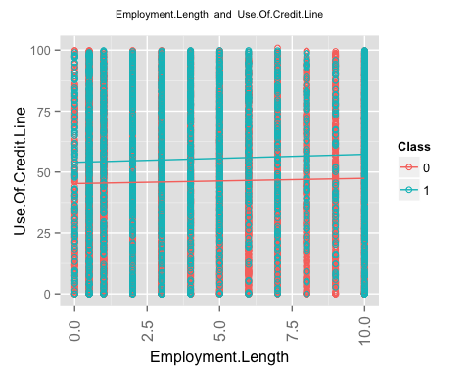 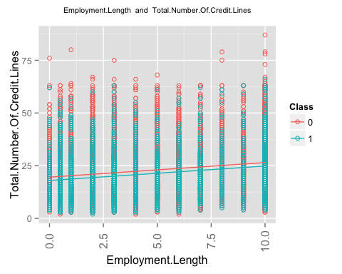 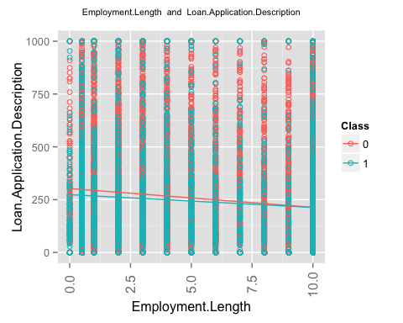 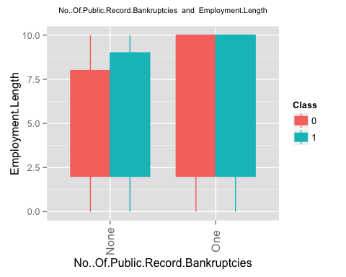 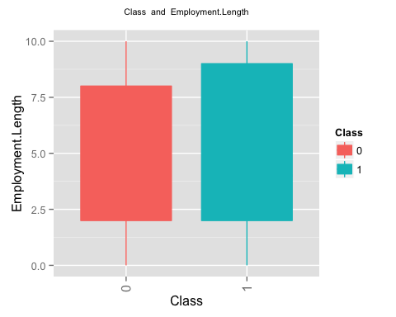 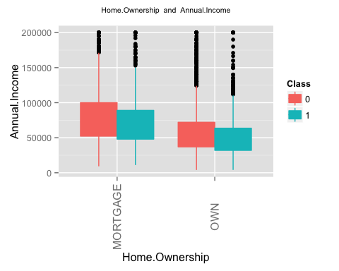 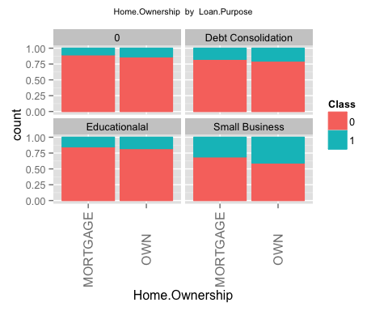 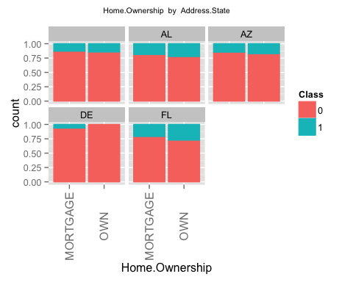 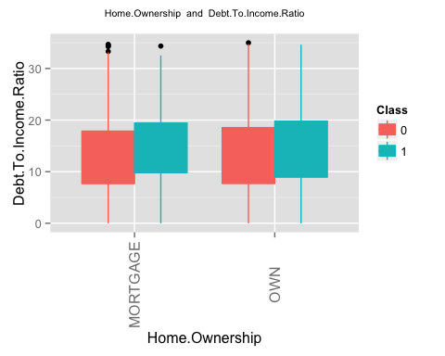 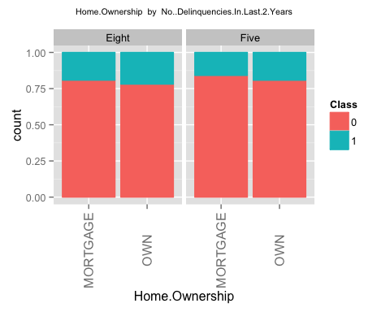 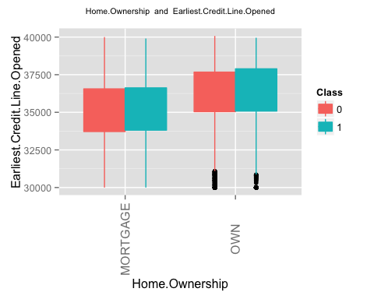 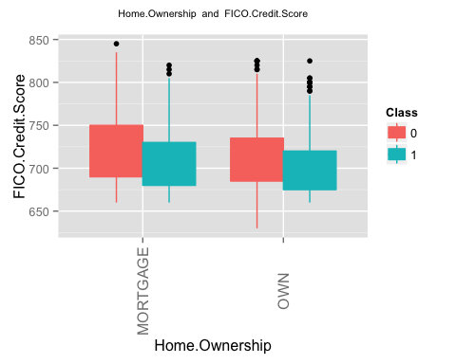 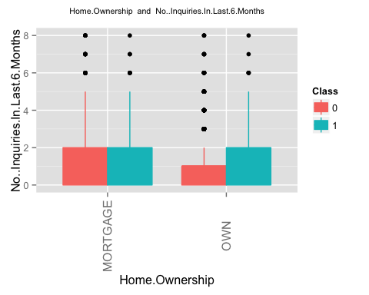 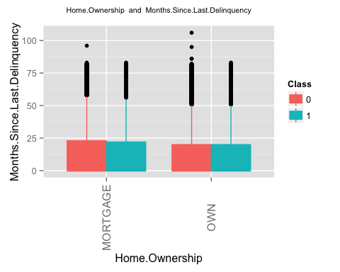 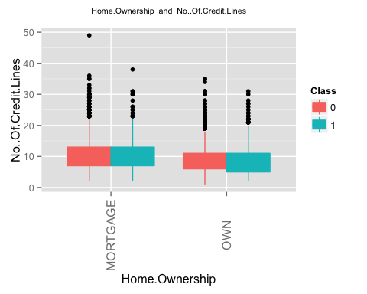 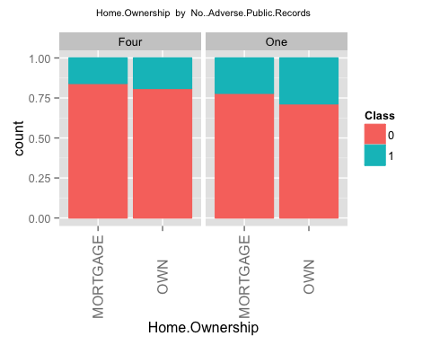 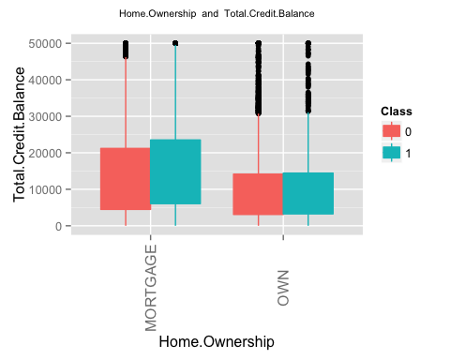 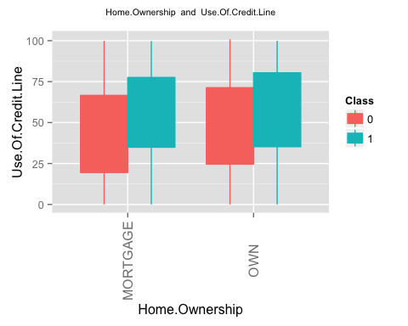 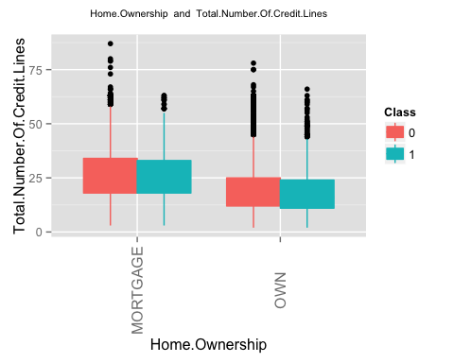 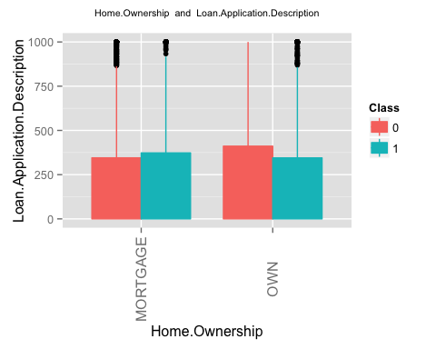 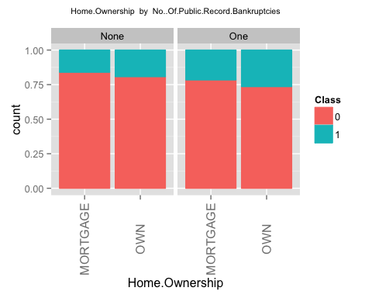 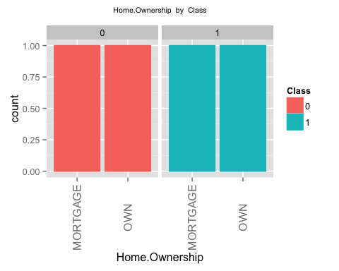 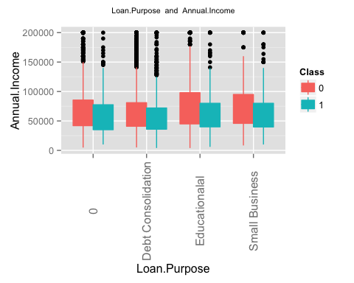 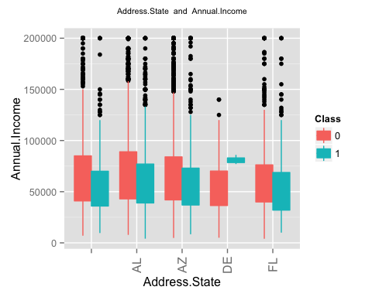 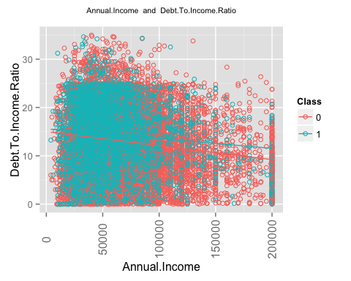 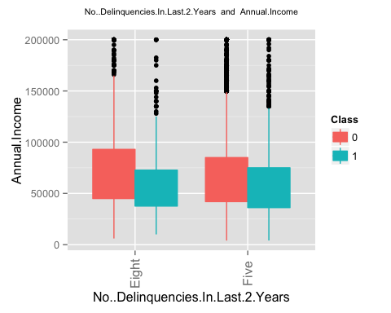 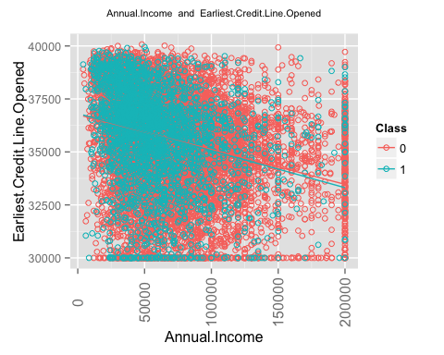 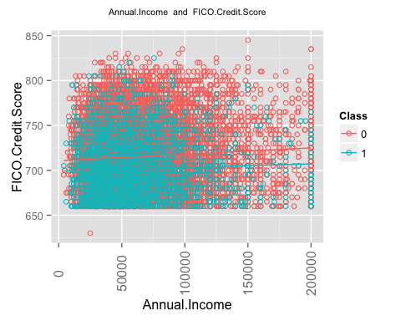 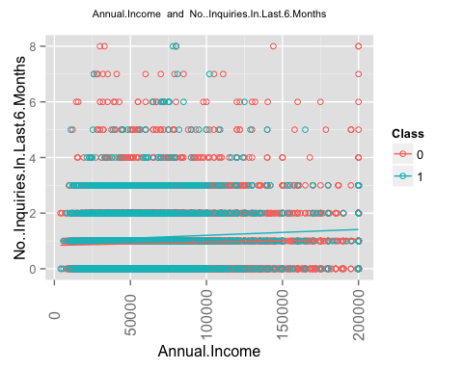 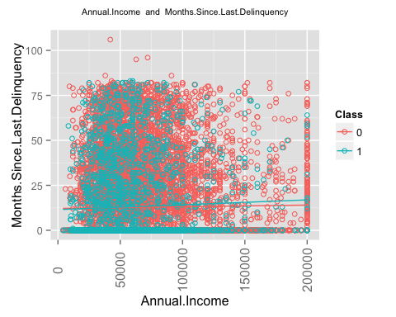 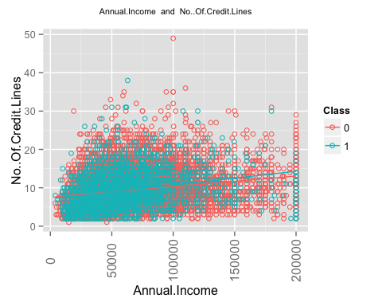 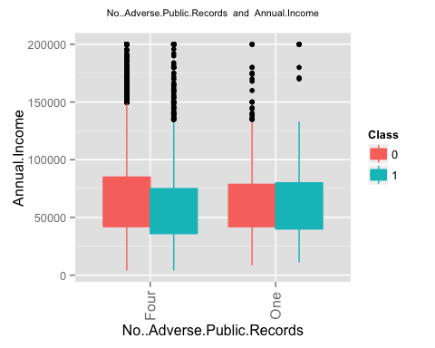 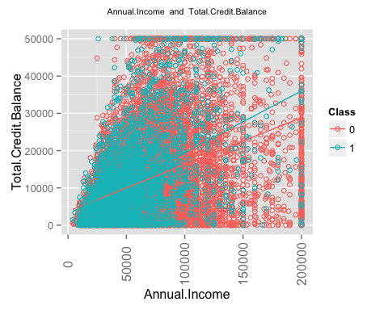 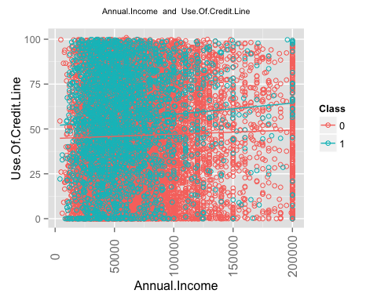 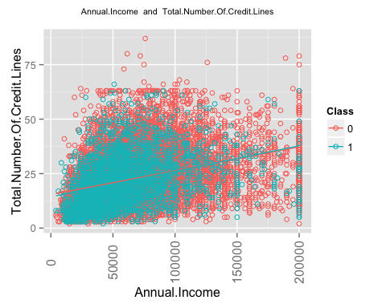 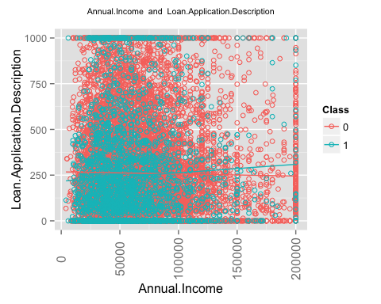 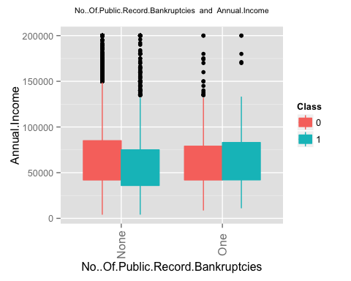 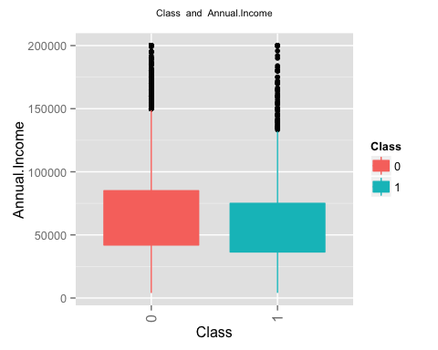 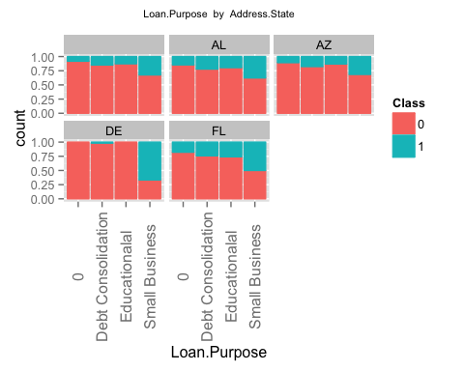 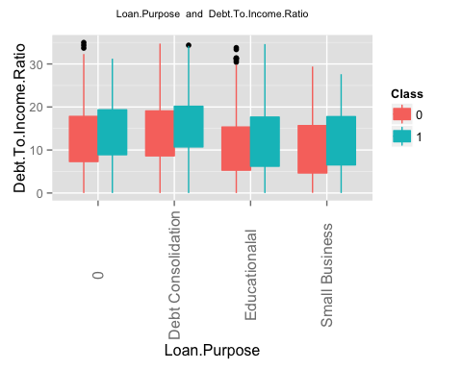 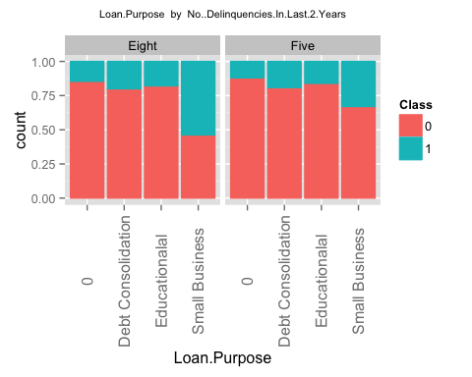 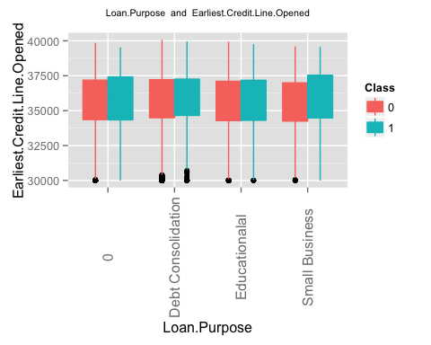 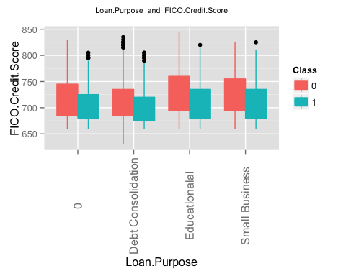 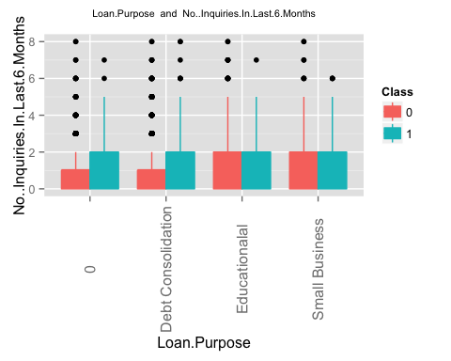 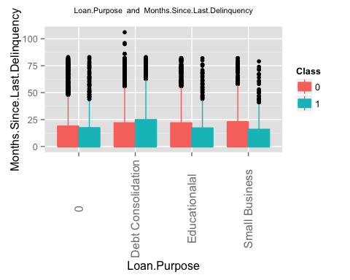 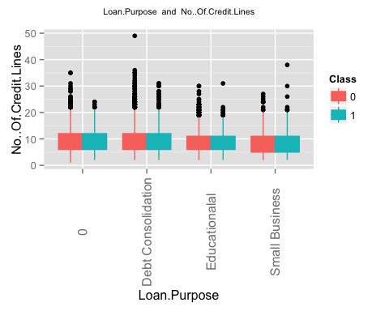 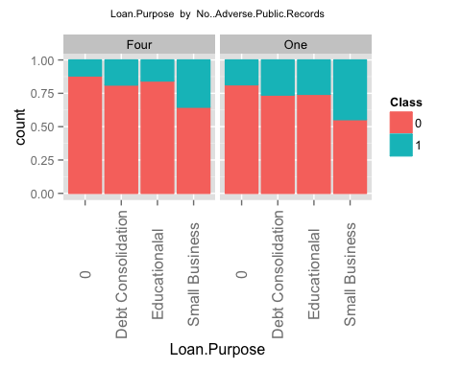 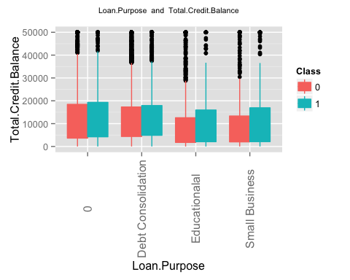 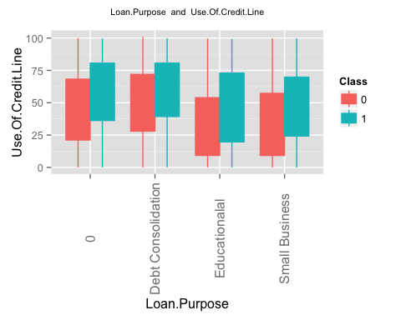 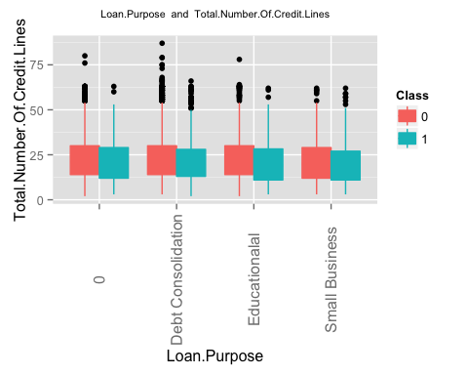 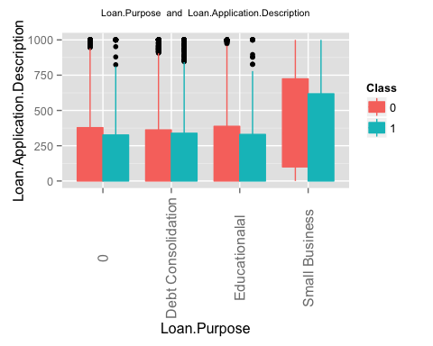 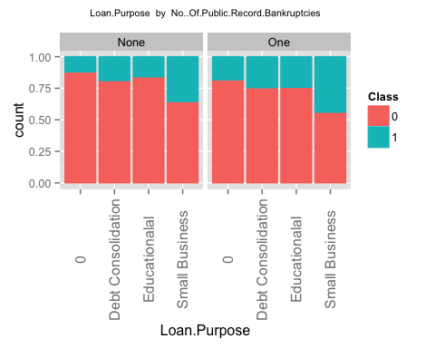 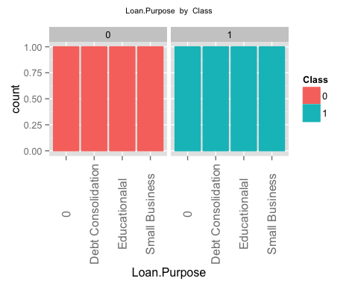 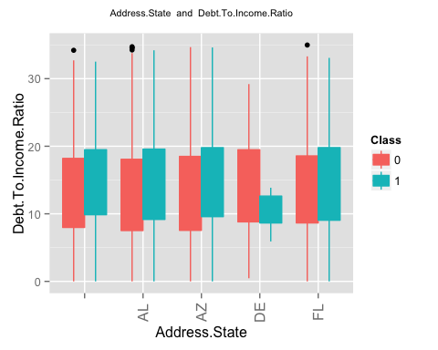 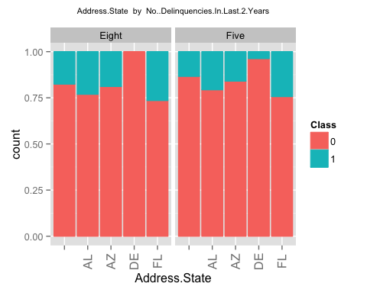 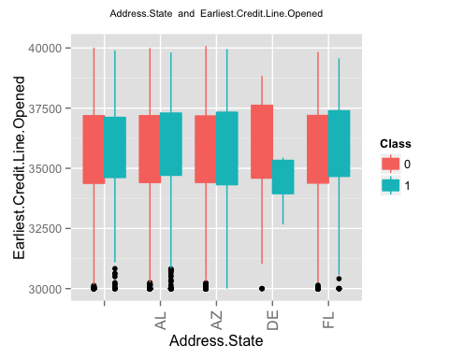 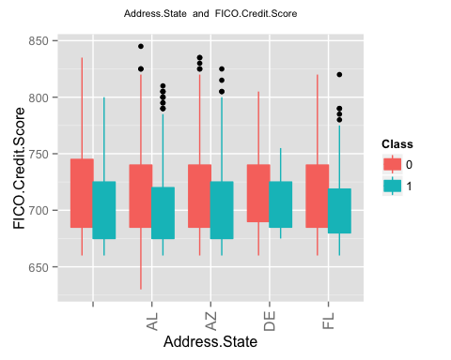 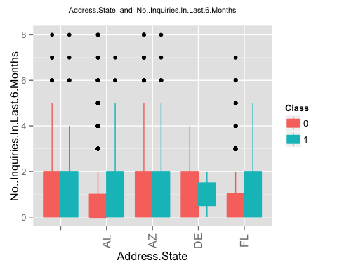 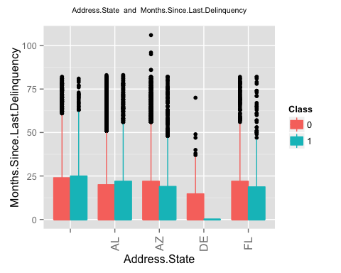 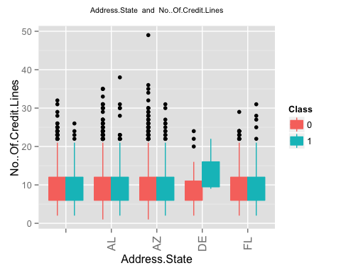 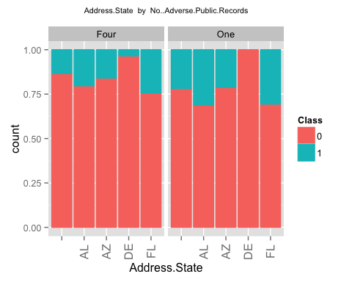 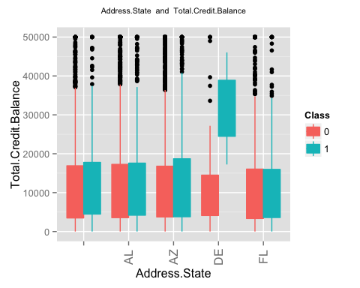 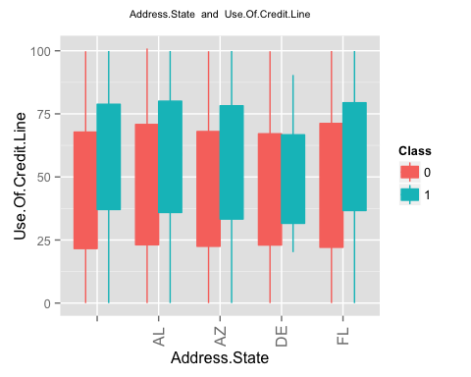 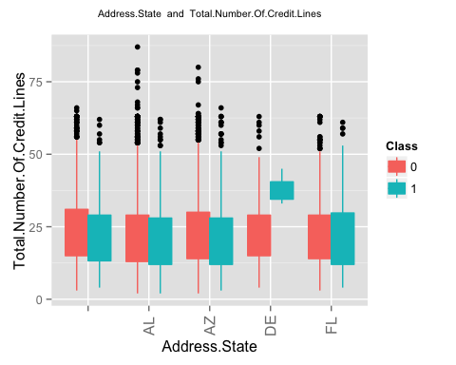 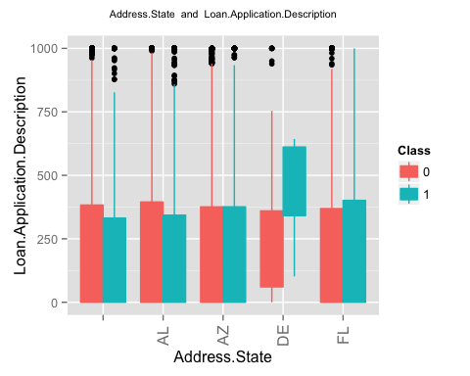 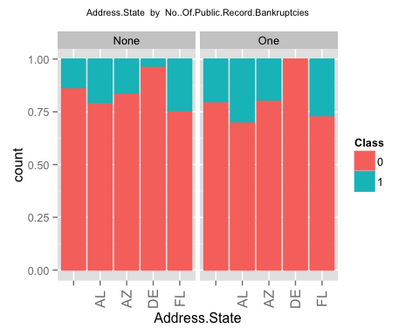 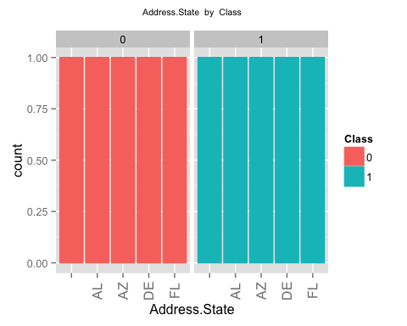 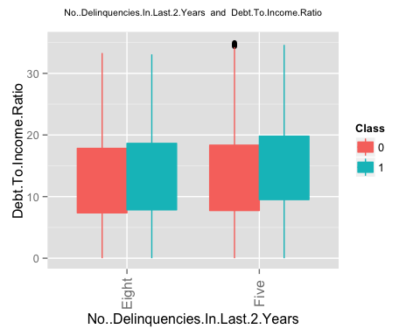 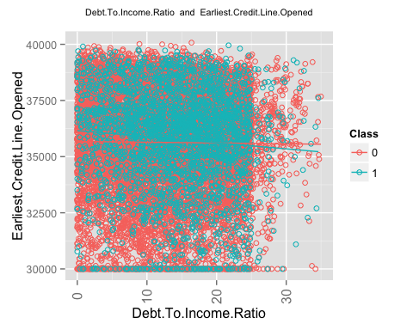 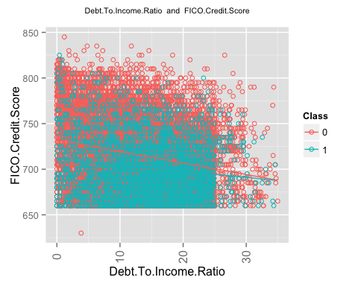 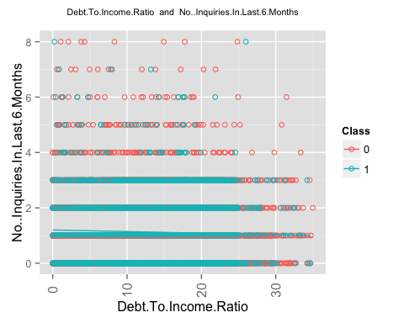 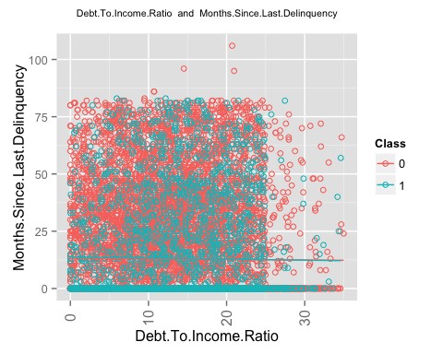 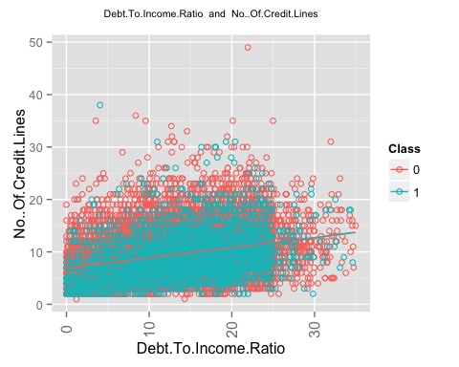 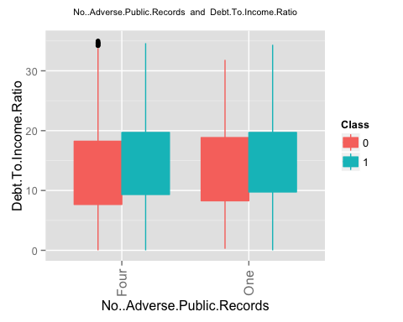 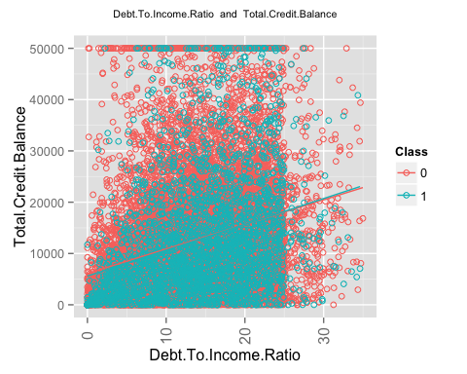 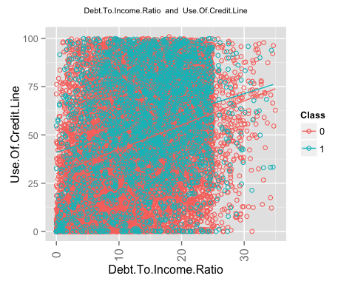 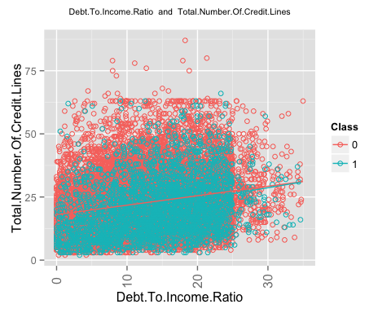 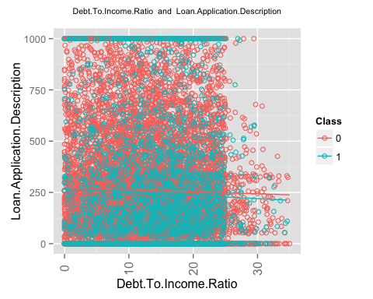 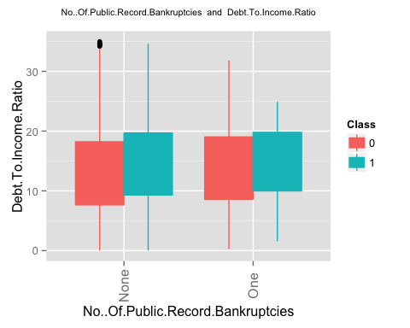 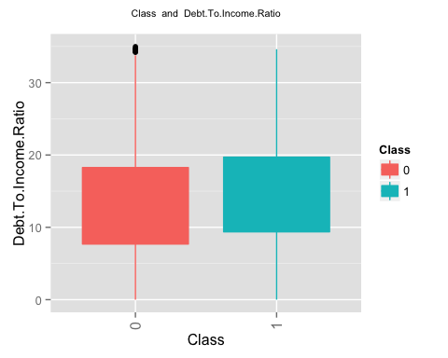 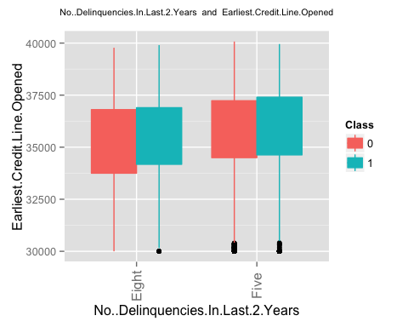 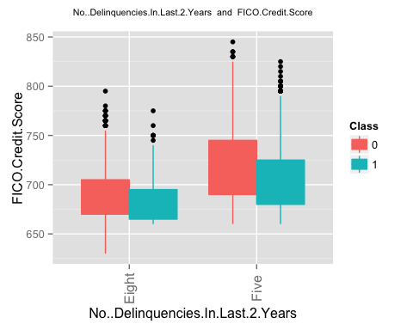 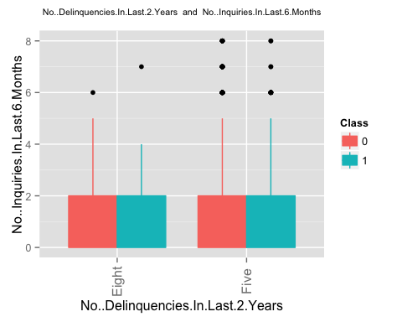 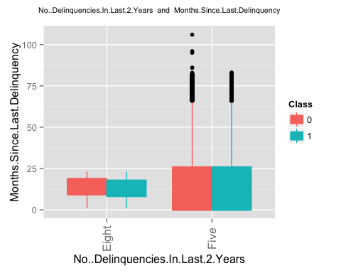 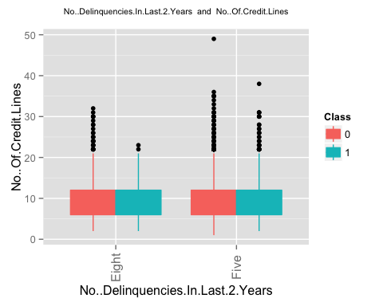 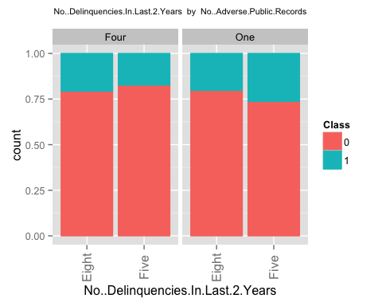 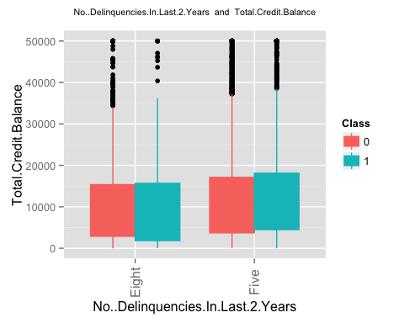 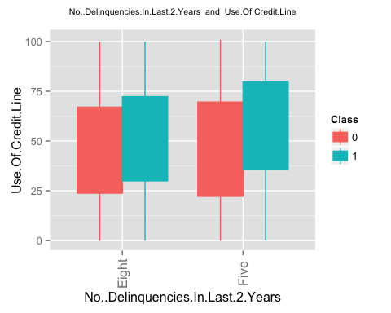 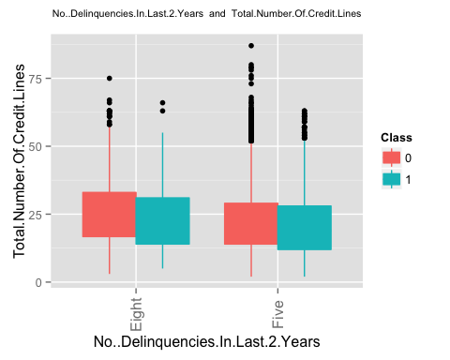 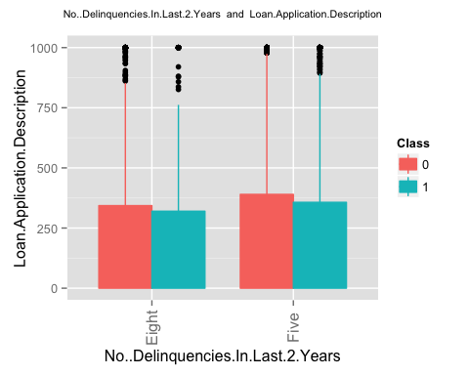 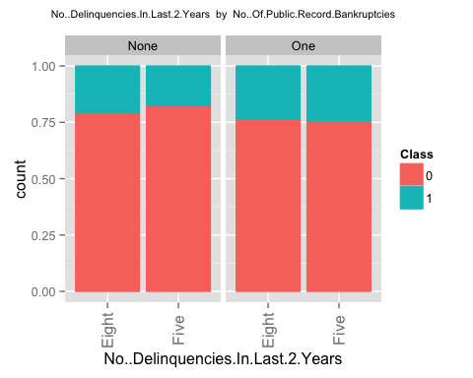 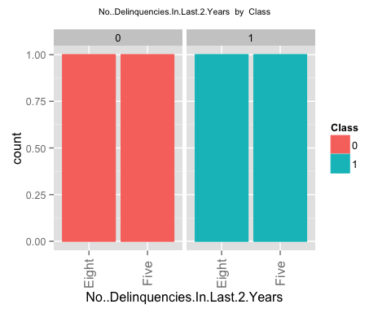 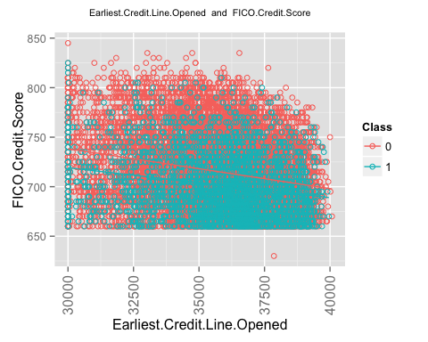 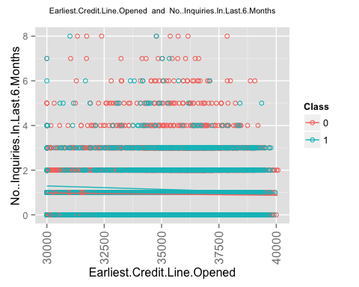 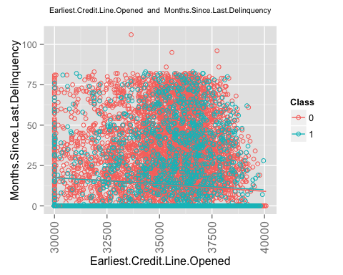 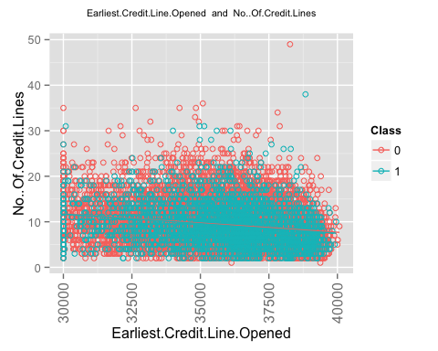 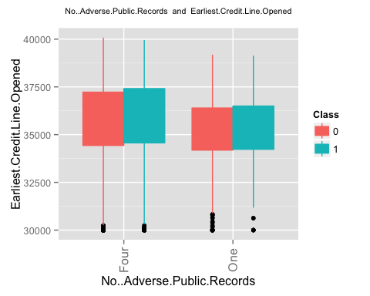 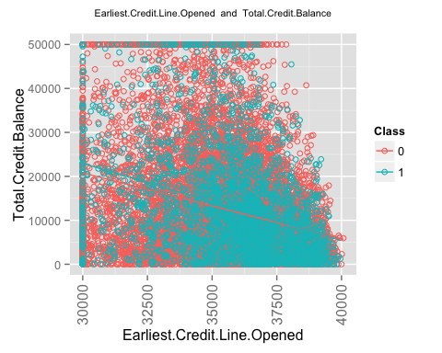 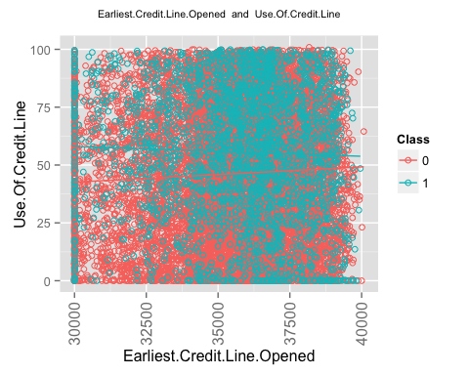 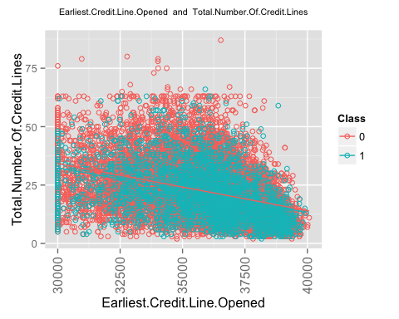 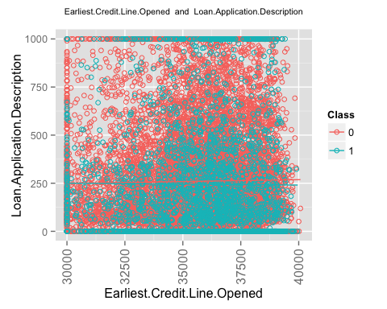 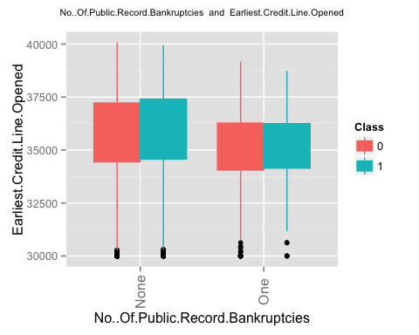 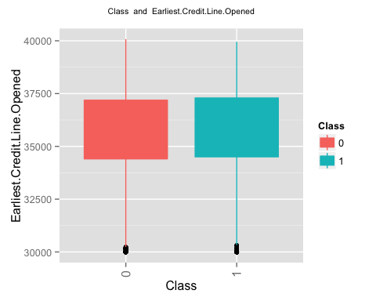 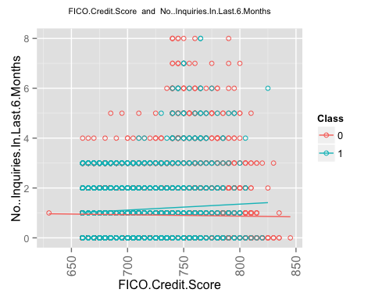 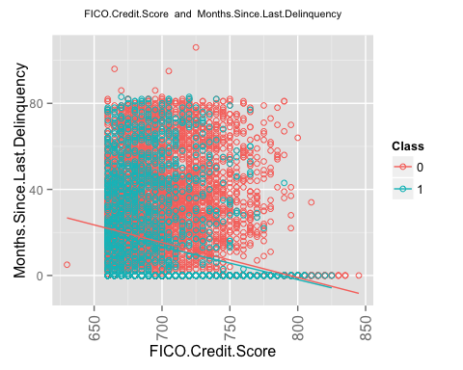 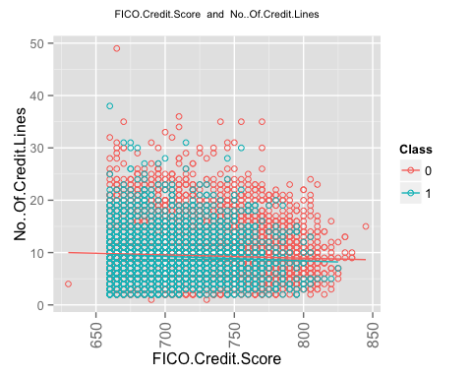 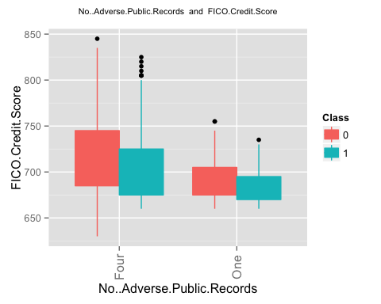 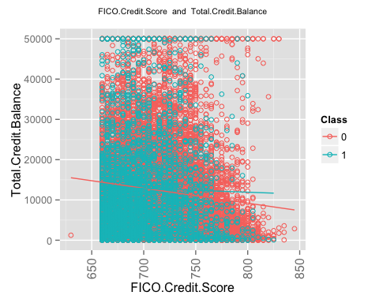 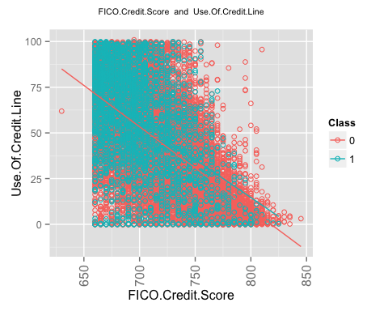 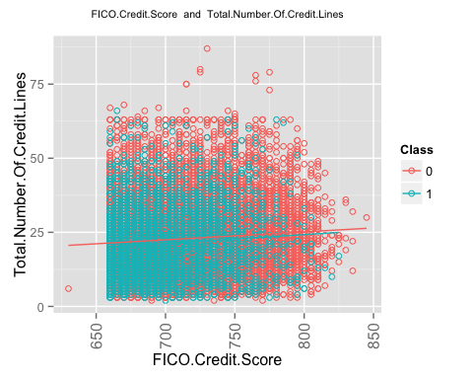 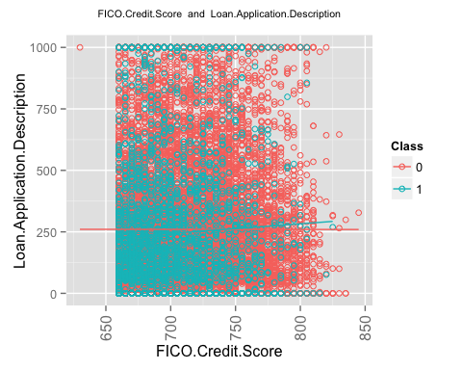 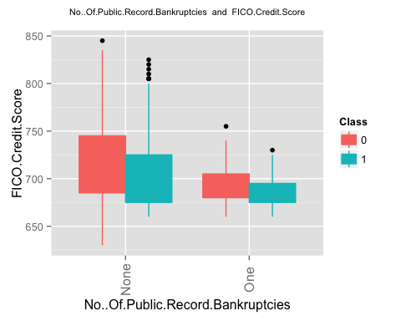 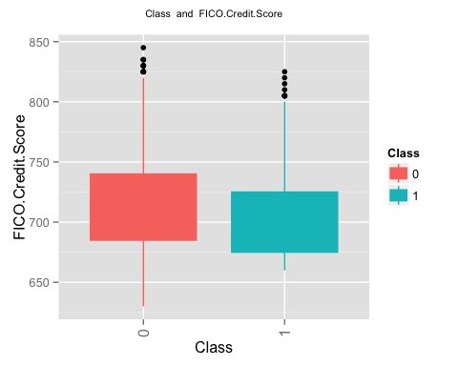 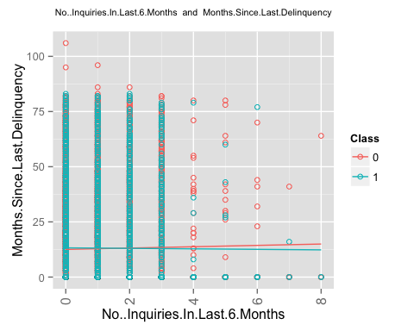 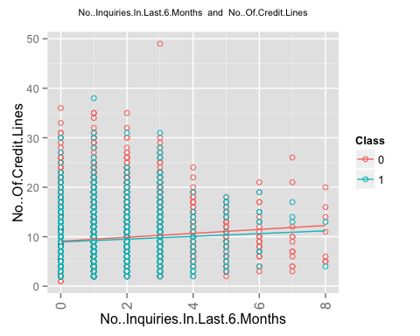 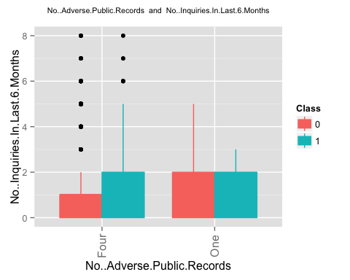 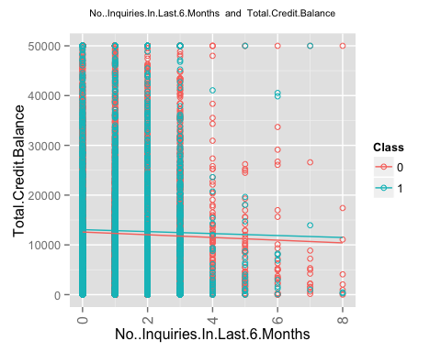 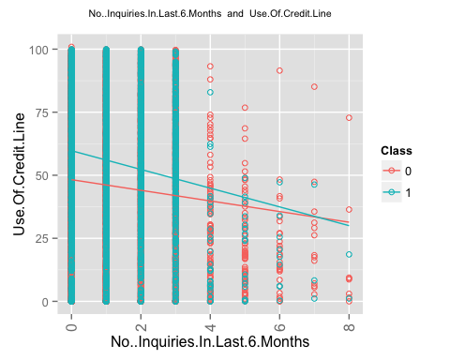 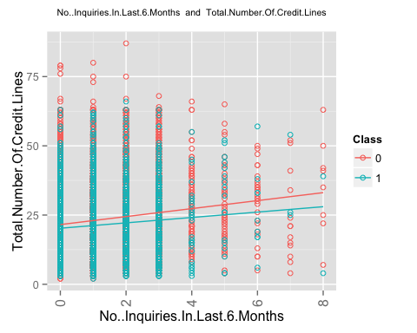 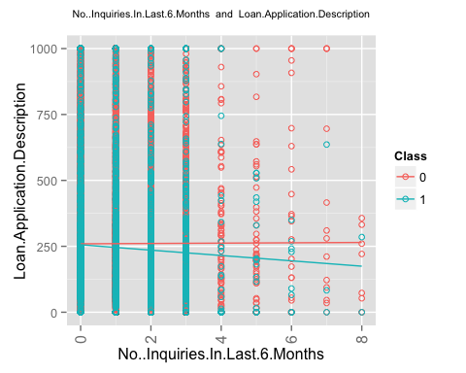 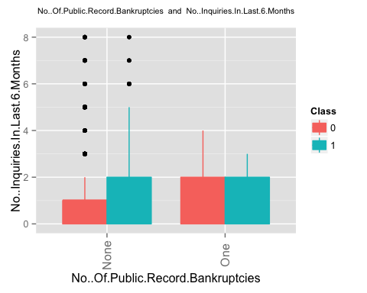 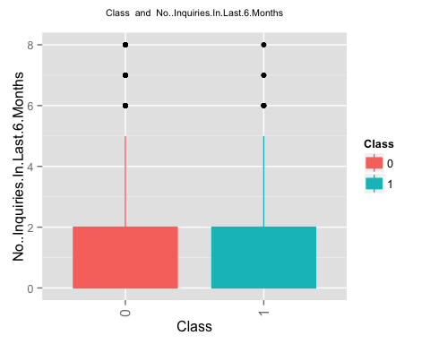 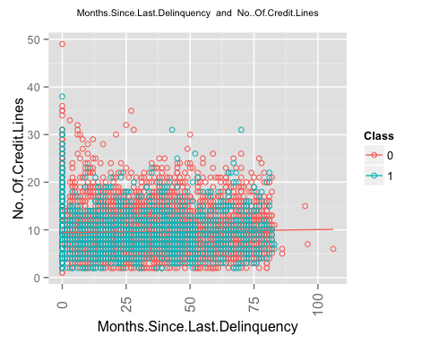 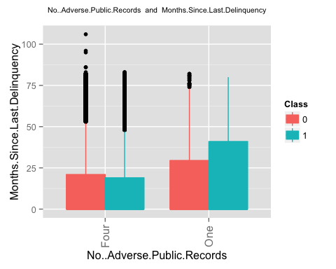 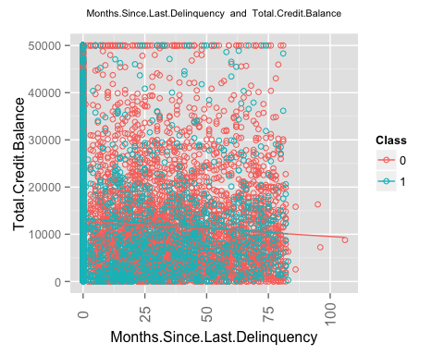 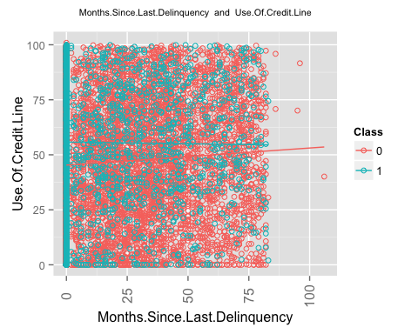 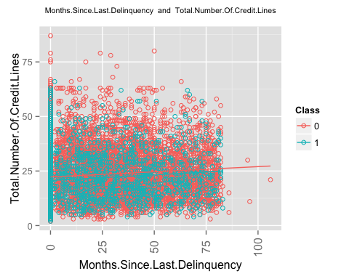 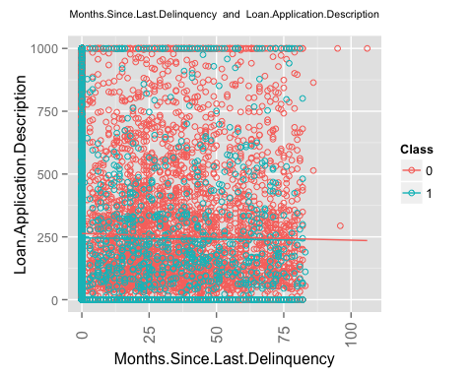 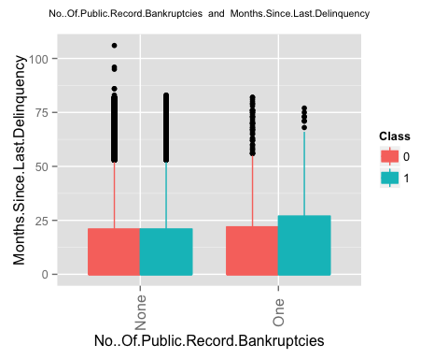 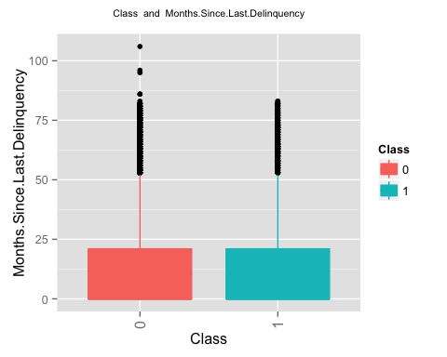 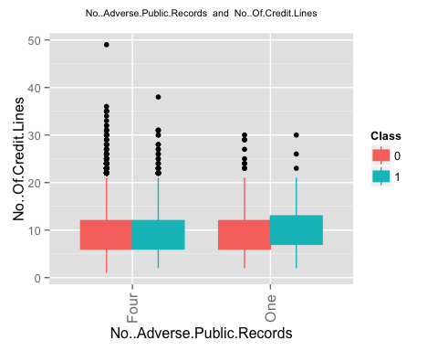 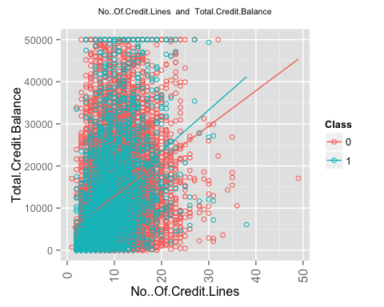 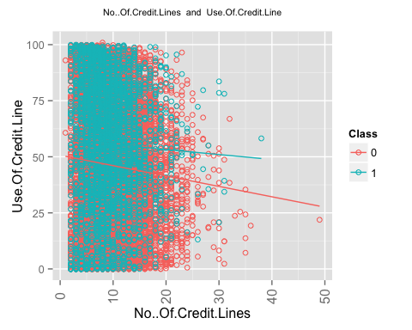 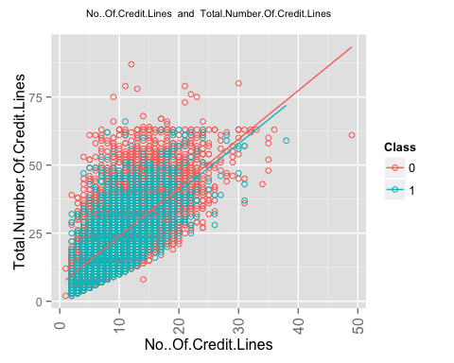 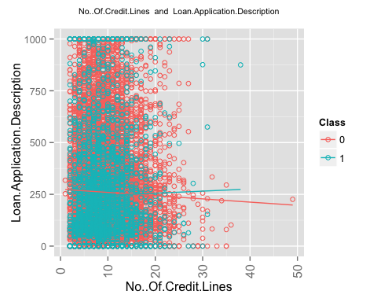 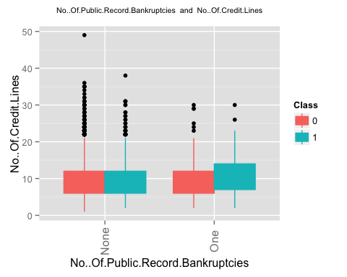 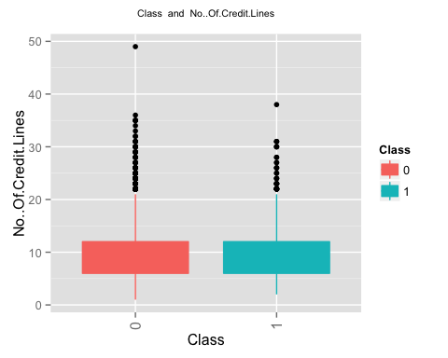 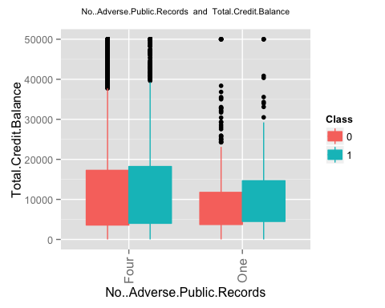 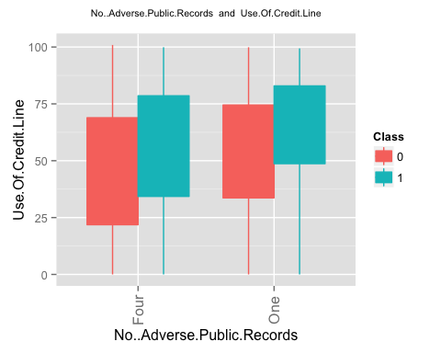 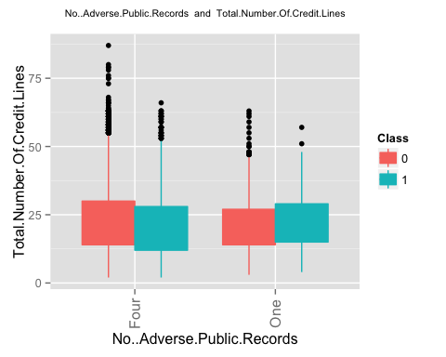 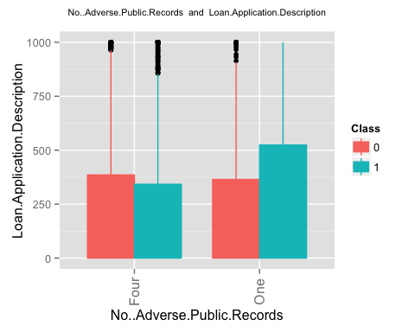 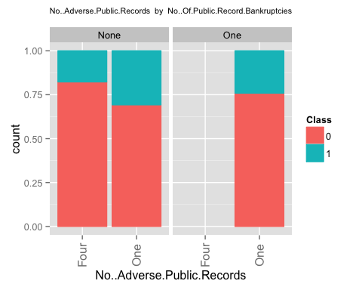 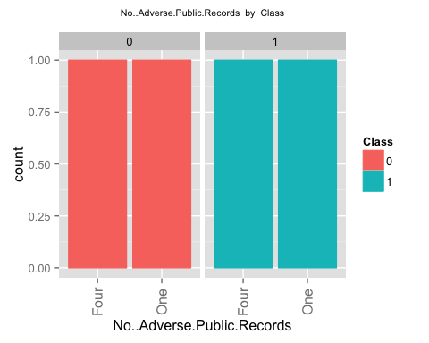 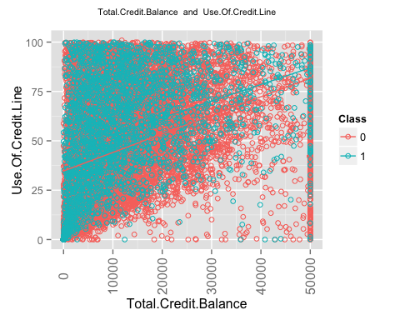 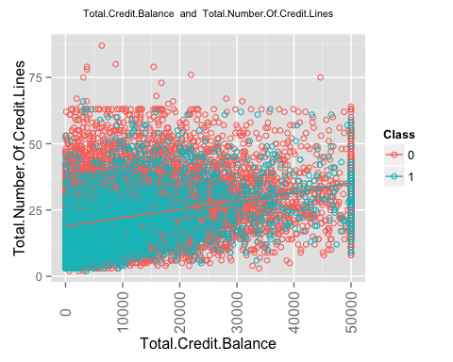 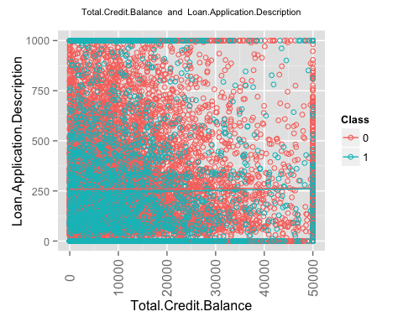 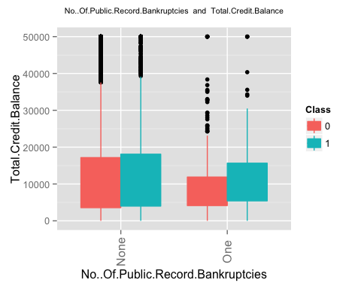 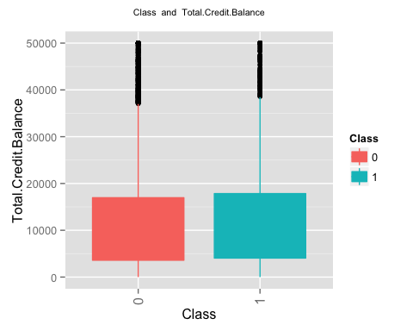 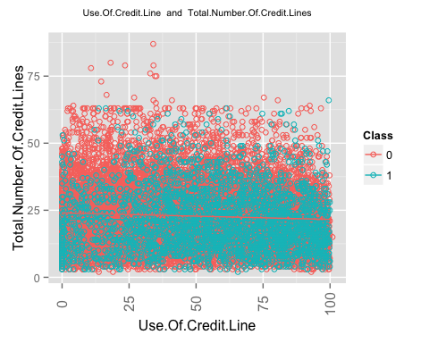 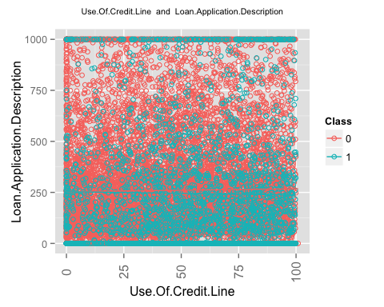 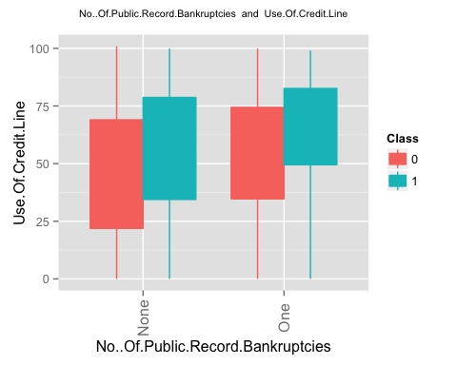 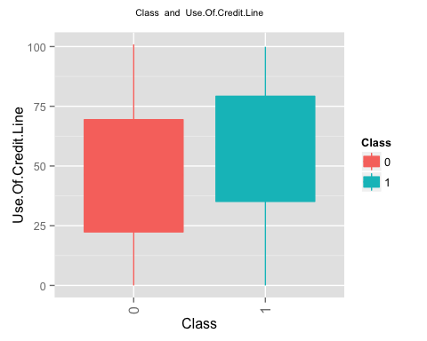 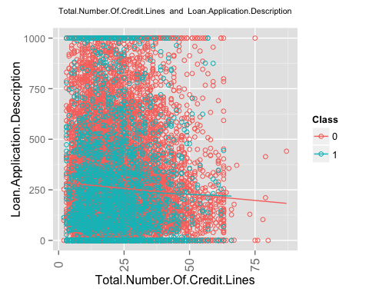 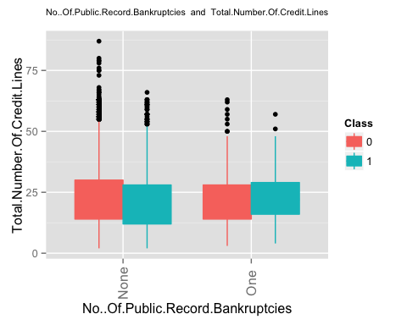 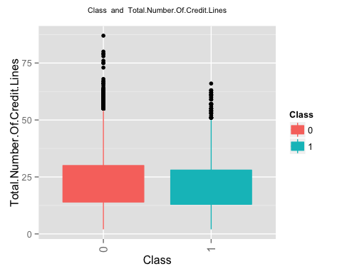 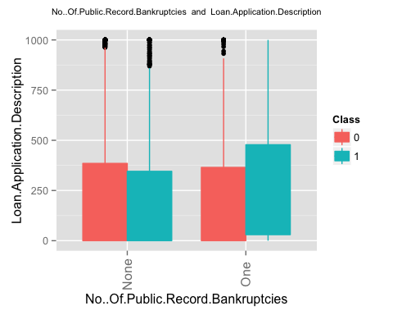 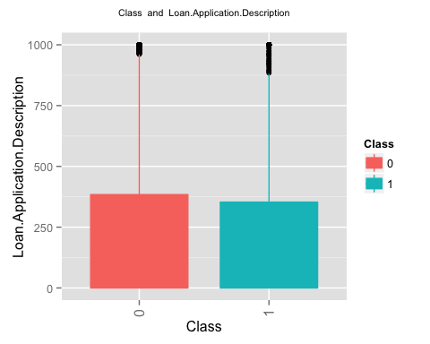

## [1] "finished generating the second set of plots i.e. plots for a pair of columns"

#  
# Now run the feature selection process. It will do following.  
# 1. It will find the top 20 features using random forest  
# 2. It will run a logistic regression based on a single column at a time.  
# 3. It will run a logistic regression based on interaction of just 2 columns at a time.  
# 4. It wil generate a decision tree based on single column at a time.  
# 5. It will generate a decision tree based on 2 column at a time.  
  
frml1 <- as.formula('Class ~ .')  
findusefulfeatures(train_data,alpha = 0.05,ranking='accuracy',k=20,frml1,ntree=100,cp = 0.001)

## [1] 1 11 12 13 14 16 18 19  
## [1] 1 3 5 8 10 11 12 13 14 16 17 18 19  
## [1] 1 2 3 4 5 6 7 8 9 10 11 12  
## col1 col1_pvalue  
## 2 Loan.Amount 5.447427e-10  
## 3 Loan.Term 3.014354e-109  
## 4 Employment.Length 1.951919e-01  
## 5 Home.Ownership 2.942695e-07  
## 6 Annual.Income 1.008072e-29  
## 7 Loan.Purpose 1.838044e-54  
## 8 Address.State 2.797006e-25  
## 9 Debt.To.Income.Ratio 3.034988e-18  
## 10 No..Delinquencies.In.Last.2.Years 4.320257e-03  
## 11 Earliest.Credit.Line.Opened 3.892871e-06  
## 12 FICO.Credit.Score 5.720770e-57  
## 13 No..Inquiries.In.Last.6.Months 4.438187e-10  
## 14 Months.Since.Last.Delinquency 1.808097e-01  
## 15 No..Of.Credit.Lines 0.000000e+00  
## 16 No..Adverse.Public.Records 1.564228e-08  
## 17 Total.Credit.Balance 2.456128e-02  
## 18 Use.Of.Credit.Line 5.018697e-49  
## 19 Total.Number.Of.Credit.Lines 7.113617e-08  
## 20 Loan.Application.Description 1.162155e-02  
## 21 No..Of.Public.Record.Bankruptcies 7.682202e-05  
## [1] "here"  
## 'data.frame': 20 obs. of 4 variables:  
## $ 0 : num 16.22 14.81 6.9 3.54 17.83 ...  
## $ 1 : num -5.3771 14.9818 -0.0887 -0.4873 0.6029 ...  
## $ MeanDecreaseAccuracy: num 15.16 21.67 6.6 2.94 17.62 ...  
## $ MeanDecreaseGini : num 347 138 219 42 414 ...  
## NULL  
## [1] "top ranked features based on random forest accuracy"  
## [1] "Loan.Term"   
## [2] "FICO.Credit.Score"   
## [3] "Total.Number.Of.Credit.Lines"   
## [4] "Annual.Income"   
## [5] "Use.Of.Credit.Line"   
## [6] "Total.Credit.Balance"   
## [7] "Loan.Amount"   
## [8] "Earliest.Credit.Line.Opened"   
## [9] "Loan.Purpose"   
## [10] "No..Of.Credit.Lines"   
## [11] "Months.Since.Last.Delinquency"   
## [12] "Debt.To.Income.Ratio"   
## [13] "Employment.Length"   
## [14] "No..Delinquencies.In.Last.2.Years"  
## [15] "No..Adverse.Public.Records"   
## [16] "Address.State"   
## [17] "No..Inquiries.In.Last.6.Months"   
## [18] "Home.Ownership"   
## [19] "No..Of.Public.Record.Bankruptcies"  
## [20] "Loan.Application.Description"   
## [1] "now rankinsg based on logistic regression. This is custom log reg"  
## [1] "importance of single columns"  
## col1 col1_pvalue  
## 2 Loan.Amount 3.528174e-10  
## 3 Loan.Term 1.198036e-103  
## 4 Employment.Length 4.677503e-01  
## 5 Home.Ownership 2.715358e-07  
## 6 Annual.Income 1.729156e-30  
## 7 Loan.Purpose 9.017809e-20  
## 8 Address.State 1.432499e-14  
## 9 Debt.To.Income.Ratio 2.982071e-21  
## 10 No..Delinquencies.In.Last.2.Years 3.931542e-03  
## 11 Earliest.Credit.Line.Opened 2.978993e-03  
## 12 FICO.Credit.Score 1.819495e-73  
## 13 No..Inquiries.In.Last.6.Months 9.822172e-18  
## 14 Months.Since.Last.Delinquency 5.026655e-01  
## 15 No..Of.Credit.Lines 2.941988e-02  
## 16 No..Adverse.Public.Records 1.559451e-08  
## 17 Total.Credit.Balance 3.987362e-02  
## 18 Use.Of.Credit.Line 1.613549e-54  
## 19 Total.Number.Of.Credit.Lines 1.925709e-10  
## 20 Loan.Application.Description 1.046548e-02  
## 21 No..Of.Public.Record.Bankruptcies 6.752512e-05  
## col1 col2  
## 136 No..Of.Credit.Lines Use.Of.Credit.Line  
## 143 No..Adverse.Public.Records Loan.Application.Description  
## 139 No..Of.Credit.Lines No..Of.Public.Record.Bankruptcies  
## 33 Loan.Term Loan.Application.Description  
## 62 Home.Ownership Loan.Application.Description  
## 106 Earliest.Credit.Line.Opened Use.Of.Credit.Line  
## 9 Loan.Amount FICO.Credit.Score  
## 78 Debt.To.Income.Ratio Earliest.Credit.Line.Opened  
## 75 Annual.Income Loan.Application.Description  
## 86 Debt.To.Income.Ratio Total.Number.Of.Credit.Lines  
## 76 Annual.Income No..Of.Public.Record.Bankruptcies  
## 134 No..Of.Credit.Lines No..Adverse.Public.Records  
## 96 No..Delinquencies.In.Last.2.Years Use.Of.Credit.Line  
## 25 Loan.Term FICO.Credit.Score  
## 130 Months.Since.Last.Delinquency Use.Of.Credit.Line  
## 148 Use.Of.Credit.Line Total.Number.Of.Credit.Lines  
## 147 Total.Credit.Balance No..Of.Public.Record.Bankruptcies  
## 71 Annual.Income No..Adverse.Public.Records  
## 153 Loan.Application.Description No..Of.Public.Record.Bankruptcies  
## 152 Total.Number.Of.Credit.Lines No..Of.Public.Record.Bankruptcies  
## 43 Employment.Length No..Of.Credit.Lines  
## 140 No..Adverse.Public.Records Total.Credit.Balance  
## 39 Employment.Length Earliest.Credit.Line.Opened  
## 18 Loan.Amount No..Of.Public.Record.Bankruptcies  
## 4 Loan.Amount Home.Ownership  
## 93 No..Delinquencies.In.Last.2.Years No..Of.Credit.Lines  
## 17 Loan.Amount Loan.Application.Description  
## 82 Debt.To.Income.Ratio No..Of.Credit.Lines  
## 95 No..Delinquencies.In.Last.2.Years Total.Credit.Balance  
## 23 Loan.Term No..Delinquencies.In.Last.2.Years  
## 142 No..Adverse.Public.Records Total.Number.Of.Credit.Lines  
## 125 No..Inquiries.In.Last.6.Months Loan.Application.Description  
## 110 FICO.Credit.Score No..Inquiries.In.Last.6.Months  
## 12 Loan.Amount No..Of.Credit.Lines  
## 135 No..Of.Credit.Lines Total.Credit.Balance  
## 51 Home.Ownership Debt.To.Income.Ratio  
## 13 Loan.Amount No..Adverse.Public.Records  
## 113 FICO.Credit.Score No..Adverse.Public.Records  
## 34 Loan.Term No..Of.Public.Record.Bankruptcies  
## 94 No..Delinquencies.In.Last.2.Years No..Adverse.Public.Records  
## 60 Home.Ownership Use.Of.Credit.Line  
## 26 Loan.Term No..Inquiries.In.Last.6.Months  
## 145 Total.Credit.Balance Total.Number.Of.Credit.Lines  
## 92 No..Delinquencies.In.Last.2.Years Months.Since.Last.Delinquency  
## 138 No..Of.Credit.Lines Loan.Application.Description  
## 118 FICO.Credit.Score No..Of.Public.Record.Bankruptcies  
## 124 No..Inquiries.In.Last.6.Months Total.Number.Of.Credit.Lines  
## 141 No..Adverse.Public.Records Use.Of.Credit.Line  
## 77 Debt.To.Income.Ratio No..Delinquencies.In.Last.2.Years  
## 73 Annual.Income Use.Of.Credit.Line  
## 70 Annual.Income No..Of.Credit.Lines  
## 7 Loan.Amount No..Delinquencies.In.Last.2.Years  
## 59 Home.Ownership Total.Credit.Balance  
## 105 Earliest.Credit.Line.Opened Total.Credit.Balance  
## 89 No..Delinquencies.In.Last.2.Years Earliest.Credit.Line.Opened  
## 61 Home.Ownership Total.Number.Of.Credit.Lines  
## 100 Earliest.Credit.Line.Opened FICO.Credit.Score  
## 5 Loan.Amount Annual.Income  
## 149 Use.Of.Credit.Line Loan.Application.Description  
## 15 Loan.Amount Use.Of.Credit.Line  
## 128 Months.Since.Last.Delinquency No..Adverse.Public.Records  
## 150 Use.Of.Credit.Line No..Of.Public.Record.Bankruptcies  
## 16 Loan.Amount Total.Number.Of.Credit.Lines  
## 3 Loan.Amount Employment.Length  
## 115 FICO.Credit.Score Use.Of.Credit.Line  
## 48 Employment.Length Loan.Application.Description  
## 80 Debt.To.Income.Ratio No..Inquiries.In.Last.6.Months  
## 117 FICO.Credit.Score Loan.Application.Description  
## 114 FICO.Credit.Score Total.Credit.Balance  
## 57 Home.Ownership No..Of.Credit.Lines  
## 84 Debt.To.Income.Ratio Total.Credit.Balance  
## 65 Annual.Income No..Delinquencies.In.Last.2.Years  
## 21 Loan.Term Annual.Income  
## 72 Annual.Income Total.Credit.Balance  
## 38 Employment.Length No..Delinquencies.In.Last.2.Years  
## 31 Loan.Term Use.Of.Credit.Line  
## 49 Employment.Length No..Of.Public.Record.Bankruptcies  
## 112 FICO.Credit.Score No..Of.Credit.Lines  
## 123 No..Inquiries.In.Last.6.Months Use.Of.Credit.Line  
## 35 Employment.Length Home.Ownership  
## 22 Loan.Term Debt.To.Income.Ratio  
## 120 No..Inquiries.In.Last.6.Months No..Of.Credit.Lines  
## 8 Loan.Amount Earliest.Credit.Line.Opened  
## 137 No..Of.Credit.Lines Total.Number.Of.Credit.Lines  
## 102 Earliest.Credit.Line.Opened Months.Since.Last.Delinquency  
## 24 Loan.Term Earliest.Credit.Line.Opened  
## 144 Total.Credit.Balance Use.Of.Credit.Line  
## 101 Earliest.Credit.Line.Opened No..Inquiries.In.Last.6.Months  
## 103 Earliest.Credit.Line.Opened No..Of.Credit.Lines  
## 37 Employment.Length Debt.To.Income.Ratio  
## 19 Loan.Term Employment.Length  
## 151 Total.Number.Of.Credit.Lines Loan.Application.Description  
## 108 Earliest.Credit.Line.Opened Loan.Application.Description  
## 83 Debt.To.Income.Ratio No..Adverse.Public.Records  
## 97 No..Delinquencies.In.Last.2.Years Total.Number.Of.Credit.Lines  
## 55 Home.Ownership No..Inquiries.In.Last.6.Months  
## 126 No..Inquiries.In.Last.6.Months No..Of.Public.Record.Bankruptcies  
## 46 Employment.Length Use.Of.Credit.Line  
## 69 Annual.Income Months.Since.Last.Delinquency  
## 58 Home.Ownership No..Adverse.Public.Records  
## 127 Months.Since.Last.Delinquency No..Of.Credit.Lines  
## 68 Annual.Income No..Inquiries.In.Last.6.Months  
## 99 No..Delinquencies.In.Last.2.Years No..Of.Public.Record.Bankruptcies  
## 41 Employment.Length No..Inquiries.In.Last.6.Months  
## 10 Loan.Amount No..Inquiries.In.Last.6.Months  
## 122 No..Inquiries.In.Last.6.Months Total.Credit.Balance  
## 30 Loan.Term Total.Credit.Balance  
## 44 Employment.Length No..Adverse.Public.Records  
## 133 Months.Since.Last.Delinquency No..Of.Public.Record.Bankruptcies  
## 14 Loan.Amount Total.Credit.Balance  
## 87 Debt.To.Income.Ratio Loan.Application.Description  
## 28 Loan.Term No..Of.Credit.Lines  
## 98 No..Delinquencies.In.Last.2.Years Loan.Application.Description  
## 36 Employment.Length Annual.Income  
## 146 Total.Credit.Balance Loan.Application.Description  
## 27 Loan.Term Months.Since.Last.Delinquency  
## 20 Loan.Term Home.Ownership  
## 132 Months.Since.Last.Delinquency Loan.Application.Description  
## 116 FICO.Credit.Score Total.Number.Of.Credit.Lines  
## 79 Debt.To.Income.Ratio FICO.Credit.Score  
## 88 Debt.To.Income.Ratio No..Of.Public.Record.Bankruptcies  
## 119 No..Inquiries.In.Last.6.Months Months.Since.Last.Delinquency  
## 104 Earliest.Credit.Line.Opened No..Adverse.Public.Records  
## 50 Home.Ownership Annual.Income  
## 52 Home.Ownership No..Delinquencies.In.Last.2.Years  
## 64 Annual.Income Debt.To.Income.Ratio  
## 47 Employment.Length Total.Number.Of.Credit.Lines  
## 66 Annual.Income Earliest.Credit.Line.Opened  
## 67 Annual.Income FICO.Credit.Score  
## 129 Months.Since.Last.Delinquency Total.Credit.Balance  
## 29 Loan.Term No..Adverse.Public.Records  
## 107 Earliest.Credit.Line.Opened Total.Number.Of.Credit.Lines  
## 2 Loan.Amount Loan.Term  
## 42 Employment.Length Months.Since.Last.Delinquency  
## 74 Annual.Income Total.Number.Of.Credit.Lines  
## 32 Loan.Term Total.Number.Of.Credit.Lines  
## 45 Employment.Length Total.Credit.Balance  
## 56 Home.Ownership Months.Since.Last.Delinquency  
## 111 FICO.Credit.Score Months.Since.Last.Delinquency  
## 53 Home.Ownership Earliest.Credit.Line.Opened  
## 85 Debt.To.Income.Ratio Use.Of.Credit.Line  
## 90 No..Delinquencies.In.Last.2.Years FICO.Credit.Score  
## 63 Home.Ownership No..Of.Public.Record.Bankruptcies  
## 6 Loan.Amount Debt.To.Income.Ratio  
## 109 Earliest.Credit.Line.Opened No..Of.Public.Record.Bankruptcies  
## 11 Loan.Amount Months.Since.Last.Delinquency  
## 131 Months.Since.Last.Delinquency Total.Number.Of.Credit.Lines  
## 121 No..Inquiries.In.Last.6.Months No..Adverse.Public.Records  
## 81 Debt.To.Income.Ratio Months.Since.Last.Delinquency  
## 54 Home.Ownership FICO.Credit.Score  
## 40 Employment.Length FICO.Credit.Score  
## 91 No..Delinquencies.In.Last.2.Years No..Inquiries.In.Last.6.Months  
## col1_pvalue col2_pvalue interaction_pvalue  
## 136 2.8802829072474e-05 0.00340784613572053 1.469414e-05  
## 143 0.0951084877410009 0.000361256645524775 1.153116e-04  
## 139 0.00250006527645819 0.119823016510031 1.874468e-04  
## 33 1.55310182851682e-44 0.000151583312843115 2.042368e-04  
## 62 2.33027054841923e-10 0.243903519810651 2.336931e-04  
## 106 1.34520480266343e-05 3.998362002925e-06 2.337271e-04  
## 9 0.0013770356166589 4.57250042898105e-40 3.208464e-04  
## 78 7.37842116823067e-05 9.93758484684574e-06 7.241166e-04  
## 75 1.30238451474791e-26 5.5053140757349e-05 1.194119e-03  
## 86 0.00716590344772577 3.7298145100434e-11 1.455347e-03  
## 76 7.25391082848488e-32 0.304022032173198 1.513816e-03  
## 134 0.00293928346048951 0.750638108526139 1.613739e-03  
## 96 1.67422296246811e-05 0.00745517570860545 2.510737e-03  
## 25 0.045544388318445 4.20408391344527e-62 2.550148e-03  
## 130 0.00693252507948086 3.84220308777183e-50 2.854137e-03  
## 148 3.82053867970001e-06 2.72589078330968e-07 3.020875e-03  
## 147 0.0836517306445989 0.594423886683503 4.357789e-03  
## 71 2.16783513971109e-31 0.992153834834652 4.359782e-03  
## 153 0.00144758089935106 0.253905458492877 4.603817e-03  
## 152 1.26451868212439e-11 0.445594505032946 5.088639e-03  
## 43 0.0340892035798703 0.000380602287373174 5.117961e-03  
## 140 0.0709487436175935 0.0719139073305853 5.385850e-03  
## 39 0.00777668628448502 0.852618865318275 5.687800e-03  
## 18 8.70895318897454e-09 0.930164427148427 5.897247e-03  
## 4 3.33659578713089e-12 2.24796336216622e-08 7.343639e-03  
## 93 0.000232944906767564 0.00126088821079976 8.367762e-03  
## 17 0.000820680184947072 0.000243136921330857 1.108040e-02  
## 82 0.00658393605497468 6.08076108473667e-06 1.184292e-02  
## 95 0.000121191194625847 0.124761389247894 1.757423e-02  
## 23 3.13705002786245e-07 0.00019346080951507 1.806211e-02  
## 142 0.686247100775171 3.39564995888472e-11 2.263617e-02  
## 125 2.01794071620962e-15 0.674648861297553 2.692567e-02  
## 110 2.07559373315618e-50 0.0793257539354933 2.702020e-02  
## 12 0.354502712515876 0.000242275619656585 2.851482e-02  
## 135 0.000269628533652922 0.468098420398899 2.864020e-02  
## 51 5.57066632410132e-05 9.29475426227795e-14 3.635378e-02  
## 13 3.22818692848503e-09 0.13192654529021 3.702395e-02  
## 113 7.069511128295e-66 0.0329340635912173 3.998449e-02  
## 34 9.9881410813232e-95 0.0155370175710472 4.428383e-02  
## 94 0.000886842665481188 0.919720907221159 5.035694e-02  
## 60 0.000317968495096123 1.01445155942702e-28 5.223902e-02  
## 26 4.07171299774929e-64 1.24141781865384e-13 5.514283e-02  
## 145 0.769462293876555 2.86622526222022e-11 6.013611e-02  
## 92 0.00308573463748472 0.0738834788680639 6.290768e-02  
## 138 0.00423273581686714 0.00573635553424206 6.653106e-02  
## 118 1.13292307112973e-68 0.0652759757590693 7.255348e-02  
## 124 1.94671036743443e-09 2.46741009866911e-05 8.000509e-02  
## 141 0.902648604964496 4.28607077513337e-47 8.057764e-02  
## 77 0.0726003525132282 0.00337328762917105 9.698616e-02  
## 73 4.6787553316576e-12 3.44726131093237e-10 1.061563e-01  
## 70 6.30567115334635e-11 0.333927759165077 1.106291e-01  
## 7 0.459550540119593 0.00309027927312781 1.160930e-01  
## 59 4.87992918252687e-07 0.000521770197088078 1.226283e-01  
## 105 0.000178156075150551 0.0829645948945921 1.257558e-01  
## 89 0.189540293757374 0.0114073428119776 1.308730e-01  
## 61 0.00484828818116294 0.0216756721131599 1.331398e-01  
## 100 0.151304640264717 0.78773777210556 1.332945e-01  
## 5 1.79046693901096e-07 3.36283749878293e-24 1.389998e-01  
## 149 1.9734344178419e-37 0.965746714529678 1.446216e-01  
## 15 0.000162471355398631 1.16952049135454e-22 1.482491e-01  
## 128 0.943153820912106 0.000181039312922308 1.519343e-01  
## 150 2.21681213574441e-49 0.832714473317246 1.543061e-01  
## 16 0.0154260489528071 1.01585180817151e-08 1.544385e-01  
## 3 0.0166570664204823 0.188714657849954 1.684153e-01  
## 115 9.38873526397754e-18 0.30145570953753 1.705919e-01  
## 48 0.604740250595142 0.00938252208628633 1.708812e-01  
## 80 1.83850752951727e-15 1.19167143211978e-07 1.711433e-01  
## 117 1.70033823642786e-48 0.146470395809326 1.778194e-01  
## 114 1.00361621529951e-45 0.200167123820334 1.908104e-01  
## 57 0.00136205897925823 0.841025942820976 1.953733e-01  
## 84 3.02947212269541e-09 0.162113601948921 1.965084e-01  
## 65 5.93143453263831e-08 0.00600512261772663 2.037785e-01  
## 21 3.22738048931103e-29 4.35239909760447e-26 2.216377e-01  
## 72 3.17579543915794e-26 0.00450169500494473 2.282098e-01  
## 38 0.379956602495759 0.00739790313193761 2.308028e-01  
## 31 3.59624968056253e-26 9.84143776612198e-40 2.336741e-01  
## 49 0.417037030203703 0.00119675326069085 2.381301e-01  
## 112 5.91693984724806e-12 0.302373472384843 2.405554e-01  
## 123 5.45320896134286e-11 1.02804986670578e-39 2.530583e-01  
## 35 0.670974117253768 0.0275885836167077 2.625985e-01  
## 22 3.21388597295421e-24 6.08480458272211e-14 2.650050e-01  
## 120 1.69339996522734e-06 0.176778704082 2.679418e-01  
## 8 0.12913009749981 0.00148882696662576 2.801933e-01  
## 137 0.349601136710575 4.60024536829492e-07 2.907142e-01  
## 102 0.0314012054148548 0.318764228525845 2.929985e-01  
## 24 0.018418632381229 0.000316739555395368 3.085656e-01  
## 144 0.008631285852882 6.86701870990251e-33 3.091305e-01  
## 101 0.00208381316518006 0.120005063620345 3.129156e-01  
## 103 0.0412945636239368 0.371541578712813 3.162644e-01  
## 37 0.424465636412135 1.73369847194434e-06 3.227190e-01  
## 19 1.42228176927718e-38 0.490597692097245 3.304789e-01  
## 151 2.93358445799586e-08 0.031053601735147 3.346002e-01  
## 108 0.00396935268713047 0.438355442285344 3.520557e-01  
## 83 1.21878696334435e-20 0.00151670490204693 3.762349e-01  
## 97 0.0226083318583802 0.00163673449594548 3.808140e-01  
## 55 0.000137167722251437 2.87975541453989e-08 3.923529e-01  
## 126 2.83439460989038e-16 0.0409805389152285 3.942600e-01  
## 46 0.52828352729156 9.56413482340791e-18 3.964365e-01  
## 69 1.66355214272994e-24 0.780115415822472 4.234756e-01  
## 58 1.22642006820831e-06 0.00172107574035849 4.270168e-01  
## 127 0.689110524543498 0.0220613077051412 4.297824e-01  
## 68 1.87056809608168e-20 0.000189352898424865 4.449975e-01  
## 99 0.00245434536197076 0.60104831052285 4.543778e-01  
## 41 0.943936919045734 1.09247594015669e-05 4.664834e-01  
## 10 7.09964317979104e-07 1.9730984524711e-07 4.665898e-01  
## 122 9.80984015608559e-09 0.221942580059942 4.757801e-01  
## 30 3.20376928982381e-50 0.459767055595474 4.777326e-01  
## 44 0.533485077896456 0.000198596416501352 4.996499e-01  
## 133 0.660694087067084 0.00246869137243284 5.072788e-01  
## 14 6.03830303221144e-06 0.604198203679033 5.239870e-01  
## 87 4.62712236153511e-14 0.637056211583728 5.348300e-01  
## 28 3.70096257432138e-18 0.00174926512646975 5.387078e-01  
## 98 0.0106372298700584 0.167118480629838 5.415982e-01  
## 36 0.365020330658643 1.35562824291551e-13 5.521085e-01  
## 146 0.234786139832737 0.028048433285633 5.700381e-01  
## 27 9.61170675594241e-79 0.520748410629501 5.739765e-01  
## 20 2.02675443243399e-48 6.5009277163763e-09 5.823558e-01  
## 132 0.898731493952215 0.0138089033353429 5.906612e-01  
## 116 8.59860660795143e-18 0.454828362129667 6.032432e-01  
## 79 0.816335180480331 1.15501240677211e-18 6.042155e-01  
## 88 1.69770192390312e-20 0.040268538783907 6.047466e-01  
## 119 8.09742075883623e-15 0.429035564953753 6.059946e-01  
## 104 0.00170600870871375 0.861974151022331 6.174271e-01  
## 50 0.239437761939723 1.99640075746541e-12 6.215531e-01  
## 52 0.16006891693244 0.0182599481382256 6.278292e-01  
## 64 3.13848600543856e-08 0.000829460615746337 6.405599e-01  
## 47 0.570221716074275 2.1718383725133e-05 6.447104e-01  
## 66 0.753249068956818 0.845510396847424 6.460450e-01  
## 67 0.966280950671899 4.72162503470889e-15 6.520771e-01  
## 129 0.384897510746997 0.0392414267894347 6.575016e-01  
## 29 8.80930762144888e-97 1.17868207645057e-06 6.666183e-01  
## 107 0.526740088184845 0.986554811065417 6.792814e-01  
## 2 0.15870119001969 1.68735054870226e-25 7.020331e-01  
## 42 0.683913869350914 0.959159269948106 7.073918e-01  
## 74 5.62882266114565e-06 0.429317156857003 7.285281e-01  
## 32 1.09863015412863e-25 1.46924976326447e-12 7.286159e-01  
## 45 0.980740170927446 0.414246419577711 7.419326e-01  
## 56 1.99887564930477e-05 0.780243598298012 7.741420e-01  
## 111 4.17291302895525e-65 0.648517504592121 7.741885e-01  
## 53 0.583717207459698 0.187699825629277 7.914451e-01  
## 85 0.00441678467748845 1.81520742766536e-11 7.940748e-01  
## 90 0.844680166093896 2.21466966394131e-06 8.071497e-01  
## 63 4.95769141093348e-07 0.0113747282447054 8.122218e-01  
## 6 0.016885267962754 7.13688577659597e-07 8.404446e-01  
## 109 0.00163072175554448 0.948155284501183 8.639409e-01  
## 11 3.80326025328503e-08 0.545113286911826 8.685643e-01  
## 131 0.685660462352509 1.5504523481744e-08 8.716466e-01  
## 121 1.40832400059152e-16 0.000101480335298032 8.959623e-01  
## 81 2.06096304427679e-16 0.680322500285015 9.255722e-01  
## 54 0.848759419018823 1.07828890730558e-32 9.472929e-01  
## 40 0.905824330908169 1.01826764310272e-25 9.668192e-01  
## 91 0.0341280561490822 0.00652122045392417 9.854791e-01  
## [1] "generate tree for column Loan.Amount starts"  
## [1] "not good tree"  
## [1] "generate tree for column Loan.Term starts"  
## [1] "not good tree"  
## [1] "generate tree for column Employment.Length starts"  
## [1] "not good tree"  
## [1] "generate tree for column Home.Ownership starts"  
## [1] "not good tree"  
## [1] "generate tree for column Annual.Income starts"  
## [1] "not good tree"  
## [1] "generate tree for column Loan.Purpose starts"  
## [1] "not good tree"  
## [1] "generate tree for column Address.State starts"  
## [1] "not good tree"  
## [1] "generate tree for column Debt.To.Income.Ratio starts"  
## [1] "not good tree"  
## [1] "generate tree for column No..Delinquencies.In.Last.2.Years starts"  
## [1] "not good tree"  
## [1] "generate tree for column Earliest.Credit.Line.Opened starts"  
## [1] "not good tree"  
## [1] "generate tree for column FICO.Credit.Score starts"  
## [1] "not good tree"  
## [1] "generate tree for column No..Inquiries.In.Last.6.Months starts"  
## [1] "not good tree"  
## [1] "generate tree for column Months.Since.Last.Delinquency starts"  
## [1] "not good tree"  
## [1] "generate tree for column No..Of.Credit.Lines starts"  
## [1] "not good tree"  
## [1] "generate tree for column No..Adverse.Public.Records starts"  
## [1] "not good tree"  
## [1] "generate tree for column Total.Credit.Balance starts"  
## [1] "not good tree"  
## [1] "generate tree for column Use.Of.Credit.Line starts"  
## [1] "not good tree"  
## [1] "generate tree for column Total.Number.Of.Credit.Lines starts"  
## [1] "not good tree"  
## [1] "generate tree for column Loan.Application.Description starts"  
## [1] "not good tree"  
## [1] "generate tree for column No..Of.Public.Record.Bankruptcies starts"  
## [1] "not good tree"  
## [1] "generate tree for column Loan.Amount starts"  
## [1] ""  
## [1] "not good tree"  
## [1] "Class ~ Loan.Amount + Loan.Term"  
## [1] "not good tree"  
## [1] "Class ~ Loan.Amount + Employment.Length"  
## [1] "not good tree"  
## [1] "Class ~ Loan.Amount + Home.Ownership"  
## [1] "not good tree"  
## [1] "Class ~ Loan.Amount + Annual.Income"

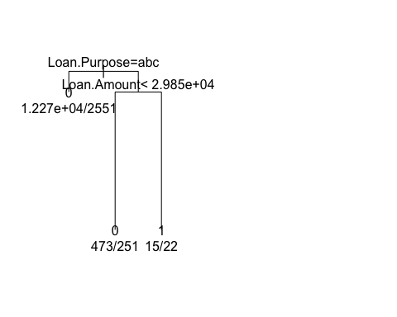

## $x  
## [1] 1.75 1.00 2.50 2.00 3.00  
##   
## $y  
## [1] 1.0000000 0.9996282 0.9996282 0.9971494 0.9971494  
##   
## NULL  
##   
## Classification tree:  
## rpart(formula = as.formula(frml1), data = X, control = rpart.control(cp = cp))  
##   
## Variables actually used in tree construction:  
## [1] Loan.Amount Loan.Purpose  
##   
## Root node error: 2824/15578 = 0.18128  
##   
## n= 15578   
##   
## CP nsplit rel error xerror xstd  
## 1 0.0012394 0 1.00000 1.0000 0.017027  
## 2 0.0010000 2 0.99752 1.0004 0.017029  
## [1] "Class ~ Loan.Amount + Loan.Purpose"  
## [1] "not good tree"  
## [1] "Class ~ Loan.Amount + Address.State"  
## [1] "not good tree"  
## [1] "Class ~ Loan.Amount + Debt.To.Income.Ratio"  
## [1] "not good tree"  
## [1] "Class ~ Loan.Amount + No..Delinquencies.In.Last.2.Years"  
## [1] "not good tree"  
## [1] "Class ~ Loan.Amount + Earliest.Credit.Line.Opened"  
## [1] "not good tree"  
## [1] "Class ~ Loan.Amount + FICO.Credit.Score"  
## [1] "not good tree"  
## [1] "Class ~ Loan.Amount + No..Inquiries.In.Last.6.Months"  
## [1] "not good tree"  
## [1] "Class ~ Loan.Amount + Months.Since.Last.Delinquency"  
## [1] "not good tree"  
## [1] "Class ~ Loan.Amount + No..Of.Credit.Lines"  
## [1] "not good tree"  
## [1] "Class ~ Loan.Amount + No..Adverse.Public.Records"  
## [1] "not good tree"  
## [1] "Class ~ Loan.Amount + Total.Credit.Balance"  
## [1] "not good tree"  
## [1] "Class ~ Loan.Amount + Use.Of.Credit.Line"  
## [1] "not good tree"  
## [1] "Class ~ Loan.Amount + Total.Number.Of.Credit.Lines"  
## [1] "not good tree"  
## [1] "Class ~ Loan.Amount + Loan.Application.Description"  
## [1] "not good tree"  
## [1] "generate tree for column Loan.Term starts"  
## [1] "Class ~ Loan.Amount + No..Of.Public.Record.Bankruptcies"  
## [1] "not good tree"  
## [1] "Class ~ Loan.Term + Employment.Length"  
## [1] "not good tree"  
## [1] "Class ~ Loan.Term + Home.Ownership"  
## [1] "not good tree"  
## [1] "Class ~ Loan.Term + Annual.Income"

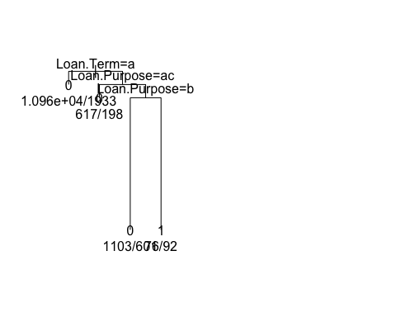

## $x  
## [1] 1.875 1.000 2.750 2.000 3.500 3.000 4.000  
##   
## $y  
## [1] 1.0000000 0.9994334 0.9994334 0.9988669 0.9988669 0.9932011 0.9932011  
##   
## NULL  
##   
## Classification tree:  
## rpart(formula = as.formula(frml1), data = X, control = rpart.control(cp = cp))  
##   
## Variables actually used in tree construction:  
## [1] Loan.Purpose Loan.Term   
##   
## Root node error: 2824/15578 = 0.18128  
##   
## n= 15578   
##   
## CP nsplit rel error xerror xstd  
## 1 0.0018886 0 1.00000 1.00000 0.017027  
## 2 0.0010000 3 0.99433 0.99717 0.017008  
## [1] "Class ~ Loan.Term + Loan.Purpose"  
## [1] "not good tree"  
## [1] "Class ~ Loan.Term + Address.State"  
## [1] "not good tree"  
## [1] "Class ~ Loan.Term + Debt.To.Income.Ratio"  
## [1] "not good tree"  
## [1] "Class ~ Loan.Term + No..Delinquencies.In.Last.2.Years"  
## [1] "not good tree"  
## [1] "Class ~ Loan.Term + Earliest.Credit.Line.Opened"  
## [1] "not good tree"  
## [1] "Class ~ Loan.Term + FICO.Credit.Score"  
## [1] "not good tree"  
## [1] "Class ~ Loan.Term + No..Inquiries.In.Last.6.Months"  
## [1] "not good tree"  
## [1] "Class ~ Loan.Term + Months.Since.Last.Delinquency"  
## [1] "not good tree"  
## [1] "Class ~ Loan.Term + No..Of.Credit.Lines"  
## [1] "not good tree"  
## [1] "Class ~ Loan.Term + No..Adverse.Public.Records"  
## [1] "not good tree"  
## [1] "Class ~ Loan.Term + Total.Credit.Balance"  
## [1] "not good tree"  
## [1] "Class ~ Loan.Term + Use.Of.Credit.Line"  
## [1] "not good tree"  
## [1] "Class ~ Loan.Term + Total.Number.Of.Credit.Lines"  
## [1] "not good tree"  
## [1] "Class ~ Loan.Term + Loan.Application.Description"  
## [1] "not good tree"  
## [1] "generate tree for column Employment.Length starts"  
## [1] "Class ~ Loan.Term + No..Of.Public.Record.Bankruptcies"  
## [1] "not good tree"  
## [1] "Class ~ Employment.Length + Home.Ownership"  
## [1] "not good tree"  
## [1] "Class ~ Employment.Length + Annual.Income"  
## [1] "not good tree"  
## [1] "Class ~ Employment.Length + Loan.Purpose"  
## [1] "not good tree"  
## [1] "Class ~ Employment.Length + Address.State"  
## [1] "not good tree"  
## [1] "Class ~ Employment.Length + Debt.To.Income.Ratio"  
## [1] "not good tree"  
## [1] "Class ~ Employment.Length + No..Delinquencies.In.Last.2.Years"  
## [1] "not good tree"  
## [1] "Class ~ Employment.Length + Earliest.Credit.Line.Opened"  
## [1] "not good tree"  
## [1] "Class ~ Employment.Length + FICO.Credit.Score"  
## [1] "not good tree"  
## [1] "Class ~ Employment.Length + No..Inquiries.In.Last.6.Months"  
## [1] "not good tree"  
## [1] "Class ~ Employment.Length + Months.Since.Last.Delinquency"  
## [1] "not good tree"  
## [1] "Class ~ Employment.Length + No..Of.Credit.Lines"  
## [1] "not good tree"  
## [1] "Class ~ Employment.Length + No..Adverse.Public.Records"  
## [1] "not good tree"  
## [1] "Class ~ Employment.Length + Total.Credit.Balance"  
## [1] "not good tree"  
## [1] "Class ~ Employment.Length + Use.Of.Credit.Line"  
## [1] "not good tree"  
## [1] "Class ~ Employment.Length + Total.Number.Of.Credit.Lines"  
## [1] "not good tree"  
## [1] "Class ~ Employment.Length + Loan.Application.Description"  
## [1] "not good tree"  
## [1] "generate tree for column Home.Ownership starts"  
## [1] "Class ~ Employment.Length + No..Of.Public.Record.Bankruptcies"  
## [1] "not good tree"  
## [1] "Class ~ Home.Ownership + Annual.Income"  
## [1] "not good tree"  
## [1] "Class ~ Home.Ownership + Loan.Purpose"  
## [1] "not good tree"  
## [1] "Class ~ Home.Ownership + Address.State"  
## [1] "not good tree"  
## [1] "Class ~ Home.Ownership + Debt.To.Income.Ratio"  
## [1] "not good tree"  
## [1] "Class ~ Home.Ownership + No..Delinquencies.In.Last.2.Years"  
## [1] "not good tree"  
## [1] "Class ~ Home.Ownership + Earliest.Credit.Line.Opened"  
## [1] "not good tree"  
## [1] "Class ~ Home.Ownership + FICO.Credit.Score"  
## [1] "not good tree"  
## [1] "Class ~ Home.Ownership + No..Inquiries.In.Last.6.Months"  
## [1] "not good tree"  
## [1] "Class ~ Home.Ownership + Months.Since.Last.Delinquency"  
## [1] "not good tree"  
## [1] "Class ~ Home.Ownership + No..Of.Credit.Lines"  
## [1] "not good tree"  
## [1] "Class ~ Home.Ownership + No..Adverse.Public.Records"  
## [1] "not good tree"  
## [1] "Class ~ Home.Ownership + Total.Credit.Balance"  
## [1] "not good tree"  
## [1] "Class ~ Home.Ownership + Use.Of.Credit.Line"  
## [1] "not good tree"  
## [1] "Class ~ Home.Ownership + Total.Number.Of.Credit.Lines"  
## [1] "not good tree"  
## [1] "Class ~ Home.Ownership + Loan.Application.Description"  
## [1] "not good tree"  
## [1] "generate tree for column Annual.Income starts"  
## [1] "Class ~ Home.Ownership + No..Of.Public.Record.Bankruptcies"  
## [1] "not good tree"  
## [1] "Class ~ Annual.Income + Loan.Purpose"  
## [1] "not good tree"  
## [1] "Class ~ Annual.Income + Address.State"  
## [1] "not good tree"  
## [1] "Class ~ Annual.Income + Debt.To.Income.Ratio"  
## [1] "not good tree"  
## [1] "Class ~ Annual.Income + No..Delinquencies.In.Last.2.Years"  
## [1] "not good tree"  
## [1] "Class ~ Annual.Income + Earliest.Credit.Line.Opened"  
## [1] "not good tree"  
## [1] "Class ~ Annual.Income + FICO.Credit.Score"  
## [1] "not good tree"  
## [1] "Class ~ Annual.Income + No..Inquiries.In.Last.6.Months"  
## [1] "not good tree"  
## [1] "Class ~ Annual.Income + Months.Since.Last.Delinquency"  
## [1] "not good tree"  
## [1] "Class ~ Annual.Income + No..Of.Credit.Lines"  
## [1] "not good tree"  
## [1] "Class ~ Annual.Income + No..Adverse.Public.Records"  
## [1] "not good tree"  
## [1] "Class ~ Annual.Income + Total.Credit.Balance"  
## [1] "not good tree"  
## [1] "Class ~ Annual.Income + Use.Of.Credit.Line"  
## [1] "not good tree"  
## [1] "Class ~ Annual.Income + Total.Number.Of.Credit.Lines"  
## [1] "not good tree"  
## [1] "Class ~ Annual.Income + Loan.Application.Description"  
## [1] "not good tree"  
## [1] "generate tree for column Loan.Purpose starts"  
## [1] "Class ~ Annual.Income + No..Of.Public.Record.Bankruptcies"  
## [1] "not good tree"  
## [1] "Class ~ Loan.Purpose + Address.State"  
## [1] "not good tree"  
## [1] "Class ~ Loan.Purpose + Debt.To.Income.Ratio"

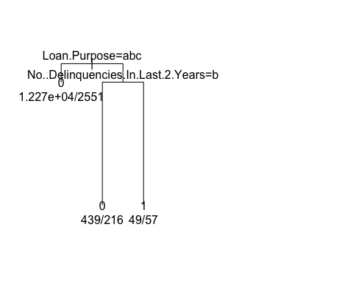

## $x  
## [1] 1.75 1.00 2.50 2.00 3.00  
##   
## $y  
## [1] 1.0000000 0.9995751 0.9995751 0.9967422 0.9967422  
##   
## NULL  
##   
## Classification tree:  
## rpart(formula = as.formula(frml1), data = X, control = rpart.control(cp = cp))  
##   
## Variables actually used in tree construction:  
## [1] Loan.Purpose No..Delinquencies.In.Last.2.Years  
##   
## Root node error: 2824/15578 = 0.18128  
##   
## n= 15578   
##   
## CP nsplit rel error xerror xstd  
## 1 0.0014164 0 1.00000 1.0000 0.017027  
## 2 0.0010000 2 0.99717 1.0007 0.017032  
## [1] "Class ~ Loan.Purpose + No..Delinquencies.In.Last.2.Years"  
## [1] "not good tree"  
## [1] "Class ~ Loan.Purpose + Earliest.Credit.Line.Opened"  
## [1] "not good tree"  
## [1] "Class ~ Loan.Purpose + FICO.Credit.Score"  
## [1] "not good tree"  
## [1] "Class ~ Loan.Purpose + No..Inquiries.In.Last.6.Months"  
## [1] "not good tree"  
## [1] "Class ~ Loan.Purpose + Months.Since.Last.Delinquency"  
## [1] "not good tree"  
## [1] "Class ~ Loan.Purpose + No..Of.Credit.Lines"  
## [1] "not good tree"  
## [1] "Class ~ Loan.Purpose + No..Adverse.Public.Records"  
## [1] "not good tree"  
## [1] "Class ~ Loan.Purpose + Total.Credit.Balance"

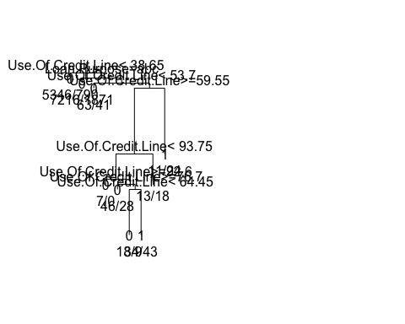

## $x  
## [1] 2.339844 1.000000 3.679688 2.000000 5.359375 3.000000 7.718750  
## [8] 6.437500 4.875000 4.000000 5.750000 5.000000 6.500000 6.000000  
## [15] 7.000000 8.000000 9.000000  
##   
## $y  
## [1] 1.0000000 0.9996415 0.9996415 0.9992829 0.9992829 0.9989244 0.9989244  
## [8] 0.9943210 0.9925505 0.9921919 0.9921919 0.9918334 0.9918334 0.9886464  
## [15] 0.9886464 0.9925505 0.9943210  
##   
## NULL  
##   
## Classification tree:  
## rpart(formula = as.formula(frml1), data = X, control = rpart.control(cp = cp))  
##   
## Variables actually used in tree construction:  
## [1] Loan.Purpose Use.Of.Credit.Line  
##   
## Root node error: 2824/15578 = 0.18128  
##   
## n= 15578   
##   
## CP nsplit rel error xerror xstd  
## 1 0.0011508 0 1.00000 1.0000 0.017027  
## 2 0.0010623 5 0.99363 1.0046 0.017057  
## 3 0.0010000 8 0.99044 1.0067 0.017071  
## [1] "Class ~ Loan.Purpose + Use.Of.Credit.Line"  
## [1] "not good tree"  
## [1] "Class ~ Loan.Purpose + Total.Number.Of.Credit.Lines"  
## [1] "not good tree"  
## [1] "Class ~ Loan.Purpose + Loan.Application.Description"  
## [1] "not good tree"  
## [1] "generate tree for column Address.State starts"  
## [1] "Class ~ Loan.Purpose + No..Of.Public.Record.Bankruptcies"  
## [1] "not good tree"  
## [1] "Class ~ Address.State + Debt.To.Income.Ratio"  
## [1] "not good tree"  
## [1] "Class ~ Address.State + No..Delinquencies.In.Last.2.Years"  
## [1] "not good tree"  
## [1] "Class ~ Address.State + Earliest.Credit.Line.Opened"  
## [1] "not good tree"  
## [1] "Class ~ Address.State + FICO.Credit.Score"  
## [1] "not good tree"  
## [1] "Class ~ Address.State + No..Inquiries.In.Last.6.Months"  
## [1] "not good tree"  
## [1] "Class ~ Address.State + Months.Since.Last.Delinquency"  
## [1] "not good tree"  
## [1] "Class ~ Address.State + No..Of.Credit.Lines"  
## [1] "not good tree"  
## [1] "Class ~ Address.State + No..Adverse.Public.Records"  
## [1] "not good tree"  
## [1] "Class ~ Address.State + Total.Credit.Balance"  
## [1] "not good tree"  
## [1] "Class ~ Address.State + Use.Of.Credit.Line"  
## [1] "not good tree"  
## [1] "Class ~ Address.State + Total.Number.Of.Credit.Lines"  
## [1] "not good tree"  
## [1] "Class ~ Address.State + Loan.Application.Description"  
## [1] "not good tree"  
## [1] "generate tree for column Debt.To.Income.Ratio starts"  
## [1] "Class ~ Address.State + No..Of.Public.Record.Bankruptcies"  
## [1] "not good tree"  
## [1] "Class ~ Debt.To.Income.Ratio + No..Delinquencies.In.Last.2.Years"  
## [1] "not good tree"  
## [1] "Class ~ Debt.To.Income.Ratio + Earliest.Credit.Line.Opened"  
## [1] "not good tree"  
## [1] "Class ~ Debt.To.Income.Ratio + FICO.Credit.Score"  
## [1] "not good tree"  
## [1] "Class ~ Debt.To.Income.Ratio + No..Inquiries.In.Last.6.Months"  
## [1] "not good tree"  
## [1] "Class ~ Debt.To.Income.Ratio + Months.Since.Last.Delinquency"  
## [1] "not good tree"  
## [1] "Class ~ Debt.To.Income.Ratio + No..Of.Credit.Lines"  
## [1] "not good tree"  
## [1] "Class ~ Debt.To.Income.Ratio + No..Adverse.Public.Records"  
## [1] "not good tree"  
## [1] "Class ~ Debt.To.Income.Ratio + Total.Credit.Balance"  
## [1] "not good tree"  
## [1] "Class ~ Debt.To.Income.Ratio + Use.Of.Credit.Line"  
## [1] "not good tree"  
## [1] "Class ~ Debt.To.Income.Ratio + Total.Number.Of.Credit.Lines"  
## [1] "not good tree"  
## [1] "Class ~ Debt.To.Income.Ratio + Loan.Application.Description"  
## [1] "not good tree"  
## [1] "generate tree for column No..Delinquencies.In.Last.2.Years starts"  
## [1] "Class ~ Debt.To.Income.Ratio + No..Of.Public.Record.Bankruptcies"  
## [1] "not good tree"  
## [1] "Class ~ No..Delinquencies.In.Last.2.Years + Earliest.Credit.Line.Opened"  
## [1] "not good tree"  
## [1] "Class ~ No..Delinquencies.In.Last.2.Years + FICO.Credit.Score"  
## [1] "not good tree"  
## [1] "Class ~ No..Delinquencies.In.Last.2.Years + No..Inquiries.In.Last.6.Months"  
## [1] "not good tree"  
## [1] "Class ~ No..Delinquencies.In.Last.2.Years + Months.Since.Last.Delinquency"  
## [1] "not good tree"  
## [1] "Class ~ No..Delinquencies.In.Last.2.Years + No..Of.Credit.Lines"  
## [1] "not good tree"  
## [1] "Class ~ No..Delinquencies.In.Last.2.Years + No..Adverse.Public.Records"  
## [1] "not good tree"  
## [1] "Class ~ No..Delinquencies.In.Last.2.Years + Total.Credit.Balance"  
## [1] "not good tree"  
## [1] "Class ~ No..Delinquencies.In.Last.2.Years + Use.Of.Credit.Line"  
## [1] "not good tree"  
## [1] "Class ~ No..Delinquencies.In.Last.2.Years + Total.Number.Of.Credit.Lines"  
## [1] "not good tree"  
## [1] "Class ~ No..Delinquencies.In.Last.2.Years + Loan.Application.Description"  
## [1] "not good tree"  
## [1] "generate tree for column Earliest.Credit.Line.Opened starts"  
## [1] "Class ~ No..Delinquencies.In.Last.2.Years + No..Of.Public.Record.Bankruptcies"  
## [1] "not good tree"  
## [1] "Class ~ Earliest.Credit.Line.Opened + FICO.Credit.Score"  
## [1] "not good tree"  
## [1] "Class ~ Earliest.Credit.Line.Opened + No..Inquiries.In.Last.6.Months"  
## [1] "not good tree"  
## [1] "Class ~ Earliest.Credit.Line.Opened + Months.Since.Last.Delinquency"  
## [1] "not good tree"  
## [1] "Class ~ Earliest.Credit.Line.Opened + No..Of.Credit.Lines"  
## [1] "not good tree"  
## [1] "Class ~ Earliest.Credit.Line.Opened + No..Adverse.Public.Records"  
## [1] "not good tree"  
## [1] "Class ~ Earliest.Credit.Line.Opened + Total.Credit.Balance"  
## [1] "not good tree"  
## [1] "Class ~ Earliest.Credit.Line.Opened + Use.Of.Credit.Line"  
## [1] "not good tree"  
## [1] "Class ~ Earliest.Credit.Line.Opened + Total.Number.Of.Credit.Lines"  
## [1] "not good tree"  
## [1] "Class ~ Earliest.Credit.Line.Opened + Loan.Application.Description"  
## [1] "not good tree"  
## [1] "generate tree for column FICO.Credit.Score starts"  
## [1] "Class ~ Earliest.Credit.Line.Opened + No..Of.Public.Record.Bankruptcies"  
## [1] "not good tree"  
## [1] "Class ~ FICO.Credit.Score + No..Inquiries.In.Last.6.Months"  
## [1] "not good tree"  
## [1] "Class ~ FICO.Credit.Score + Months.Since.Last.Delinquency"  
## [1] "not good tree"  
## [1] "Class ~ FICO.Credit.Score + No..Of.Credit.Lines"  
## [1] "not good tree"  
## [1] "Class ~ FICO.Credit.Score + No..Adverse.Public.Records"  
## [1] "not good tree"  
## [1] "Class ~ FICO.Credit.Score + Total.Credit.Balance"  
## [1] "not good tree"  
## [1] "Class ~ FICO.Credit.Score + Use.Of.Credit.Line"  
## [1] "not good tree"  
## [1] "Class ~ FICO.Credit.Score + Total.Number.Of.Credit.Lines"  
## [1] "not good tree"  
## [1] "Class ~ FICO.Credit.Score + Loan.Application.Description"  
## [1] "not good tree"  
## [1] "generate tree for column No..Inquiries.In.Last.6.Months starts"  
## [1] "Class ~ FICO.Credit.Score + No..Of.Public.Record.Bankruptcies"  
## [1] "not good tree"  
## [1] "Class ~ No..Inquiries.In.Last.6.Months + Months.Since.Last.Delinquency"  
## [1] "not good tree"  
## [1] "Class ~ No..Inquiries.In.Last.6.Months + No..Of.Credit.Lines"  
## [1] "not good tree"  
## [1] "Class ~ No..Inquiries.In.Last.6.Months + No..Adverse.Public.Records"  
## [1] "not good tree"  
## [1] "Class ~ No..Inquiries.In.Last.6.Months + Total.Credit.Balance"  
## [1] "not good tree"  
## [1] "Class ~ No..Inquiries.In.Last.6.Months + Use.Of.Credit.Line"  
## [1] "not good tree"  
## [1] "Class ~ No..Inquiries.In.Last.6.Months + Total.Number.Of.Credit.Lines"  
## [1] "not good tree"  
## [1] "Class ~ No..Inquiries.In.Last.6.Months + Loan.Application.Description"  
## [1] "not good tree"  
## [1] "generate tree for column Months.Since.Last.Delinquency starts"  
## [1] "Class ~ No..Inquiries.In.Last.6.Months + No..Of.Public.Record.Bankruptcies"  
## [1] "not good tree"  
## [1] "Class ~ Months.Since.Last.Delinquency + No..Of.Credit.Lines"  
## [1] "not good tree"  
## [1] "Class ~ Months.Since.Last.Delinquency + No..Adverse.Public.Records"  
## [1] "not good tree"  
## [1] "Class ~ Months.Since.Last.Delinquency + Total.Credit.Balance"  
## [1] "not good tree"  
## [1] "Class ~ Months.Since.Last.Delinquency + Use.Of.Credit.Line"  
## [1] "not good tree"  
## [1] "Class ~ Months.Since.Last.Delinquency + Total.Number.Of.Credit.Lines"  
## [1] "not good tree"  
## [1] "Class ~ Months.Since.Last.Delinquency + Loan.Application.Description"  
## [1] "not good tree"  
## [1] "generate tree for column No..Of.Credit.Lines starts"  
## [1] "Class ~ Months.Since.Last.Delinquency + No..Of.Public.Record.Bankruptcies"  
## [1] "not good tree"  
## [1] "Class ~ No..Of.Credit.Lines + No..Adverse.Public.Records"  
## [1] "not good tree"  
## [1] "Class ~ No..Of.Credit.Lines + Total.Credit.Balance"  
## [1] "not good tree"  
## [1] "Class ~ No..Of.Credit.Lines + Use.Of.Credit.Line"  
## [1] "not good tree"  
## [1] "Class ~ No..Of.Credit.Lines + Total.Number.Of.Credit.Lines"  
## [1] "not good tree"  
## [1] "Class ~ No..Of.Credit.Lines + Loan.Application.Description"  
## [1] "not good tree"  
## [1] "generate tree for column No..Adverse.Public.Records starts"  
## [1] "Class ~ No..Of.Credit.Lines + No..Of.Public.Record.Bankruptcies"  
## [1] "not good tree"  
## [1] "Class ~ No..Adverse.Public.Records + Total.Credit.Balance"  
## [1] "not good tree"  
## [1] "Class ~ No..Adverse.Public.Records + Use.Of.Credit.Line"  
## [1] "not good tree"  
## [1] "Class ~ No..Adverse.Public.Records + Total.Number.Of.Credit.Lines"  
## [1] "not good tree"  
## [1] "Class ~ No..Adverse.Public.Records + Loan.Application.Description"  
## [1] "not good tree"  
## [1] "generate tree for column Total.Credit.Balance starts"  
## [1] "Class ~ No..Adverse.Public.Records + No..Of.Public.Record.Bankruptcies"  
## [1] "not good tree"  
## [1] "Class ~ Total.Credit.Balance + Use.Of.Credit.Line"  
## [1] "not good tree"  
## [1] "Class ~ Total.Credit.Balance + Total.Number.Of.Credit.Lines"  
## [1] "not good tree"  
## [1] "Class ~ Total.Credit.Balance + Loan.Application.Description"  
## [1] "not good tree"  
## [1] "generate tree for column Use.Of.Credit.Line starts"  
## [1] "Class ~ Total.Credit.Balance + No..Of.Public.Record.Bankruptcies"  
## [1] "not good tree"  
## [1] "Class ~ Use.Of.Credit.Line + Total.Number.Of.Credit.Lines"  
## [1] "not good tree"  
## [1] "Class ~ Use.Of.Credit.Line + Loan.Application.Description"  
## [1] "not good tree"  
## [1] "generate tree for column Total.Number.Of.Credit.Lines starts"  
## [1] "Class ~ Use.Of.Credit.Line + No..Of.Public.Record.Bankruptcies"  
## [1] "not good tree"  
## [1] "Class ~ Total.Number.Of.Credit.Lines + Loan.Application.Description"  
## [1] "not good tree"  
## [1] "generate tree for column Loan.Application.Description starts"  
## [1] "Class ~ Total.Number.Of.Credit.Lines + No..Of.Public.Record.Bankruptcies"  
## [1] "not good tree"  
## [1] "generate tree for column No..Of.Public.Record.Bankruptcies starts"  
## [1] "Class ~ Loan.Application.Description + No..Of.Public.Record.Bankruptcies"  
## [1] "not good tree"  
## [1] "Class ~ No..Of.Public.Record.Bankruptcies + Class"  
## [1] "not good tree"

options(warn=0)